EVOLUTION PRE-SURVEY
Date: Name:
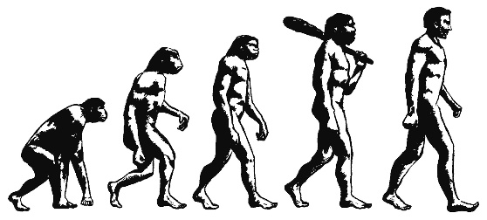
Place a CHECK by the statements you believe to be TRUE.

___ 1. Evolution is "just" a theory.
___ 2. Evolution is primarily concerned with the origin of humans.
___ 3. According to evolution, people came from monkeys a long time ago.
___ 4. Evolution is something that happened only in the past; it is not happening now.
___ 5. Evolution is something that happens to individual organisms.
___ 6. The theory of evolution talks about the past and does not have any current applications.
___ 7. Evolution through natural selection produces organisms perfectly suited to their environments.
___ 8. Evolution takes thousands of years to occur.
___ 9. There is not a lot of scientific evidence for evolution.
___ 10. Evolution involves individuals changing in order to adapt to their environment.

EVOLUTION PRE-SURVEY
Date: Name:
Place a CHECK by the statements you believe to be TRUE.

___ 1. Evolution is "just" a theory.
___ 2. Evolution is primarily concerned with the origin of humans.
___ 3. According to evolution, people came from monkeys a long time ago.
___ 4. Evolution is something that happened only in the past; it is not happening now.
___ 5. Evolution is something that happens to individual organisms.
___ 6. The theory of evolution talks about the past and does not have any current applications.
___ 7. Evolution through natural selection produces organisms perfectly suited to their environments.
___ 8. Evolution takes thousands of years to occur.
___ 9. There is not a lot of scientific evidence for evolution.
___ 10. Evolution involves individuals changing in order to adapt to their environment.

Read pages 369 – 372 in your textbook.

- What is evolution?

- What is a scientific theory?

- Summarize Darwin's observations.

z

Read pages 369 – 372 in your textbook.

- What is evolution?

- What is a scientific theory?

- Summarize Darwin's observations.

