Life Sciences 11 Kingdom Animalia - Introduction Name:
Date:
By the end of the lesson you should be able to:
Describe the 5 ways we classify animals - symmetry, germ layers, body plan, segmentation, animal evolution & early development pattern – and identify the most and least advanced forms within each classification
Animal Characteristics
- ____________________________ with a high degree of cell specialization.
- Type of cells: ____________________________
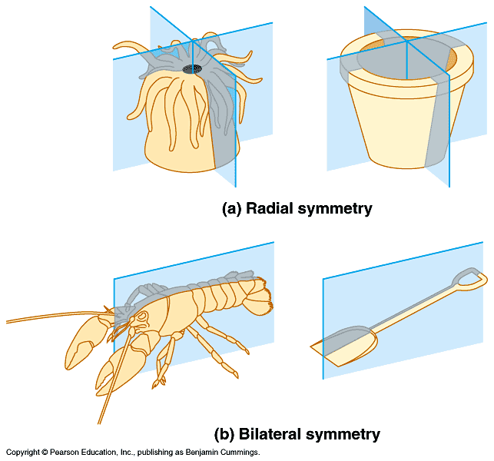
- Mode of nutrition: _________________________ by ingestion.
- ________________________ cell walls.
Classification Criteria
1. Symmetry (body axis)
- With the exception of some sponges, every kind of animal exhibits some type of body symmetry.
- Two types: _______________________ and ________________________

A. ________________
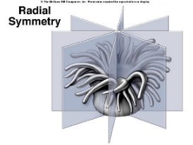
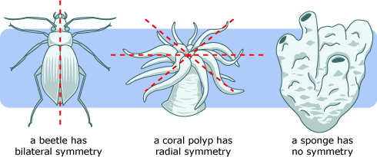
- Can be divided into ___________________ through central axis
- These have a ________________ shape
- Think of a bicycle wheel
- As a result, they have _______________,
_________________ like this sea anemone.

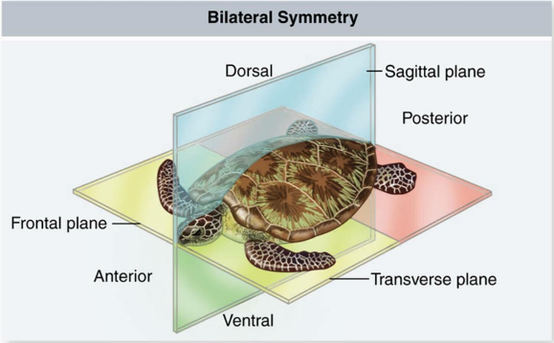
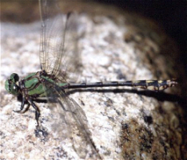
B._________________________________
- Can be cut into two equal halves _______________ ______________, through the mid dorsal line.

- Results in in anterior, posterior, ventral, dorsal, left and right.

- Allows for ______________________________ (concentration of sense organs and nerve cells at the front end of the body)

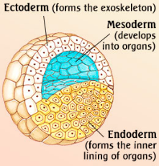
2. Germ layers
- Early in animal development, cells will choose, or differentiate into three layers called germ layers.

- The word germ means grow - the germ layers in animals grow to form the various tissues and organs
- Three types: No germ layers, diploblastic, triploblastic
A. ___________________________
- This is the most __________________ as these animals develop _________________
B. _______________________
- ____________ germ layers: ectoderm and endoderm
- __________________: outer layer (forms ____________ and ________________)
- __________________: inner layer (forms lining of ___________________)
C. _______________________
- ____________ germ layers
- ______________________ grows between the ectoderm and endoderm.
- Forms ____________________ and most of remaining internal organs
- This is the highest level
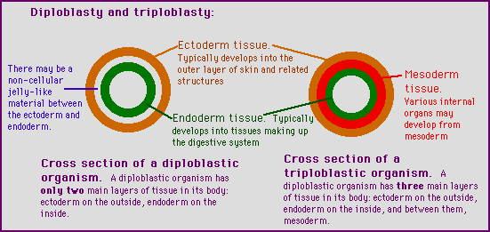
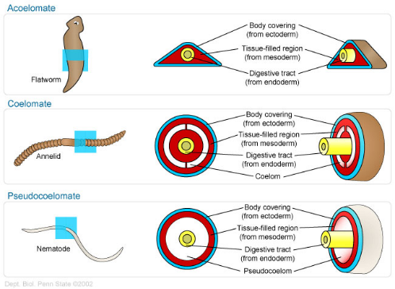
3. Body Plan: type of body cavity
The evolution of a body cavity, called a _______________, provided a place for organs and organ systems to grow
- ___________________________: no coelom
- poorly developed organs
B. ____________________________: false coelom
- Have a body cavity between endoderm and mesoderm layers
- _________________________________________________________________ through digestive tract
- Some organs systems develop in this space
C. ____________________________: true coelom
- Have a body cavity located between the mesoderm of the body wall and the new layer of mesoderm around the gut
- Allows for _________________________________
- __________________________________________
- Highest level of development

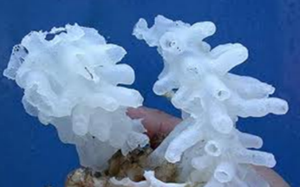
4. Segmentation leads to specialization and body regions
- Non-Segmented: no specialized sections
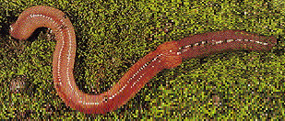
- Segmented: _____________________________________
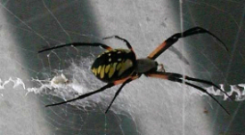
C. Segmented _________________________
- Body segments fuse together to become body regions which focus on one set of tasks

5. Animal Evolution & Early Development Pattern
- We typically study animals in three groups which reflect their evolutionary history.
A. ______________________________________:
- These phyla demonstrate a fairly linear evolution (simple biology)

- They include: Porifera, Cnidaria, Platyhelminthes and Nematodes

B. ______________________________________:
i. The __________________________________
- This is one of two main branches of animal evolution
- Named this way due to embryo development (___________ develops first from blastopore)
- They include the Annelids, Molluscs, and Arthropods

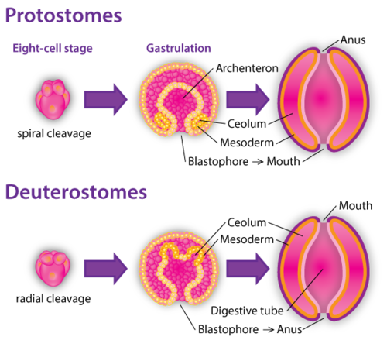

ii. The __________________________________
- These are the animals on the other great branch of animal evolution (_______ develops first)
- Include the echinoderms and lower chordates

C. Vertebrates
- Represent the most highly evolved animals (_____________)

We will learn how different phylums and groups of animals do the following processes of life:
  - Feeding
  - Respiration
  - Circulation
  - Excretion
  - Response
  - Movement
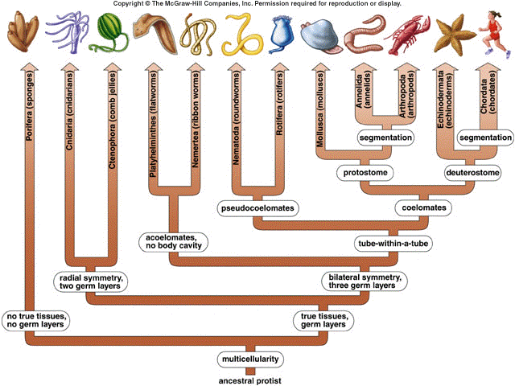
  - Reproduction

Can you …
… describe the 5 ways we classify animals - symmetry, germ layers, body plan, segmentation, animal evolution & early development pattern – and identify the most and least advanced forms within each classification?

