Phylum Porifera: The Sponges Name: Date:
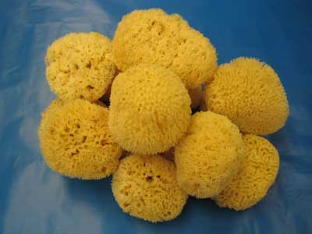
Phylum Porifera
- Porifera = ‘_____________________’
- One of the simplest and most unusual animals
- Have been on earth for at least 540 million years
- Most of them live a _________________ life in the ocean
- Most commonly used by humans for natural sponges for bathing
- They are considered animals because they are m_____________________, e__________________, h____________________ and their cells lack _______________________________________
- This phylum represents the first experiment in multi-cellularity for animals
- There are specialized cells, but they do no work cooperatively together - not _______________
- Simplest and most ________________________ animals
- Have changed little since they evolved

Body Plan
- Sponges are mostly _______________________ , have no front or back ends, and no left or right sides
- Think of a large, hollow, cylindrical water pump
- _____________________________ (collar cells) are specialized cells that use flagella to move water through pores into the sponge
- Water exits the sponge through the _________________, large hole at the top
- This movement of water is for feeding, respiration, circulation, and excretion
- _______________________ (archaeocytes) are motile cells which have a variety of functions including delivering nutrients to other cells and creating eggs for sexual reproduction
- ___________________ (epidermal) cells are flat cells which cover the outside of the sponge
- Sponges have a simple skeleton
- In harder sponges, the skeleton is make up of spiny ____________________
- A spicule is a spike-shaped structure made up of chalklike calcium carbonate or glass-like silica
- Softer sponges have an internal skeleton made up of ________________________, a network of flexible protein fibres
Spongin Spicule
Feeding, Respiration, Circulation, and Excretion
- The movement of water through their bodies is to carry out body functions
- Sponges are ___________________________________________ which means they filter food particles from the water using their choanocytes.
- Oxygen from the water ________________________________________ and waste products like ______________________________________________________________________ into the central cavity and out the osculum
Response
- Sponges do not have a _______________________________________ that would allow them to respond to their environment however, some sponges create toxins that are unpalatable or poisonous to potential predators.
Reproduction
- Sponges can reproduce either sexually or asexually
  - Sexual - __________________________________________________________
  - Larvae are motile and move to a different location
  - Asexual – __________________________ a new sponge clone forms on the side and
eventually forms a clone
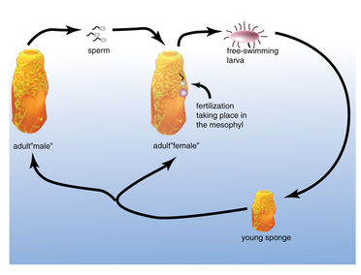
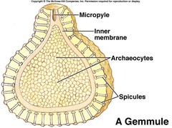
- __________________________: in unfavourable conditions, the sponge can surround ameobocytes (archaeocytes) in spicules forming a gemmule which can survive the harsh conditions then regrow the sponge
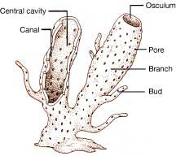

Can You …
… draw and describe the body plan of a typical sponge including each cell’s role within the sponge?
… explain water’s role in sponge survival?
… describe how a typical sponge reproduces and obtains nutrients?

