Scientific Drawings
Date: Name:
1) Look at the specimen carefully and examine the significant features that will be included in the drawing.
2) DRAW ONLY WHAT YOU SEE!! Do not include what you think you should see.
3) All drawings must be done in pencil ONLY.
4) Drawings must be large and clear so that features can be easily distinguished.
5) No more than two drawings should be on a single page.
6) Always use distinct, single lines when drawing.

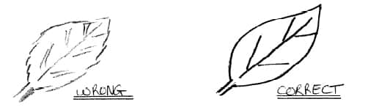
7) To illustrate darker areas on a specimen, use stippling or dots. Do not shade in any area of your drawing.
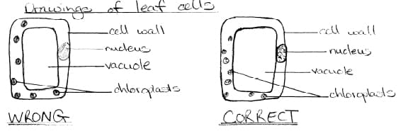
All drawings must have the following indicated:
– Title (give a full, clear and concise title that explains what is being illustrated)
– Caption (description which explains what this drawing is and what it will be used for in the case of a lab set-up)
– Magnification (indicate the magnification at which the specimen was observed if using a microscope)
– Labels (always include labels of the important features of the specimen. Each label line must be straight and should not overlap with other label lines; all labels must be to one. Annotations are used to give information about the specimen that cannot be seen on the diagram (e.g. you may want to record that the nucleus was stained blue or that the two flagella on the organism could not be seen and so are not included on the diagram.

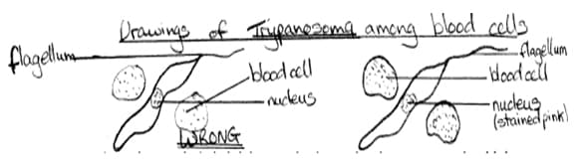

When doing scientific drawings, use the following checklist to make sure your drawings have all the required components:

- Two drawings per page
- Title
- Caption
- Labels and annotations
- Magnification
- No shading, only stippling (dotting)
- No sketchy lines, only single lines
- Neat and clean

