Sexual Reproduction in Flowering Plants
Name:
Introduction  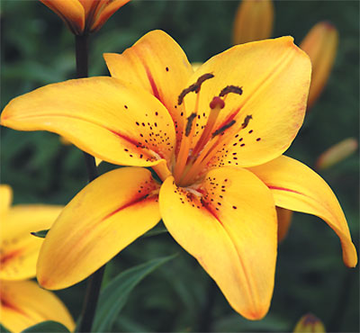 | The angiosperms are seed-bearing plants that produce flowers. The seeds, which contain the plant embryo, are produced in the flower. All the parts of a flower are actually modified leaves that are specialized for their roles in the reproductive process. Flower parts are arranged in circles called whorls. They are attached at the enlarged base of the flower, the receptacle.  Flower structures can be divided into two groups: the essential organs and the accessory organs. The essential organs are the reproductive structures, which include the stamens (male) and the pistils (AKA carpals) (female). The accessory organs are the sepals and petals, which surround and protect the essential organs.
The stamen is the male reproductive organ and consists of two parts: the anther and the filament. The anther is the enlarged structure at the top of the stamen. Inside the anther are pollen sacs. Special cells within the pollen sacs undergo meiosis to form pollen grains. Each pollen grain contains two sperm nuclei. When the pollen grains mature, the pollen sacs split open to release the dust-like pollen. The filament is a thin stalk that supports the anther.

The pistil is the female reproductive organ and consists of three parts: the stigma, style, and ovary. The stigma is an enlarged portion at the top of the pistil that becomes moist and sticky when mature. The style is the middle portion of the pistil. It can be long and slender, short, or even absent, depending upon the species. The ovary is the enlarged structure at the bottom of the pistil. The ovary contains one or more ovules. Special cells within the ovule undergo meiosis to form ova (eggs) containing egg nuclei.
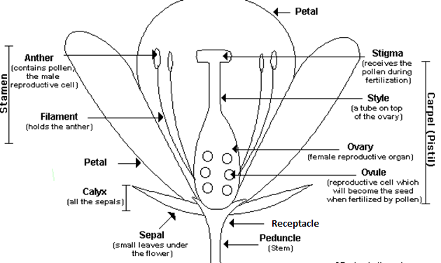
Pollination occurs when pollen grains land on the sticky surface of the stigma and are trapped there. The pollen grain germinates and a pollen tube emerges from the grain. It releases special enzymes that digest a cell the wall on the surface of the stigma. The pollen tube grows down through the style to the ovary and enters the ovule, making a continuous passageway for the two sperm nuclei to enter the ovum. Fertilization occurs when the sperm nuclei join the egg nuclei.
The fertilized egg becomes an embryo. The wall of the ovule thickens and forms a seed, thus enclosing and protecting the embryo. The ovary wall also thickens and develops into a fruit. In some plants such as apples, the ovary walls become fleshy and contain stored sugars and starches. In other plants such as walnuts, the ovary walls become dry and hard.

Purpose
- To study the structure of a typical flower.
- To study the male and female reproductive organs needed for sexual reproduction in flowering plants.

Materials
fresh flower(s) | hand lens | plain paper | clear tape
dissecting needle | forceps | metric ruler | scalpel or razor blade

Procedure

- Separate the last page of this lab to make the Observations Chart accessible.

- Obtain a single flower and observe its parts carefully. Flower parts are arranged in a circular pattern. Each circle is called a whorl. The whorls are attached at the enlarged receptacle located at the base of the flower. Please read this overview before you begin your flower dissection: As you examine your flower, you will be carefully removing parts beginning with the outer whorl and working your way in towards the pistil. You will arrange each whorl in a circle on the plain paper, beginning with the sepals as the largest outermost circle. As you proceed with your dissection, you will carefully tape each whorl of flower parts into position and label them (please use pencil!). As each whorl is observed and removed, you will complete the appropriate information in the Observations column of the chart. Use the information in the handout to complete the Function column of the chart.

- The sepals form the outermost whorl of the flower. The sepals are leaf-like structures that are usually green in colour. Sometimes, the sepals are the same colour as the petals, or appear to be another set of petals of a different colour. The function of the sepals is to protect the inner part of the flower before it blossoms. Gently remove the sepals, tape them into position onto the paper, and label them. On the chart, record the following observations:
- How many sepals does your flower have?
- Describe the appearance of the sepals (veins parallel or branched, colour, markings, etc.).

- The petals are found directly under the sepals. The colour and odor of the petals help to attract birds and insects to the flower for pollination. Gently remove the petals, tape them into position onto the paper, and label them. On the chart, record the following observations:
- How many petals does your flower have?
- Describe the appearance of the petals (veins parallel or branched, colour, markings, etc.).

- The stalk-like structures inside the petals are the stamens, the male reproductive organs. Depending on the species, the stamens may be attached to the receptacle, to the petals, or to the pistil. The enlarged portion at the top of the stamen is the anther. Inside the anther are pollen sacs, which produce pollen grains. When the pollen grains mature, the pollen sacs

split open, releasing the dust like pollen grains. The filament is the thin structure that supports the anther. Gently remove the stamens, tape them into position onto the paper, and label them. Using a clean slide, add a drop of water then gently tap the anther three time on the droplet of water. Place a cover slip on the slide. Examine your slide under a compound microscope using low lighting. Try to find pollen grains under high power. On the chart, record the following observations:
- How many stamens does your flower have?
- To which structure(s) were the filaments attached?
- Have the pollen sacs opened? How can you tell?
- If pollen grains are visible, describe their appearance.

- The central structure of the flower is the female reproductive organ, the pistil. The top of the pistil is the stigma. When mature the stigma is enlarged, and its surface is moist and sticky. The style is the middle portion of the pistil. It supports the sigma. Some flowers lack a style. The ovary is the enlarged structure at the bottom of the pistil. The ovary contains one or more ovules, which in turn, contain the egg nuclei. Carefully remove the pistil by cutting it from the stem just under the ovary. Using pencil, make a life-sized sketch of the entire pistil (just the outline) in the center of the plain paper and label it. Cut the style just at the top of the ovary, tape it next to your sketch, and label the stigma and style. Using the ruler, measure the length of the style in millimeters. Cut a thin cross-wise section of the ovary and tape it under the stigma and style. Label the ovary wall and ovules. Using the dissecting needle, carefully pick out the ovules. On the chart, record the following observations:
- What colour is the pistil?
- Describe the appearance of the stigma. Is the stigma mature? How can you tell?
- How long is the style in mm?
- Describe the appearance of the ovary.

7. Check your flower parts sheet and your chart for the following:
• All flower parts are correctly taped in place.
• All flower parts are labeled correctly (in pencil).
• The pistil is drawn on the paper (in pencil).
• Your name(s) and class period are written on the paper.
• The Observations column of your chart is completed.

Discussion - Write your answers using complete sentences. Name:

- Which does your flower produce in greater numbers: ovules or pollen grains? Explain why this would be important in terms of reproductive success.

- What are some adaptations of flower petals to help attract pollinators?

- How is the stigma of your flower adapted to capture and hold pollen?

- Describe where pollination and fertilization occur.

- Explain the differences between pollination and fertilization.

- a) In which part of the male reproductive organ are the pollen grains made?

b) In which part of the female reproductive organ are the egg cells made?

c) By which nuclear process are these gametes formed?

- How do the sperm nuclei in a pollen grain reach the egg nucleus in an ovule?

- a) Which part of the flower becomes the seed?

b) Which part becomes the fruit?

c) Which part of the fruit contains the embryo?

Conclusion
Check your chart to be sure that the function column is complete. Then summarize the information presented in this lab by creating a brief outline. Your outline should include information about types of flower parts, male and female structures, pollination, fertilization, and development of seed and fruit. Use the Introduction as your guide!
Names _____________________________ Complete this table as you do the lab.

OBSERVATIONS
Structure | Function | Observations
Receptacle
Sepals |  | a)  b)
Petals |  | a)  b)
Stamens
Filament
Anther
Pollen grains
Pistil |  | a)
Stigma |  | b)
Style |  | c)
Ovary |  | d)
Ovule

Names _____________________________ Tape Your Flower Parts here.

