Unit 2: Evolution – How Evolution - Macro Date: _____________
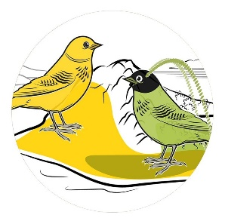
Objectives - By the end of the lesson you should be able to:
- Describe how macro-evolution (speciation) is different from micro-evolution
- Describe 3 patterns of speciation
- Compare and contrast Gradualism with Punctuated Equilibrium
Macro-evolution: AKA Speciation
- __________________________: _______________________________
Recall:
- Species: population of organisms that are able to breed and produce viable, fertile offspring

- When a __________________________________________ (by a geographic barrier for example), speciation can occur over a long period of time as all of the small changes in the gene pool due to micro-evolution add up over time.

- Eventually the differences in the two populations are so great that the two populations can ___________________________________________________ to make viable, fertile offspring. We now have two different species. _______________ is said to have occurred.

Patterns of Speciation
1. __________________________________________ AKA Adaptive Radiation
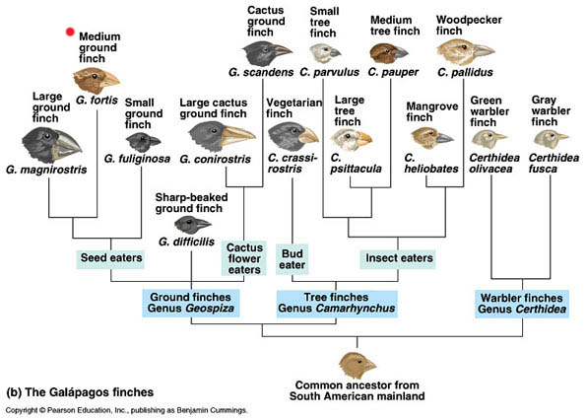
  - Occurs when small fragments of a population ___________________________________ … they adapt (evolve) to their new habitats

  - _________________________________________________

  - EX. ______________________________

2. _____________________________________________
- Occurs when _________________________________
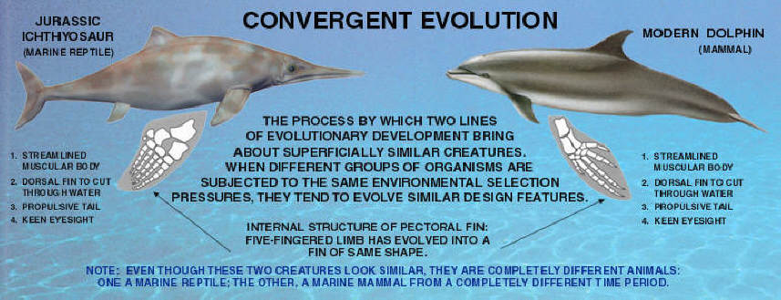
___________________ and adapt (evolve) so will display similar characteristics

- _________________________________ so DNA is not closely related
- EX. _____________________________

3. ____________________________________________
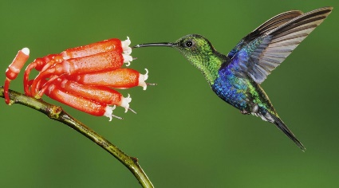
- Occurs when organisms are closely connected to one another by biological interactions (symbiosis) and _______ ____________________ . A change in one organism may be followed by a corresponding change in the other organism.
- EX. _________________________________

Rate of Evolution
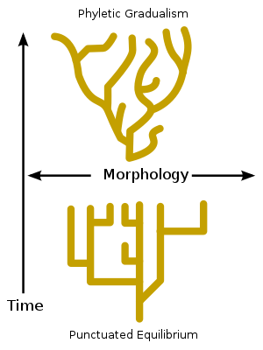
- There is no defined speed that evolution happens in, but there are two trends that can be clearly observed in the fossil record: Gradualism and Punctuated Equilibrium
Gradualism – Modern theory based on the principles of Charles Darwin
- ___________________________ evolution of a species over time
- Small changes (micro evolution) _______________________________ over time
- Fossils are direct evidence that show speciation over time
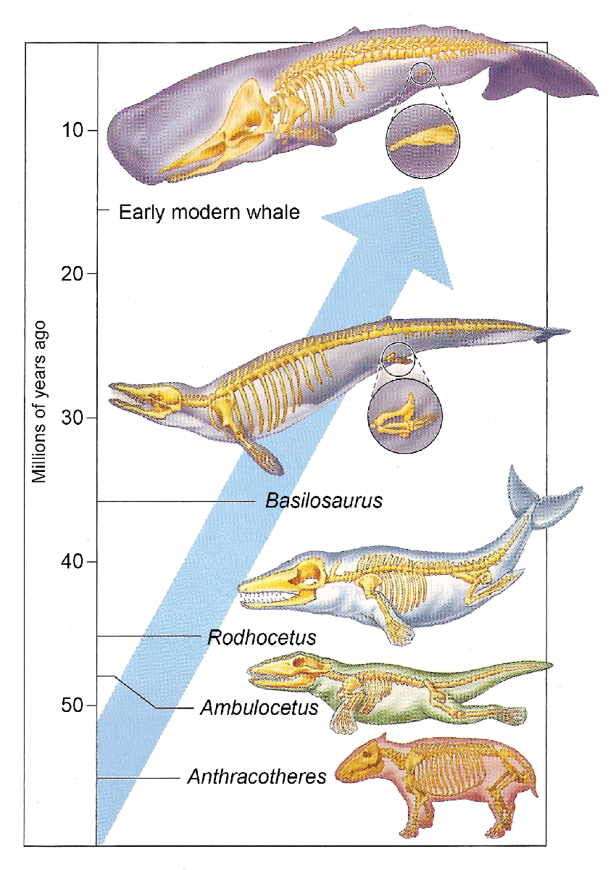
- The fossil record demonstrates clear examples of slow and steady changes over millions of years preserved in progressively younger layers of rock
Punctuated Equilibrium - Eldredge and Gould in 1972
- Long periods of stasis (_________________) with short, rapid periods of change (__________________)
- Associated with __________________________________________
- The fossil record also demonstrates clear examples of periods of little change followed by rapid changes
Punctuated equilibrium predicts that a lot of evolutionary change takes place in short periods of time tied to speciation events. Here's an example of how the model works:
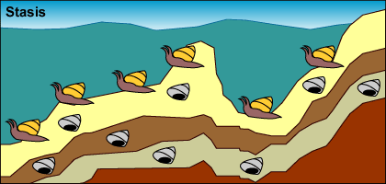
Ex: Mollusk Evolution by Punctuated Equilibrium
- ____________________ A population of mollusks is experiencing stasis, living, dying, and getting fossilized every few hundred thousand years. Little observable evolution seems to be occurring judging from these fossils

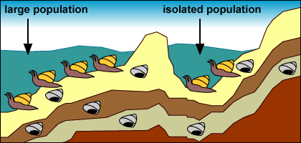
- ____________________: A drop in sea level ____________ and _____________________________ of mollusks from the rest of the population.

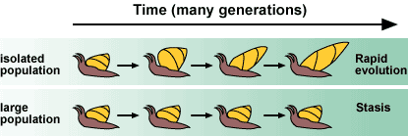
- _____________________________: The small, isolated population experiences strong selection and _________________ because of the novel environment and small population size: The environment in the newly formed lake exerts new selection pressures on the isolated mollusks. Also, their small population size means that _________________ influences their evolution. The isolated population undergoes rapid evolutionary change.

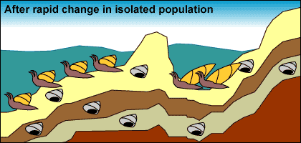
- ________________________: Few fossils representing transitional forms are preserved because of their relatively ___________________________ size, the ______________ of change, and their ___________________________.

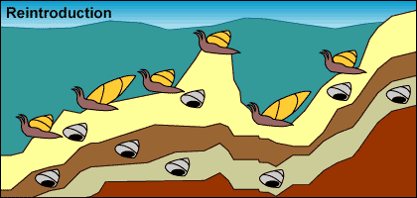
- _________________________: Sea levels rise, reuniting the isolated mollusks with their sister lineage.

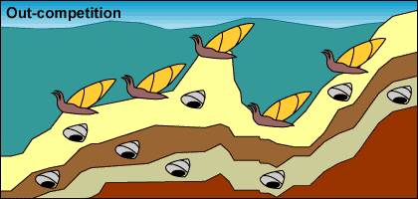
- _____________________________ : The isolated population _______________________________. Larger population size and a stable environment make evolutionary change less likely. The formerly isolated branch of the mollusk lineage may _________________________ their ancestral population, causing it to go extinct.
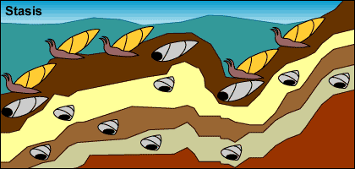
- ___________________________ : Larger population size and a larger range move us back to step 1: stasis with occasional fossil preservation.

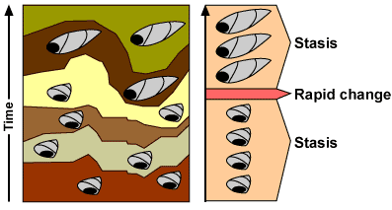
- This process would produce the following pattern in the fossil record:

- We observe similar patterns in the fossil records of many organisms. For example, the fossil records of certain foraminiferans (single-celled protists with shells) are consistent with a punctuated pattern.
- 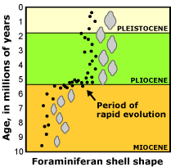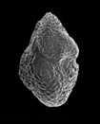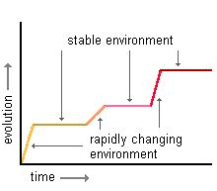

- In the fossil record we can observe examples of gradual, non-punctuated, evolution in some species and long periods of stasis followed by rapid change in other species. There is fossil evidence for both theories!
- The question that needs answering is not which one is correct, but what are the relative frequencies of punctuated and gradual change?
Comparison
Which graphs/diagrams are showing Gradualism? Punctuated Equilibrium? Why?
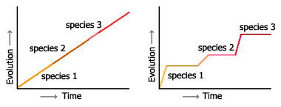

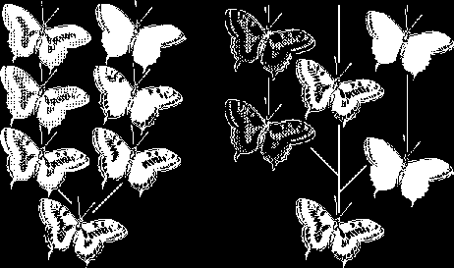

______________ (Scientist(s)) ___________________(Scientist(s))

________________ (Theory) ______________ (Theory)
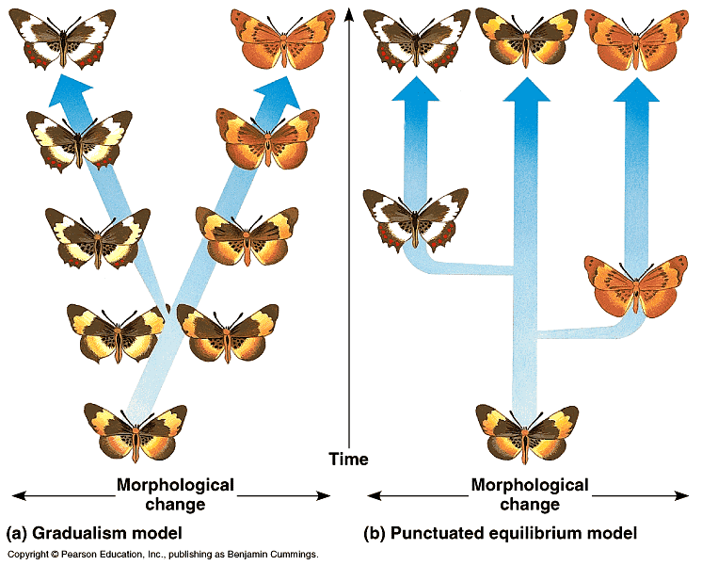
Can you …
… describe how macro-evolution (speciation) is different from micro-evolution?
… explain 3 patterns of speciation?
… compare and contrast Gradualism with Punctuated Equilibrium?

