Date: Organism Organizer:

The Prime Minister's Dinner (AKA How to Make a Dichotomous Key)

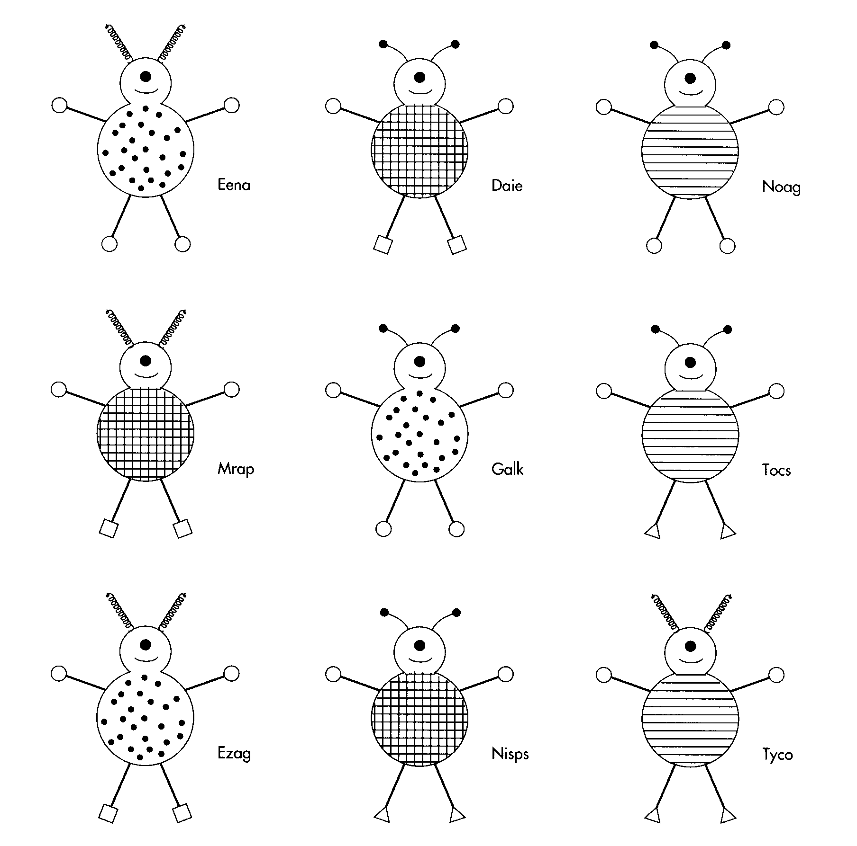Six Martians landed in the schoolyard this morning and introduced themselves as Eena, Daie, Noag, Mrap, Galk, and Tocs. As ambassadors for the planet Mars they have been invited to dine with the Prime Minister. You are the Prime Minister's aide, and the Prime Minister has asked you to make up a dichotomous key so she will know their names without having to ask. Time is important for the PM, so she asks you to be as efficient as possible with the least number of questions to read before identifying each Martian.

You know that you can successfully create a key using only 5 questions (typically 1 less question than organisms you are identifying) so you are confident that you can successfully create a dichotomous key to help the Prime Minister out.

**Create a Dichotomous Key**

Instructions:

1. Name each creature.
2. Identify features of the creatures that can be used to identify them.
3. Create questions that will separate the creatures into smaller and smaller groups until each has been identified.
4. Ask your neighbour or teacher to check your key by identifying each organism.

