Unit 2: Taxonomy Date: _____________
Objectives
By the end of the lesson you should be able to:
- State the levels of classification and the man who created the classification system
- Describe the 3 domains and the 4 kingdoms
- Discuss the relatedness of organisms based on their classification
Recall:
1) Life is both similar and diverse
2) Evolution helps us understand who is related to who
BUT….How do we organize and make sense of all these different life forms?
Taxonomy
- The solution to this problem is ____________________ - the study of naming and classifying organisms
- Based upon Carl Linneaus’ system of ___________________________________________
(name in 2 parts, based on Latin words)
Classifications
- The first question in taxonomy is: What are the main divisions?
- There used to be only 2 kingdoms: plants and animals.
- Now, the latest classification system employs a “super category” called _________________

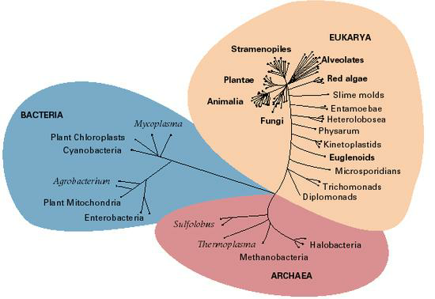
Domains
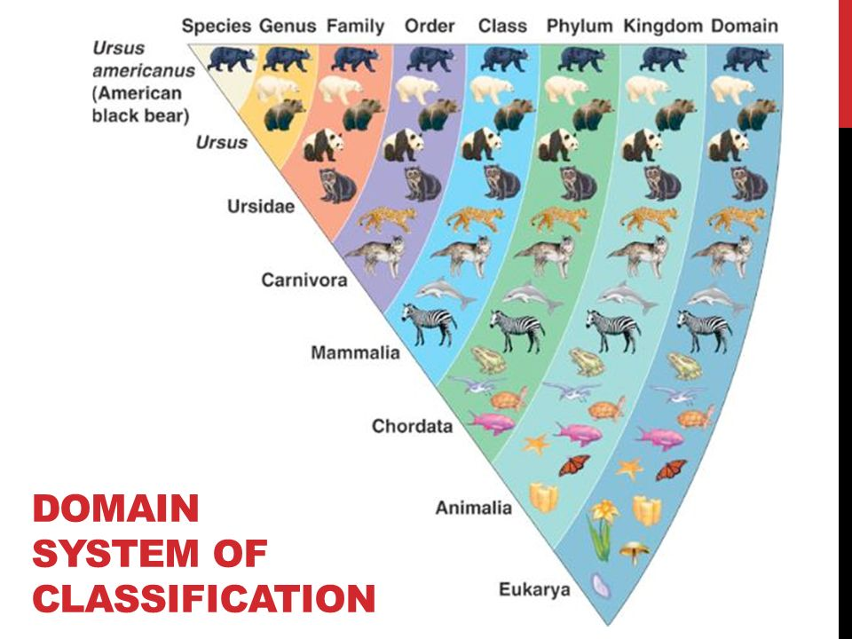

Domain Archaea
- This includes one Kingdom: ________________________________.
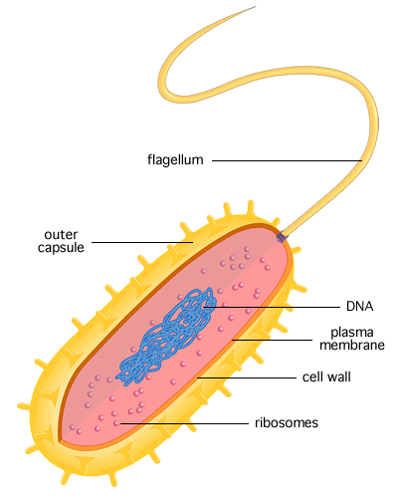
- They include forms of bacteria today that live in the most _______________________ such as hot springs and sulfur pools.
- Examples include:
  - ___________________
  - ___________________
Characteristics:
- Type of cells: _______________________________
- Number of cells:__________________________ (microscopic)
- Mode of nutrition: some ______________________, some heterotrophic ______________________
- Cell structures: have a cell wall but lacking ______________________
- Oxygen use ________________ (_______________________________________________)
- ___________ unique to Archaea
- Live in ________________________________

Domain Bacteria
- Includes one Kingdom: ________________________
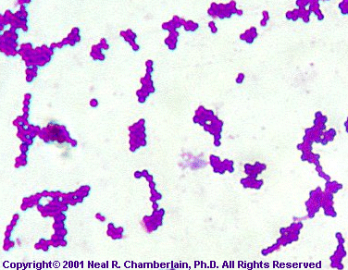
- They include most of the bacteria that we are familiar with such as E. coli (gut bacteria).

Characteristics:
- Type of cells: __________________________
- Number of cells: _______________________________ (microscopic)
- Mode of nutrition: some autotrophic, some heterotrophic
- Cell structures: cell walls contain ____________________
- Oxygen use ______________________(__________________________________________________)
- DNA unique to Eubacteria
- Live in ____________________________________ (almost everywhere!)

Domain Eukarya
- This is a huge domain that includes all the __________________________________ organisms.
- In this domain, we will see and use the more conventional 7 levels of classification.

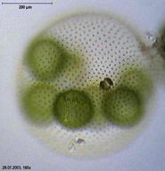
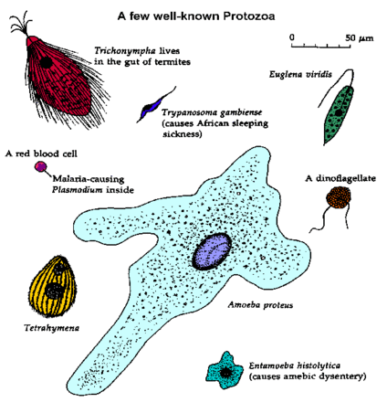
We divide domain Eukarya into four kingdoms:

Kingdom 1: Protista
- Type of cells: ________________________
- Number of cells: mostly__________________some colonial,
some multicellular
- Mode of nutrition: some autotrophic, some heterotrophic
- Cell structures: may have cell walls of _____________ or may
have chloroplasts
- __________
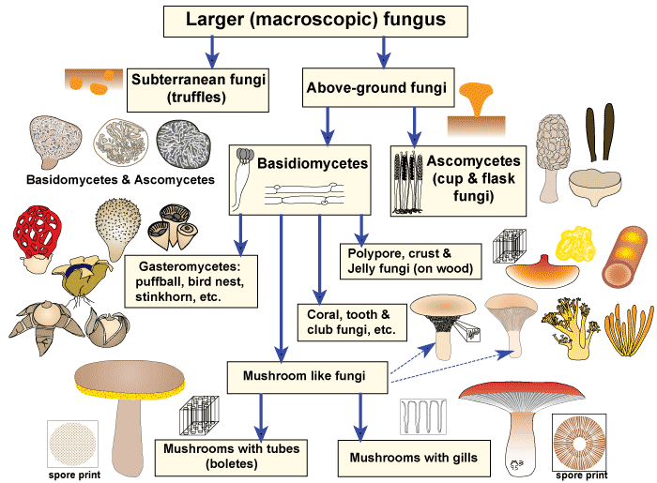
- “Catch-all” or "Junk Drawer" of the Kingdoms

Kingdom 2: Fungi
- Cell type: eukaryotic
- Number of cells: mostly multicellular, some unicellular
(such as yeast)
- Mode of nutrition: ________________________
- Cell structures: cell walls made of _____________
- Non-motile
- ___________________________
- Produce ______________________
Kingdom 3: Plantae
- Type of cells: eukaryotic
- Number of cells: ______________________
- Mode of nutrition: ______________________
- Cell structures: have _____________________ and cell walls
made of _________________________
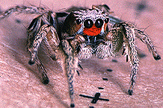
- ________________________________
- Asexual and sexual reproduction

Kingdom 4: Animalia
- Type of cells: __________________
- Number of cells: ___________________
- Mode of nutrition: _______________________
- Cell structures: _____________________ or chloroplasts
- ______________
- Sexual and asexual reproduction
- Largest group is the ________________________ = 70% of all animals
Conclusion
- Taxonomy shows us where a species________________________________________________
- Let’s use humans, chimpanzees, house cats, and maple trees as examples to illustrate this:

Examples of Taxonomic Classification
Humans Chimps House Cats Maple Trees
Domain Eukarya Eukarya Eukarya Eukarya
Kingdom Animalia Animalia Animalia Plantae
Phylum Chordata Chordata Chordata Tracheophyta
Class Mammalia Mammalia Mammalia Angiospermidea
Order Primata Primata Carnivora Sapindales
Family Hominidia Hominidia Felidia Aceridea
Genus Homo Pan Felis Acer
Species sapiens trogolodytes catus rubrum

- We use the _________________________ and ________________________ name to identify organisms.
Ex. __________________________________ , _______________________________________
Notice that the Genus is capitalized, and the species is not. The name should be in italics if typed or underlined if printed.

House Cat Lion
Domain Eukarya Eukarya
Kingdom Animalia Animalia
Phylum Chordata Chordata
Class Mammalia Mammalia
Order Carnivora Carnivora
Family Felidae Pantherinae
Genus Felis Panthera
Species catus leo

How do we identify lions? ____________________

Can You …
- …state the levels of classification and the man who created the classification system?
- … describe the 3 domains and the 4 kingdoms?
- … discuss the relatedness of organisms based on their classification?

