Biology 11 Algae & Bryophyta Name:

**Objectives:**

By the end of the lesson you should be able to:

* State the 3 types of algae **∙** Draw the fifecycle of a bryophyte
* Why we believe land plants developed from algae **∙** Give examples of bryophytes

**The First “Plants”:**

* For more than 3 billion years, Earth’s terrestrial surface was lifeless
  + life evolved in the seas
  + plant life evolved in the seas from ________________
  + 1st photosynthetic organisms were ______________ _____________ algae

**Chlamydomonas**



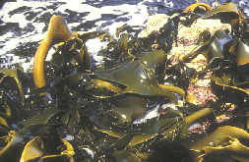

**Brown Algae:**

* Kingdom _____________________
* Phylum ________________________________
* Mostly marine and temperate

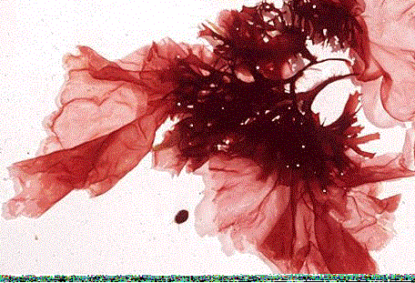**Red Algae:**

* Kingdom __________________
* Phylum ________________________
* Most common in warmer tropical waters
* In temperate zones, found in deeper water

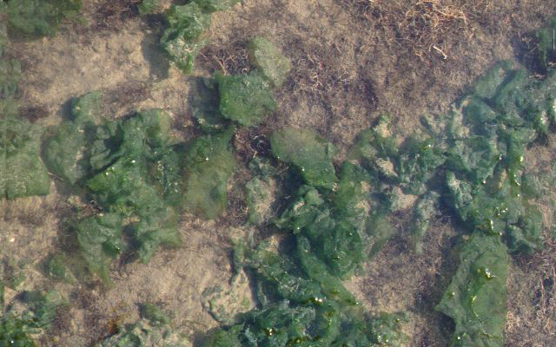**Green Algae:**

* Kingdom _____________________
* Phylum __________________________
* Very diverse group
* Include 3 forms:
  + _______________________
  + _______________________
  + _______________________
* Live in all environments: fresh and salt water, soil

1. 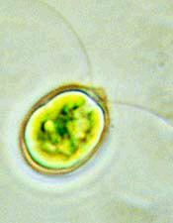**Unicellular Green Algae:**

* Very common in fresh water as part of ________________________.
* Ex. *_____________________________*

1. **Colonial Green Algae:**

* Live in long ____________________or as __________________ ___________________.

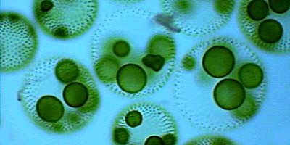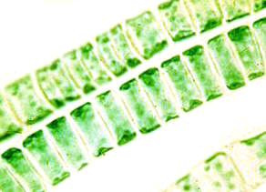

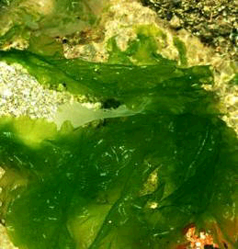

1. **Multicellular Green Algae:**

* Mostly _________________.
* __________________ of land plants

**Evolution of Land Plants:**

* 500 mya land plants evolved
  + special adaptations for life on dry land
    - protection from drying = ___________________
      * waxy ______________
    - gas exchange (through cuticle)
      * _________________
    - water & nutrient conducting systems
      * ______________ & __________________
    - protection for embryo
      * __________________

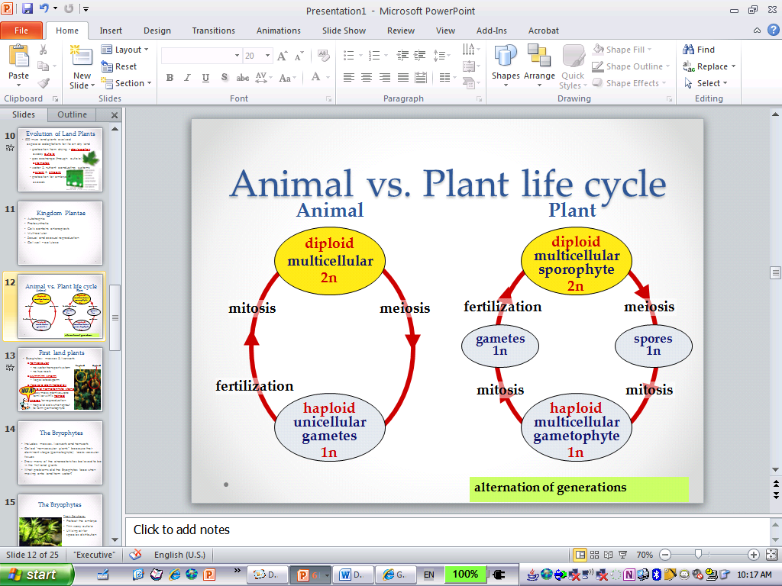

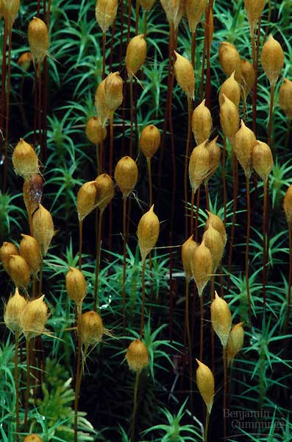**First Land Plants:**

* _____________________: mosses & liverworts
  + ____________________
    - no ______________ ____________________ system
    - no true _________________
  + _______________________________
    - flagellated sperm
  + lifecycle dominated by __________ ______________ stage
    - fuzzy moss plant you are familiar with is _________________
  + ______________ for reproduction
    - haploid cells which sprout to form ____________________

**The Bryophytes:**

* Includes: ________________________________________
* Called “__________________________________” because their dominant stage (___________________) lacks vascular tissues
* Show many of the characteristics believed to be in the first land plants
* What problems did the Bryophytes face when moving onto land from water?

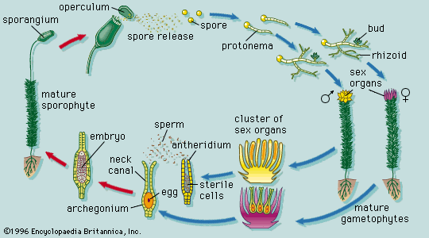**Typical Life Cycle:**

* Utilize ______________________________ from algae
* **Gametophyte** (n) shows two distinct sexes: the ________________________________ and the ________________________________________
* This is the ______________________stage (________________________) and is involved in _____________ reproduction

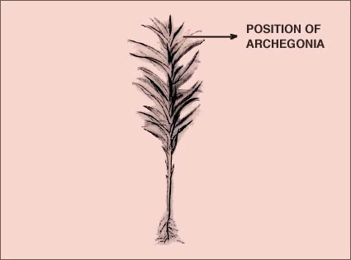**The Archegonium:**

* This is the _________________shoot
* It contains the ________________________(at the top of the shoot) which is:

- ___________________

- ___________________ (n)

- produces by ______________ and contains the _____________

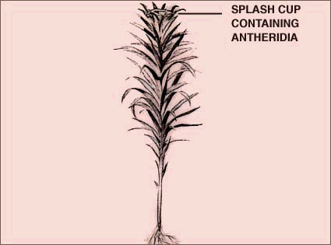**The Antheridium:**

* The_________________ gametophyte, the __________________(top of shoot), is:

- __________________

- _________________ (n)

- produces _____________________________ by ____________

* _________________________ occurs when there is enough water for the ___________ to swim to the ________ (in the archegonium)

**The Sporophyte:**

* ______________________ results in a ____________________________ which grows out of the ___________________ and forms a __________________________________
* Sporophyte contains _________________ tissue
* It produces ________________, ______________ borne spores by _________________

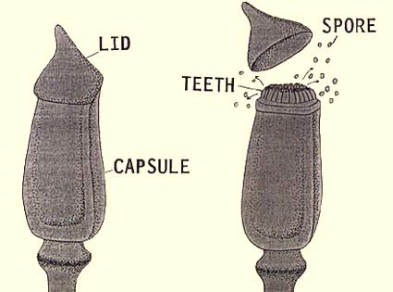

These _______________then germinate to form the _______________________________

