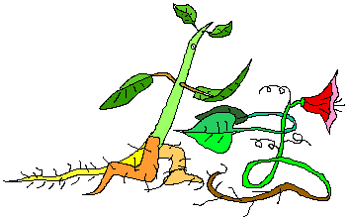
Biology 11 Amazing Plant Race! Name:

Welcome to the Amazing Plant Race! You are a Race Official in the Amazing Plant Race. There are 8 contestants competing in 6 locations around the world. At each location your job is to eliminate a contestant and explain why.
Note…at one location there is a double elimination…Sooooo VERY exciting!!!

Contestants of the 2012 Amazing Plant Race:

- Carl Corn Stalk

- Hank Hornwort
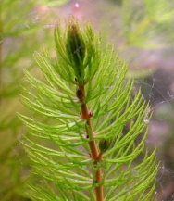
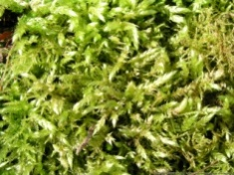
- Max Moss

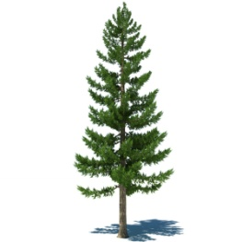
- Peter Pine Tree

- Gary Ginkgo
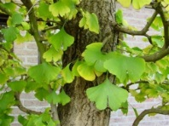

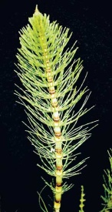
- Holly Horsetail

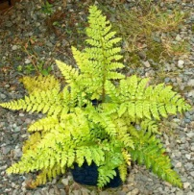
- Fern

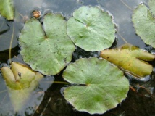
- Lily Pad

Locations of the 2015 Amazing Plant Race:
- The race starts in a farmer’s field in Saskatchewan, Canada ….who will be eliminated and why?
- Peat Bog in northern Scotland ….choose the next contestant to be eliminated and explain why.
- Xinjiang Semi Desert, China ….who doesn’t make it past this location and why?
- African Savannah...this is the double elimination!! Which two contestants are eliminated and why?
- Amazon Rainforest, Brazil ….which contestant will be eliminated in the semi-final and why?
- The final location is the Honolulu, Hawaii….which contestant WINS at this location and why?

Post-Race Analysis:
- If the locations had been reversed, would you have chosen a different winner? Why or why not?
- Would you expect each student in the class to choose the same winner as you did? Why or why not?
- Can you think of a plant that was not chosen as a contestant that would be a better winner than the one you chose? If so, which plant and why?

Official Payment Plan:
Each elimination explanation is worth 4 Race Dollars; increased detail and reasoning will earn you more Race Dollars up to the maximum of 4 Race Dollars per explanation. The final winning explanation is worth 6 Race Dollars. Post-Race Analysis is worth 5 Race Dollars. The total possible payment allotted for this race is 35 Race Dollars. Best of Luck!

Amazing Plant Race Results: Official Payment Plan
Name:
Round 1 Elimination: ___________________________
Explanation:

Round 2 Elimination: ___________________________
Explanation:

Round 3 Elimination: ___________________________
Explanation:

Round 4 DOUBLE Elimination: ___________________________ and ___________________________
Explanations:

Round 5 Elimination: ___________________________
Explanation:

Round 6 Elimination: ___________________________
Explanation:

Post-Race Analysis #1

Post-Race Analysis #2

Post-Race Analysis #3

