Phylum Annelida: The Segmented Worms

What is an Annelid?
- Annelids are worms with ___________________________________________
- Their name comes from the Latin annellus which means ‘little ring’
- Annelida is the first phylum with a _____________________ – a body cavity surrounded in mesoderm
- Along with Arthropoda and Mollusca, Annelida are considered ___________________________, which means they develop mouth first in early development
- While considered less advanced than the Deuterostomes, these phyla are the dominant animals on Earth today
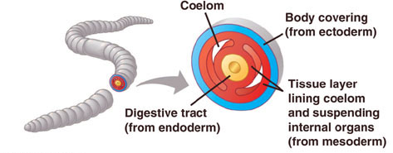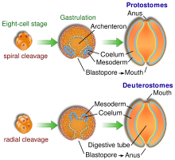
Body Plan
- Like flatworms and roundworms, annelids develop from three germ layers – triploblastic
- At this point in animal evolution, a ______________________________ developed. So there is mesoderm - and therefore muscle - around the skin and the gut
- Tube-within-a-tube ___________________________________________________ – coordinated digestion and specialization of the food tube begins
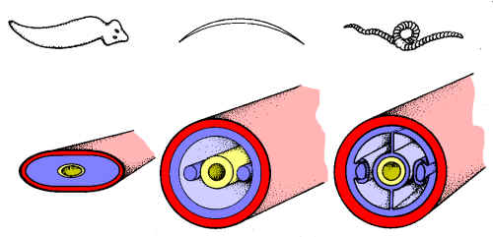

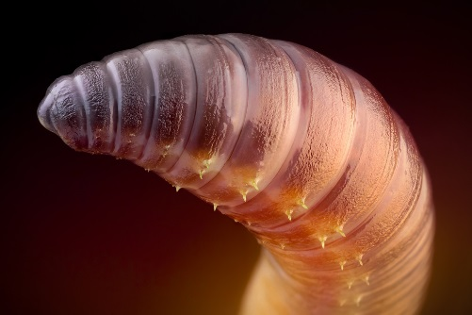
- Segmented bodies separated by _______________________ (internal walls) which may be modified to perform special functions ie. segments for eyes, antennae, excretion etc
- _______________________________________ may line the ventral side of the worm to aid in movement

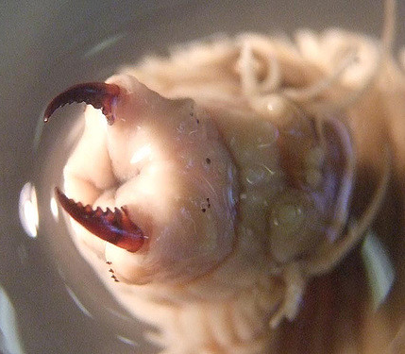
Feeding and Digestion
- Diverse feeding methods from filter feeders to predators
- Carnivorous worms such as _______________________________________________ have sharp jaws
- Decomposers may use a sticky mucous covered pharynx to feed on decaying vegetation while others filter out food particles in water in a mucous bag
- ________________________________________________ feed on the blood of the host
- Earthworms have a _______________________ to move food and soil into the ___________________
- Food moves to the __________________________________ then muscular _____________________ into smaller pieces before being absorbed in the intestine
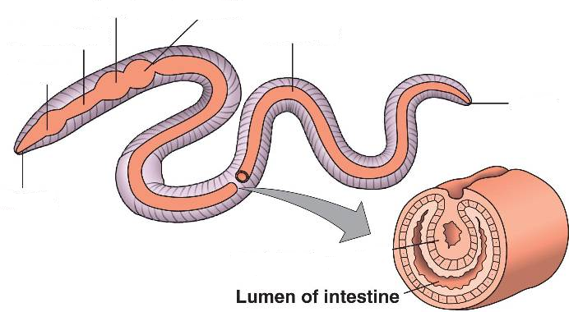

Circulation
- First phylum to have a circulatory system - frees them from diffusion of materials - can grow larger.
- ________________________________ where blood is contained within a network of _____________
- Also have “hearts” or sets of _________________________ that pump blood through dorsal and ventral blood vessels that run the length of the body
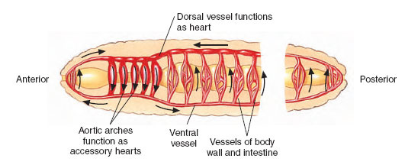

Respiration
- Aquatic annelids often ___________________________________ which exchange gases underwater
- Terrestrial annelids must stay moist as they still rely on _________ through their skin for gas exchange
Excretion
- Have specialized excretory units called _____________________ in pairs in each segment
- Used as a ___________________________________________________________________
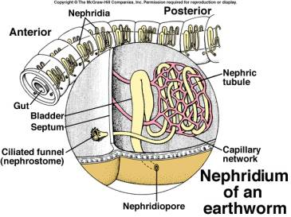
Response
- Nervous system has a ____________________________________________________________
- There are many adaptations for detecting stimuli including sensory tentacles, chemical receptors, statocysts for balance and ocelli for detecting light
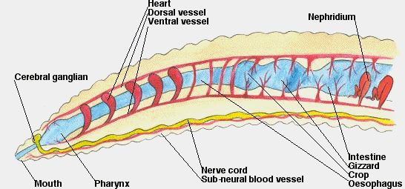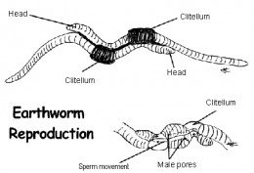
Movement
- Hydrostatic skeleton with two groups of body muscles which contract to make the worm shorter and fatter or longer and thinner
- By alternately contracting these muscles, and ____________________________________________, burrowing annelids can move through the ground
- Marine annelids have _______________________________________________________ (“foot-like”)
Reproduction
- Usually sexual reproduction with separate sexes and external fertilization
- Specialized region called the ________________________________________________________ where fertilization takes place then forms a protective cocoon

Annelid Classes
There are three major classes of Annelids:
- Class _____________________________: ex. the _____________________________
- Class _____________________________: ex. the _____________________________
- Class _____________________________: ex. the _____________________________

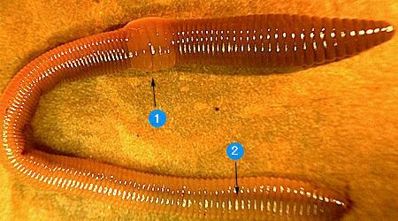
Class Oligochaeta
- “few hairs”
- Contains the earthworm
- Move using ________________(bristles)
- Fairly well adapted to land but must stay in moist environment
- Head is reduced as are obvious sense organs

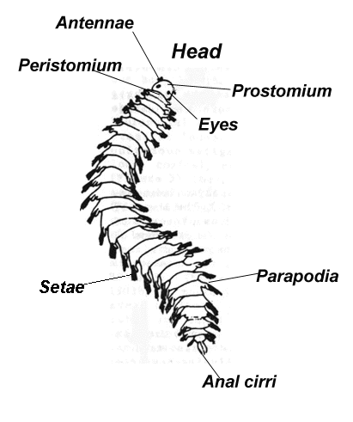
Class Polychaeta
- "many hairs"
- Contains “_____________________” that are modified setae
- Used as paddles (thus this class is marine) to move about - beginning of appendage development
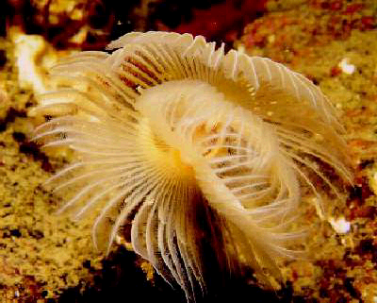
- Also used as _______________________________ - beginning of respiratory system
- Include sandworms and tubeworms

- The sandworm shows the parapodia development

Class Hirudinea
- _____________________
- These are __________________________ that feed upon the blood of vertebrates including us.
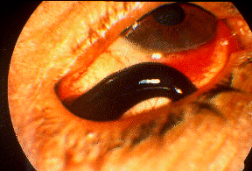
- Most common in fish
- Can be used for medical purposes

