Name: Date:

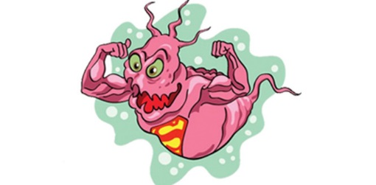**Arms Race with a Superbug**

Getting a bacterial infection is no big deal, right? Your doctor prescribes an antibiotic and you get well. Not so fast. Some bacteria—like *Acetinobacter*, aka Iraqibacter—have become resistant to commonly used antibiotics; some "superbugs" can withstand a host of different medications. A sobering case in point is *Staphylococcus aureus*. As this time line shows, strains of *Staph aureus* have gotten the better of every antibiotic we've developed, often within just a year or two of a new agent's introduction. Follow this ongoing arms race and learn about its unsettling implications below.

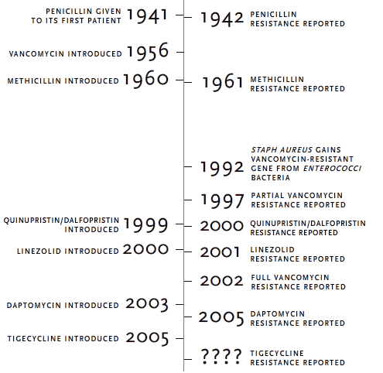

|  |  |
| --- | --- |
| **Evolution of Antibiotic Resistance:** |  |
|  |
| Forty or fifty years ago, thanks to antibiotics, scientists thought medicine had all but eradicated infectious agents as a major health threat. Instead, the past two decades have seen an alarming resurgence of infectious diseases and the appearance of new ones.   Today, the AIDS virus, tuberculosis, malaria, diarrheal diseases and other infectious agents pose far greater hazards to human existence than any other creatures.   This upsurge of infectious disease is a problem we have unwittingly created for ourselves. The rise of rapid, frequent, and relatively cheap international travel allows diseases to leap from continent to continent. Inadequate sanitation and lack of clean drinking water are another factor. A third is the "antibiotic paradox" -- the overuse of the "miracle drugs" to the point that they lose their potency.   Whenever antibiotics wage war on microorganisms, a few of the enemy are able to survive the drug. Because microbes are always mutating, some random mutation eventually will protect against the drug. Antibiotics used only when needed and as directed usually overwhelm the bugs. Too much antibiotic use selects for more resistant mutants. When patients cut short the full course of drugs, the resistant strains have a chance to multiply and spread.   In some countries, such as the United States, patients expect and demand antibiotics from doctors, even in situations where they are inappropriate or ineffective. Our immune systems will cure many minor bacterial infections on their own, if given the chance, and antibiotics have no effect on viral infections at all. Every time antibiotics are used unnecessarily, they add to the selective pressure we are putting on microbes to evolve resistance. Then, when we really need antibiotics, they are less effective.   While drug companies race to develop new antibiotics that kill resistant microbes, scientists are urging patients and doctors to limit antibiotic use.   That means not asking for penicillin when all you have is a cold, since colds are caused by viruses that are not affected at all by antibiotics. It means taking all the pills that are prescribed, even if you're feeling better. Physicians have to resist prescribing the strongest and most broadly effective drugs unless the disease absolutely requires it. If society adopts these measures rigorously, the drugs may regain at least some of their lost "miracle" powers. |

**How do Bacteria Become Resistant to Antibiotics?**

1. Populations of bacteria have lots of variation.

* Some more bacteria are more resistant to certain antibiotics than others.



    

Least Resistant ---------------------------------------------------------------------------------- Most Resistant

|  |  |
| --- | --- |
| 1. Antibiotics will kill the least resistant bacteria first. 2. After one day of treatment with antibiotics, the shaped bacteria all die. | 1. After four days of treatment with antibiotics, the , and shaped bacteria all die. |
| 1. The person is feeling much better after the fourth day of antibiotics and decides not to take the fifth day of antibiotics. 2. The most resistant bacteria, in this case the circular ones, are alive and begin to divide. | 1. By not finishing all five days of antibiotics, the individual has ______________________ microbes. This new population are all extremely resistant to antibiotics. The individual has selected for a population that is even harder to kill than the original population. 2. These bacteria can spread their resistance through horizontal gene transfer such as:   _________________________  _________________________  _________________________ |

