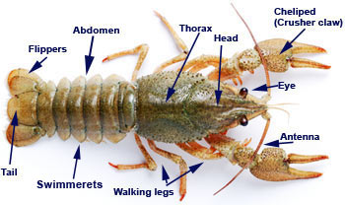
Phylum Arthropoda: Jointed Legs
What is an Arthropod?
- Most dominant animal phylum on Earth making up 75% of all animals
- Name comes from Latin ‘jointed foot’
- Segmented bodies with a _____________________________________
- ____________________________________ and ____________________________________
- Protostomes – develop mouth first in early development
- Examples include spiders, crabs, ants and centipedes

Body Plan
- Triploblastic coelomates
- Tube-within-a-tube
- Exoskeleton: made of hard non-living __________________________________; provides strength and protection; ____________________________________
- ____________________________________ to allow for movement
- ___________________________________: can be used for many purposes and adapted and modified
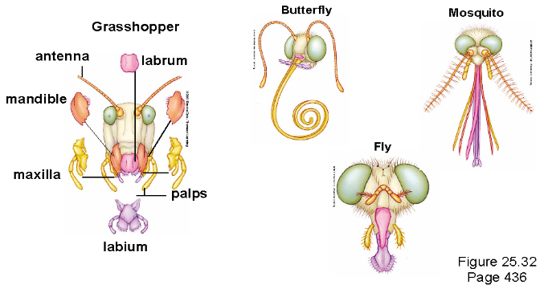
Feeding
- Hugely diverse phylum which includes herbivores to carnivores and filter feeders to parasites
- Arthropods have evolved ___________________ ___________________ such as jaws, pincers and boring drill like structures that allow them to eat almost any type of food you can imagine

Respiration
- Most aquatic arthropods such as crabs or lobsters use featherlike __________________ to breathe
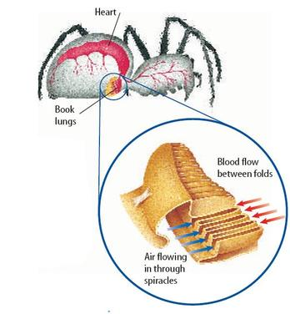
- Terrestrial arthropods such as grasshoppers use a network of branching _________________________ that extend throughout the body.
- Air enters the tracheal tubes through small openings on the side of the body called ________________
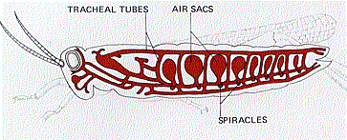
- Terrestrial arthropods such as spiders use ____________________________ for respiration.
- Book lungs are organs that have layers of respiratory tissue stacked like pages of a book
Circulation
- _____________________________________________________________________
- Blood leaves blood vessels into sinuses or cavities then collects in a large sinus surrounding the heart where it is pumped through the body
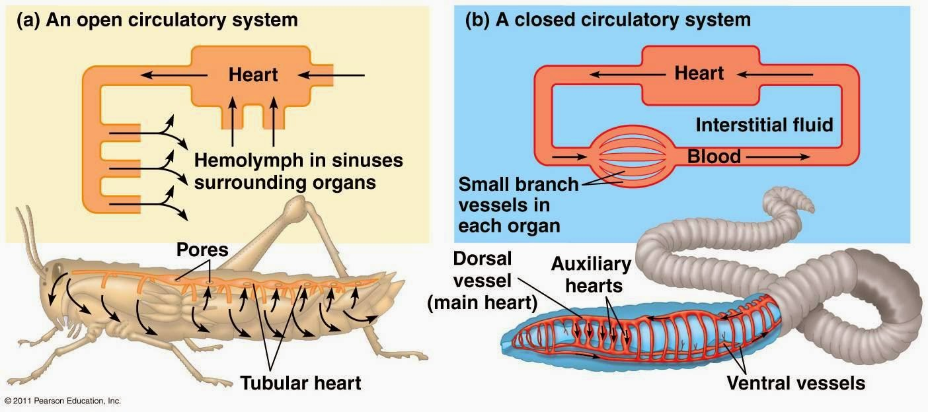
Excretion
- In terrestrial arthropods, excretion of cellular wastes such as ammonia by _______________________ – sacs which extract waste from the blood and add it to digestive wastes
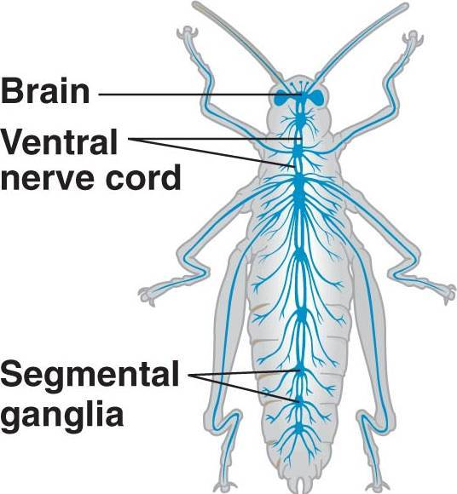
- In aquatic arthropods, excretion of cellular waste may be by diffusion or may be by kidney-like organs called _____________________________________ in organisms such as crayfish
Response
- Well-developed nervous systems with ____________________________ ___________________
- Several ganglia along the ventral nerve cord coordinate the movements of individual legs and wings
- Sophisticated sense organs such as _________________________________ that detect colour and motion to antennae which detect chemicals
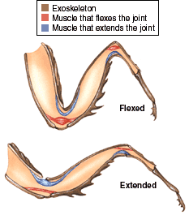
Movement
- Well-developed groups of muscles contract or relax when stimulated by the nervous system
- Different muscles _______________________________________________

Reproduction
- ____________________________________________________
- Fertilization is typically internal for terrestrial arthropods and aquatic arthropods may be internal or external
Growth and Development
- Exoskeletons do not grow as the animal grows, so arthropods undergo __________________________
- Molting is when the arthropod _______________________________________ and builds a larger one to take its place

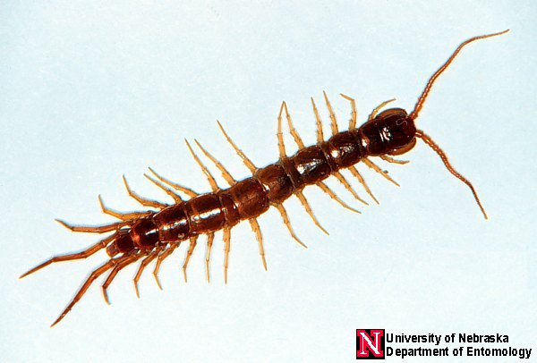
Class _______________________ - The Centipedes
Very annelid-like with repeating segments
Setae are modified to crude appendages - ____________________________
Body segments have __________________________

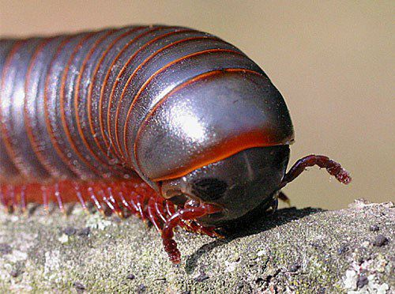
Class _______________________- The Millipedes
Very annelid like but have an exoskeleton
________________________________________
Body segments have ___________________________

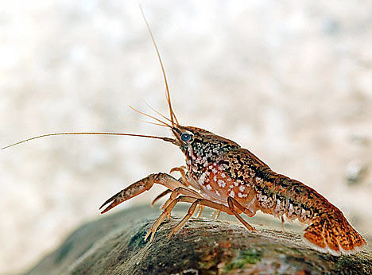

Class _____________________
Development of body regions: ___________________________
Have fused head and thorax called a “_____________________”
Show major increase in segment specialization and many specialized appendages
Excellent ____________________________________________
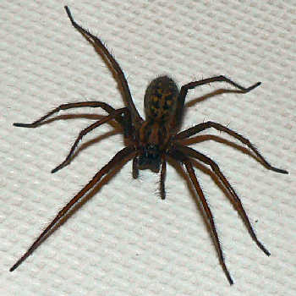
Class ____________________________
________________,______________________, ticks and mites
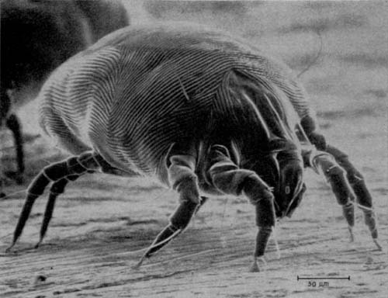
Also have a fused cephalothorax but have 4 pairs of legs (an additional pair as mouth parts)
Use ____________________________________
Are all predators or parasites

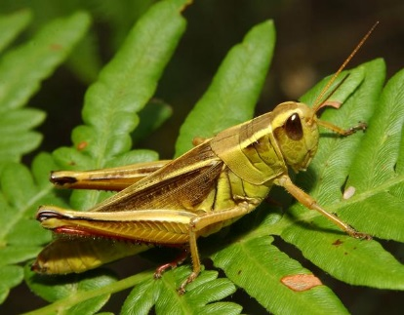
Class _____________________________________
Compose about 65% - 70% of the animal kingdom
Have three separate body regions and three pairs of legs
__________________________________________
Respiration with tracheal tubules, excretion by malpighian tubules

Why are the insects so successful??  1. __________: tiny to minute - don’t eat much, can hide  2. ____________________: hard, yet great strength  3. _____________________ - don’t eat much  4. Reproduction: all sexual - _________________  5. _______________________: many advantages | 6. Specialized _______________: eat many things  7. Adaption of exoskeleton: _______________ etc  8. Well-developed ___________________  9. Evolved ______________________________  10. Very specific _______: minimizes competition
