Arthropoda Quiz
/27
Name: Date:
- Phylum Arthropoda is the largest on Earth (True/False) (1 mark)

- List 4 of the 5 classes in Phylum Arthropoda and state one example organism of each. (4 marks)

- List 3 characteristics/advancements of Arthropods and EXPLAIN them. (3 marks)

- List 4 reasons (remember from your notes!) why insects are so successful. (4 marks)

- Label the external anatomy of the crayfish. (6 marks - ½ mark each – one line with no value)
WORD BANK (you will NOT get one for the test!) Abdomen, antennae, antennules, carapace, cephalothorax, cheliped, eye, rostrum, swimmerets, tail fan, telson, uropods, walking legs
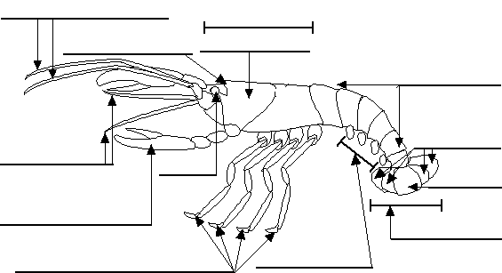

- What would you expect to find (in terms of organs and structures) inside the cephalothorax of a crayfish? List 4 things you could find. (4 marks)

- What type of respiratory system do spiders possess? How is it different from a grasshopper's respiratory system (ie. What type of respiratory system do grasshoppers have)? (2 marks)

- Malpighian tubules in insects and green glands in crayfish have a similar function. What is this function? (1 mark)

- Arthropods have exoskeletons made of ______________. One downfall of this type of skeleton is that they

have to _________________ in order to grow a new larger exoskeleton. (2 marks)

