Life Sciences 11 Microbiology: Bacteria Basics Name: Date:
Introduction
- The _____________________________ are found almost everywhere on Earth - they live anywhere that life can physically survive
- They are ______________________________________ - their importance cannot be overestimated
- They also cause some of our major diseases
Taxonomy
- Recall that there are 3 domains:
  - ________________________: prokaryotic cell; “___________________” bacteria
  - ________________________: prokaryotic cell; ancient bacteria, ______________________
  - Eukarya: eukaryotic cells
Domain Bacteria - Kingdom Eubacteria
- ___________________________________; just visible with a light microscope
General structures:
- A _____________________ (not like a plant! It's made out of ____________________ not cellulose!)
- A ____________________________________ (protective layer, decides what goes in/out)
- ______________________________ ("jelly")
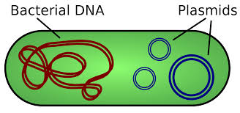
- A ____________________________________________
- Ribosomes (__________________________________________)
Other Structures:
- ______________________

  - A _____________________________________________ separate from the chromosomal DNA which can replicate independently and be _________________ between bacterial cells

- ________________________
  - Used for _____________________
- Pili
  - Used for ___________________________________________________, in
_______________________________ from one cell to another, small
movements and cell-cell adhesion
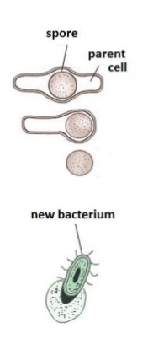
- Capsule
  - These are non-protein ____________________________________ outside of a bacteria cell
- ______________________
  - Endospores are tough coated structures that contain a ______________________________
  - Endospores can remain dormant waiting for more favourable growth conditions

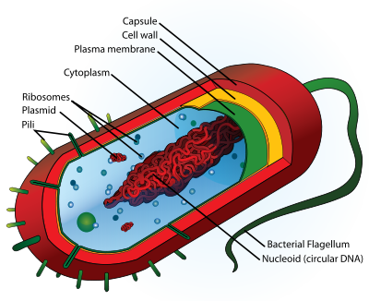
Typical Prokaryotic Cell

Form and Arrangement
- Form: the _________________ of the bacteria
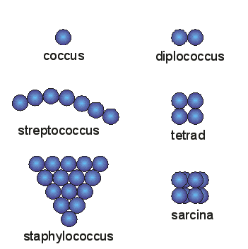
- Arrangement: how the bacteria are _________________________________
- Forms and Arrangement
FORMS:
1. _____________________
- Cell form (shape) is a __________________

2. ______________________
- Cells are longer than wide (_________); typically solo, in pairs or chains
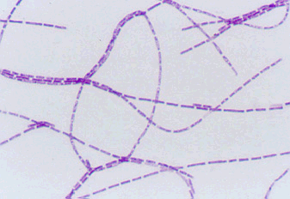
3. ___________________________________
- Longer than wide and _______________
- Most are __________________ and in a single arrangement
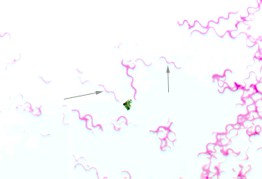
Can you …
… state the classification of bacteria and why?
… describe the structures of bacteria?
… describe the form and arrangement of bacteria?

