Life Sciences 11 Bacteria: The Details Name: Date:
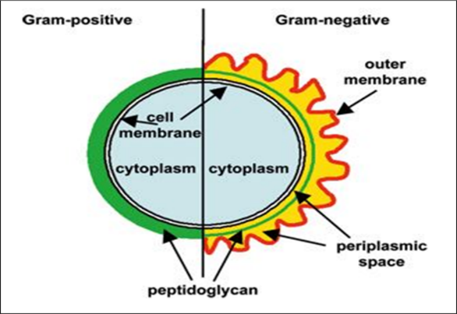
Types of Bacteria
A) __________________________Bacteria
- Have _________________________ with lots of _______________________
- __________________________________________; especially to Penicillin
- Appear __________________________________________
B) _________________________Bacteria
- Have _________________________ with ________________________________________ so are more
__________________________________________ especially Penicillin.
- Appear _______________________________ in Gram stain.
Penicillin, and other antibiotics, _______________________________________________________ molecules
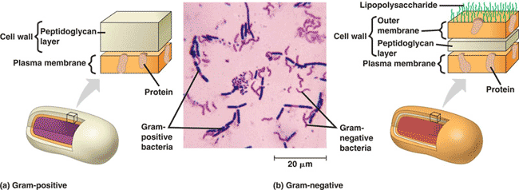

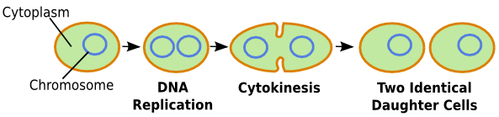
Reproduction
- Bacteria reproduce asexually via _____________________________
- However, bacteria can create new combination of genes through:
  - _______________________________: genes introduced _______________________ to bacteria
  - _______________________________: ____________________________ of genes between bacteria
  - _______________________________: genes taken up __________________________________

Modes of Nutrition
Prokaryotes need a ________________________ and _______________________ to survive.
- Carbon source: - ______________________________ (requires fixation of inorganic C source: CO₂)
- _____________________________ (requires organic C source: glucose)
- Energy source: - ________________________________ (from light)
- ______________________________ (from chemicals)
1. Autotrophic: ________________________________________ (require fixation of inorganic CO₂)
A) Photoautotrophs (photo = light, auto = self, troph = nourishment)
- Use _________________ energy with CO₂ to make organic compounds (ex. Carbohydrates – glucose)
- Ex. ________________________ (blue-green algae)

B. Chemoautotrophs (chemo = chemical, auto = self, troph = nourishment)
- Use CO₂ as a carbon source and energy from ____________________________ (instead of light) to make organic compounds (ex. Carbohydrates - glucose).
- Examples include:
- Using H₂S, _______________ bacteria - Using CH₄, methane fixers
- Using NH₃, ______________ bacteria - Using Fe⁺³, iron fixers.

2. Heterotrophic: ________________________________________________ require an organic C source – glucose
A) Photoheterotrophs: (photo = light, hetero = (an)other, troph = nourishment)
- require light energy to make ATP (cell usable energy) and an organic food source; very few prokaryotes do this!
B) Chemoheterotrophs: (chemo = chemical, hetero = (an)other, troph = nourishment)
- ________________________________________________________; most widely used method by bacteria!
Mode of Nutrition | Energy Source | Carbon Source | Types of Prokaryotes
Photoautotrophs
Chemoautotrophs
Photoheterotrophs
Chemoheterotrophs
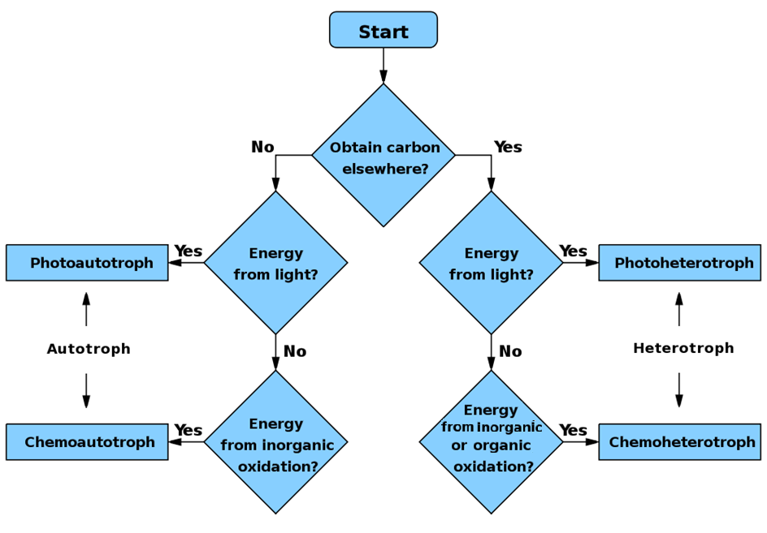

Chemoheterotrophs and Oxygen
Believe it or not, but not all bacteria require O₂ to live!
- ___________________________________: _________________________ to grow and for cellular respiration
- ______________________________________: will use O₂ ______________________________ but can grow by fermentation (without O₂)
- ______________________________________: ____________________________! Grow by fermentation
Importance of Bacteria
- Importance of bacteria can be divided into two categories from a human prospective: Pros and Cons
1. Beneficial Aspects (Pros) 2. Harmful Aspects (Cons)
- __________________ A. ___________________
- ____________________________ B. _________________________
- Industrial Uses C. __________________________
- Part of animals first line of defense
- ______________________________
Importance of Bacteria: Pros
A) Decomposition:
- _____________________________________ so the nutrients can be reabsorbed by other living organisms
B) Recycle Inorganic Nutrients
- N₂ fixers are bacteria that ________________________________________________________ which _______ _______________________ and use to make proteins and nucleic acids
C) Industrial Uses
a) ___________________ c) Tobacco curing
b) ___________________ d) Antibiotics
D) Part of the first line of defense
- Bacteria ___________________________________________________
- Bacteria also live in our gut
E) Genetic research
- Bacteria are ___________________________________________________________ - ideal for genetic studies
- Used to figure out many biochemical pathways and basic patterns of gene control
Importance of Bacteria: Cons
A. Destruction of Food
- Bacteria ______________________________________________ (one of our two main competitors)
- We have learned to use technology to reduce bacteria food spoilage
B) Rotting Structures
- Bacteria destroy many things we want preserved
C) Diseases: Bacteria can __________________________________________________________________________
Ex. Botulism - 1 g of botulism toxin could kill one million people!
Other examples, Can cause _____________________, ______________, ________________, damage to circulatory system and sometimes fatal allergic reactions (ex salmonella, E.coli)
Bacterial Resistance
- A classic example of evolution is unfolding today as we wage war against bacteria
- Due to _______________________________________________________, bacteria have developed an
_____________________________________________________ to antibiotics (HOW?)

Can You …

… describe the difference between Gram positive and Gram negative bacteria?
… describe how bacteria reproduce?
… describe 3 methods of horizontal gene transfer between bacteria?
… describe bacteria modes of nutrition & oxygen use?
… describe the pros and cons of bacterial existence?
… explain why and how bacterial resistance occurs?

