Bell Ringer – The Five Fingers of Evolution (5 Ways to Change the Gene Pool)
Match the diagrams with the proper vocabulary terms and definitions. Looking at colour on screen may help some diagrams. You can use each vocabulary term more than once. WORD BANK:
Genetic drift Gene Flow Natural Selection
Non-random mating (sexual selection) Mutation Gene Pool

Change in allele frequency due to a chance event.
The exchange of genes between two populations.
The movement of alleles from one population to another.
Consists of all the genes and their different alleles, present in an interbreeding population.
Those best suited to the environment survive and pass on their genes to the next generation.
A random change in the DNA (a copying error in meiosis) of an organism that can be passed down to the next generation.
A change in the gene pool due as a result of chance or random events such as natural disasters.
Mates are chosen based on selection criteria (colour, displays, size, song etc).
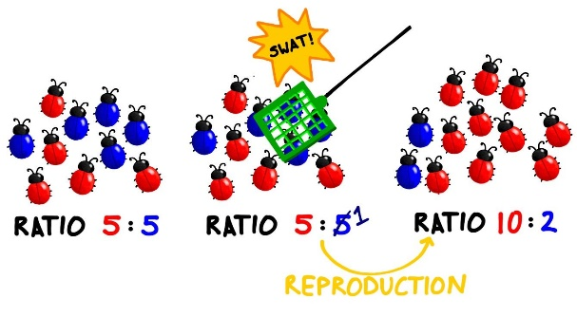
Harems: one male has many females that is mates with
