Date: Bell Ringer – Introduction to Biology Name:
- All life is made up of at least one or more cells – Give an example of a unicellular organism and a multicellular organism.

What does differentiation mean?

- Life must obtain and use materials and energy (Metabolism) – Give an example of an autotroph and a heterotroph.
Label the following with photosynthesis and cellular respiration
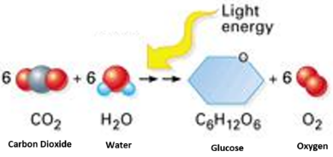

- Life g________________ and d _________________.

- Life reproduces itself – In asexual reproduction, hereditary information …

– In sexual reproduction, hereditary information …

- Life responds to its environment – Living things detect and respond to changes in their environment called _______

3 more characteristics of life to go on the back!

Date: Bell Ringer – Introduction to Biology Name:
- All life is made up of at least one or more cells – Give an example of a unicellular organism and a multicellular organism.

What does differentiation mean?

- Life must obtain and use materials and energy (Metabolism) – Give an example of an autotroph and a heterotroph.
Label the following with photosynthesis and cellular respiration

- Life g________________ and d _________________.

- Life reproduces itself – In asexual reproduction, hereditary information …

– In sexual reproduction, hereditary information …

- Life responds to its environment – Living things detect and respond to changes in their environment called _______

3 more characteristics of life to go on the back!

- Life adapts over time - evolves - to survive in its environment - What is the driving force behind evolution?

- Life maintains homeostasis – Give an example of homeostasis in the human body.

- Life is based on a universal genetic code – What does DNA code for? ie. It is a set of instructions to make …

- Label the drawings with the correct level of organization.
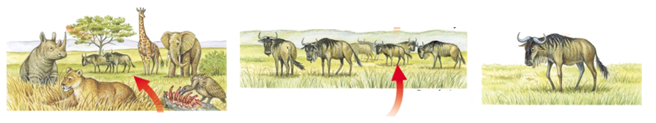

- Life adapts over time - evolves - to survive in its environment - What is the driving force behind evolution?

- Life maintains homeostasis – Give an example of homeostasis in the human body.

- Life is based on a universal genetic code – What does DNA code for? ie. It is a set of instructions to make …

- Label the drawings with the correct level of organization.

