Name: Bell Ringer Date:
Fill in the alternation of generations diagram:
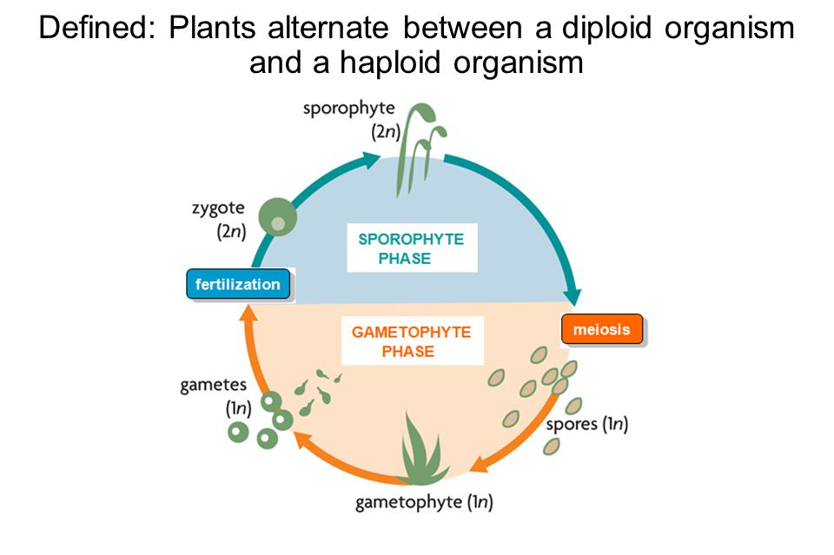
Word Bank: sporophyte, gametophyte, fertilization, meiosis, spores, gametes, zygote, gametophyte phase, sporophyte phase. Extra word that can be used multiple times – MITOSIS! Where does it happen? Which structures are haploid? Which structures are diploid?

Name: Bell Ringer Date:
Fill in the alternation of generations diagram:
Word Bank: sporophyte, gametophyte, fertilization, meiosis, spores, gametes, zygote, gametophyte phase, sporophyte phase. Extra word that can be used multiple times – MITOSIS! Where does it happen? Which structures are haploid? Which structures are diploid?

