Name: Bell Ringer Date:
- Match the structures and functions and label the diagram!
____ Ribosomes | A - Small, independently replicating, transferable circular DNA
____ Plasmid | B - 'Jelly' that makes up the cell interior – where metabolism takes place
____ Cytoplasm | C - Thick non-protein layer surrounding the cell
____ Plasma membrane | D - Contains the cytoplasm, determines what goes in and out of the cell
____ Endospore | E - Maintains the shape of the cell – structural support
____ Capsule | F - Protein synthesis
____ Pili | G - Attachment to solid surfaces, transfer of DNA from one cell to another and cell-cell adhesion
____ Cell wall | H - A free floating chromosome of DNA
____ Flagella | I - Tough coated structure which contains a full bacterial chromosome
____ Nucleoid | J - Used for movement

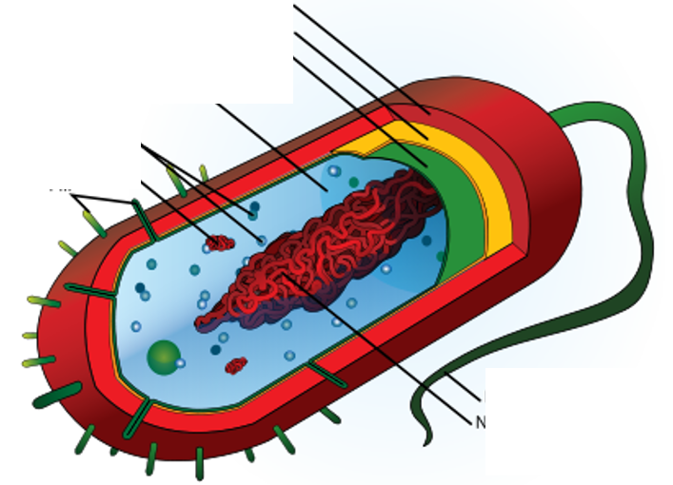

- What is the important p-word for the material that makes up the cell wall of bacteria?
Name: Bell Ringer Date:
- Match the structures and functions and label the diagram!
____ Ribosomes | A - Small, independently replicating, transferable circular DNA
____ Plasmid | B - 'Jelly' that makes up the cell interior – where metabolism takes place
____ Cytoplasm | C - Thick non-protein layer surrounding the cell
____ Plasma membrane | D - Contains the cytoplasm, determines what goes in and out of the cell
____ Endospore | E - Maintains the shape of the cell – structural support
____ Capsule | F - Protein synthesis
____ Pili | G - Attachment to solid surfaces, transfer of DNA from one cell to another and cell-cell adhesion
____ Cell wall | H - A free floating chromosome of DNA
____ Flagella | I - Tough coated structure which contains a full bacterial chromosome
____ Nucleoid | J - Used for movement

- What is the important p-word for the material that makes up the cell wall of bacteria?

