Name: Bell Ringer Date:
1. Which of the following is NOT a method of horizontal gene transfer (bacteria genetic exchange)?
a. Transduction b. Conjugation c. Binary Fission d. Transformation
2. Label each of the following using the words above, and explain what is occurring.
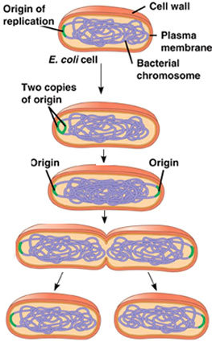
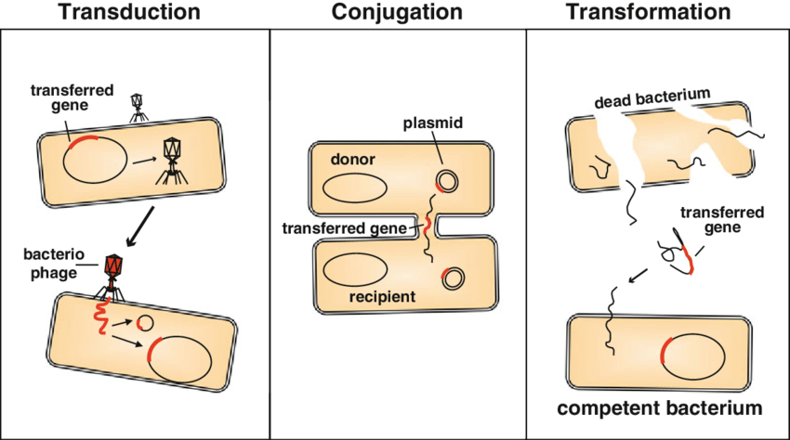

Name: Bell Ringer Date:
1. Which of the following is NOT a method of horizontal gene transfer (bacteria genetic exchange)?
a. Transduction b. Conjugation c. Binary Fission d. Transformation
2. Label each of the following using the words above, and explain what is occurring.

