Date: Bell Ringer – Biological Molecules Name:
Biomolecule | Main Elements | Monomer (single unit building block) | Types and Examples | Functions | Sketch | Foods to Eat | Other
Carbohydrates | ______ | _________ | Monosaccharides  – ex. Glucose  Disaccharides  – ex. Lactose  _____________  – ex. Cellulose  – Chitin  – Glycogen  – Starch | Energy for cells (used in cellular respiration to make ATP)  - Structural – used to make plant cell walls (dietary fibre)  - Structural – used to make exoskeleton of crustaceans such as crabs  - Short term energy storage in animals  - Short term energy storage in plants | __________________________ | Pasta, bread, rice, grain, potatoes | Before a big game, athletes often carbo-load to help improve performance
Lipids | C, H, O | **Glycerol & fatty acid** | ______________  Phospholipids  Steroids | Long term energy storage  ____________________________  Hormones (molecules that travel through the blood to affect cells around the body) |  | Oils, butter, meats, avocados | Lipids are fatty, waxy, or oily compounds that are insoluble in water
Proteins | C, H, O, N | ________ | Enzymes  Antibodies  Many structural proteins | Increase rate of chemical reactions  Immune system  Various functions | 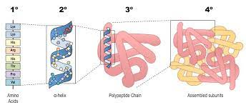 | Meats, eggs, dairy, fish, legumes | Amino acids are located in the cytoplasm of the cell  The difference between proteins is the sequence of the amino acids and how they are folded up
___________ | C, H, O, N, P | Nucleotide | DNA  RNA  ATP | Hereditary information  ________________________ | 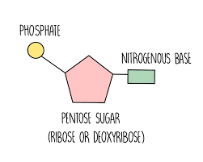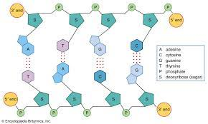  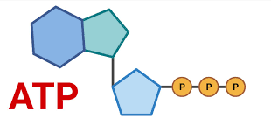 | _________ | DNA contains the information to build life  mRNA is a copy of a section of DNA that exits the nucleus  ATP stores energy in its high energy bonds

Biomolecule | Main Elements | Monomer (single unit building block) | Types and Examples | Functions | Sketch | Foods to Eat | Other
Carbohydrates | C, H, O | Mono-saccharide | Monosaccharides  – ex. Glucose  Disaccharides  – ex. Lactose  Polysaccharides  – ex. Cellulose  – Chitin  – Glycogen  – Starch | Energy for cells (used in cellular respiration to make ATP)  - Structural – used to make plant cell walls (dietary fibre)  - Structural – used to make exoskeleton of crustaceans such as crabs  - Short term energy storage in animals  - Short term energy storage in plants |  | Pasta, bread, rice, grain, potatoes | Before a big game, athletes often carbo-load to help improve performance
Lipids | C, H, O | **Glycerol & fatty acid** | Triglycerides  Phospholipids  Steroids | Long term energy storage  Cell membrane structure  Hormones (molecules that travel through the blood to affect cells around the body) |  | Oils, butter, meats, avocados | Lipids are fatty, waxy, or oily compounds that are insoluble in water
Proteins | C, H, O, N | Amino acid | Enzymes  Antibodies  Many structural proteins | Increase rate of chemical reactions  Immune system  Various functions |  | Meats, eggs, dairy, fish, legumes | Amino acids are located in the cytoplasm of the cell  The difference between proteins is the sequence of the amino acids and how they are folded up
Nucleic Acids | C, H, O, N, P | Nucleotide | DNA  RNA  ATP | Hereditary information  Cellular energy |  | Fruits, veggies, meats  ATP is made by the cell | DNA contains the information to build life  mRNA is a copy of a section of DNA that exits the nucleus  ATP stores energy in its high energy bonds

