Name: Bell Ringer Date:
- Complete the diagrams by filling in the boxes.

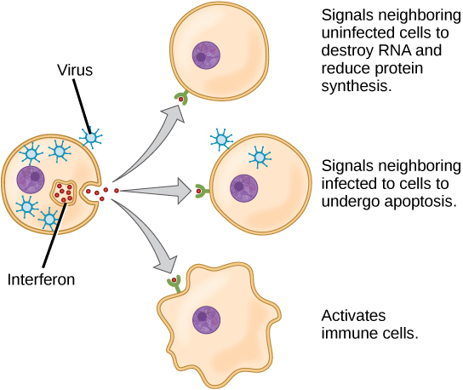

- Label the diagram below. Explain what is happening.
- Explain how a blood test would tell you if are immune to a particular pathogen.

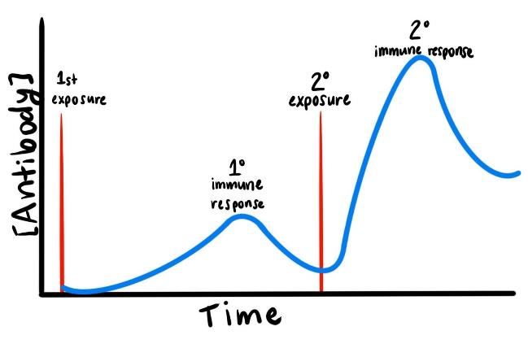
- Explain how a vaccine works with reference to this diagram.

- Is diagram A or B showing herd immunity? What is herd immunity?

