Bell Ringer Name:
Life Sciences 11 Date:

Which is a prokaryotic cell and which is a eukaryotic cell? State at LEAST two ways you can tell which is which. If you have extra time after doing the back side of this paper, add some structures and functions to this diagram.
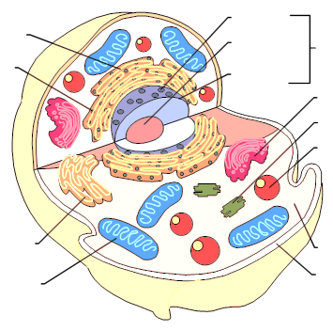

Bell Ringer Name:
Life Sciences 11 Date:

Which is a prokaryotic cell and which is a eukaryotic cell? State at LEAST two ways you can tell which is which. If you have extra time after doing the back side of this paper, add some structures and functions to this diagram.
This entire diagram is a NUCLEUS. What does a nucleus do? __________________________________________
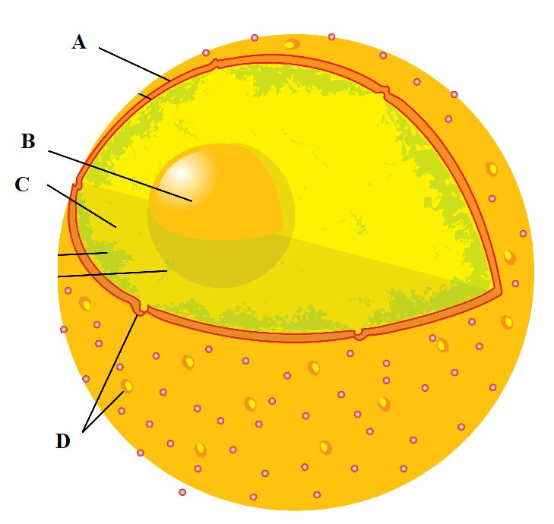
What are the structures and functions of the parts of the nucleus labeled A, B, C and D?

This entire diagram is a NUCLEUS. What does a nucleus do? __________________________________________
What are the structures and functions of the parts of the nucleus labeled A, B, C and D?

