Bell Ringer
Name: Date:
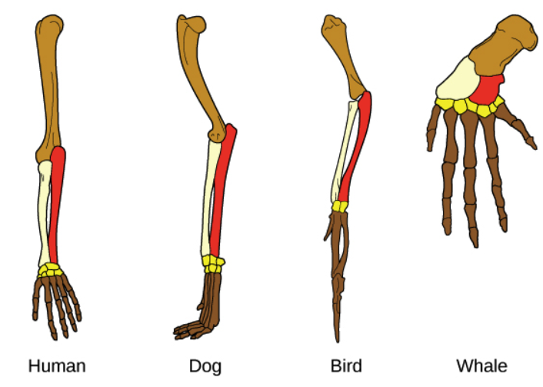
Give the name of each line of evidence and briefly explain what it is and its significance.

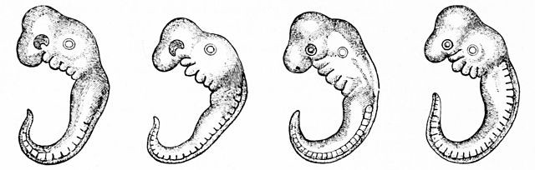

Embryos of four different species. From Left to Right; chicken, tortoise, pig, human.

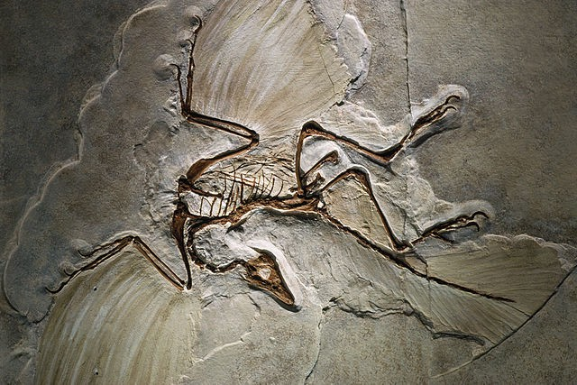

An Archaeopteryx fossil, an intermediary species between modern birds and dinosaurs.

