Bell Ringer Name: Date:
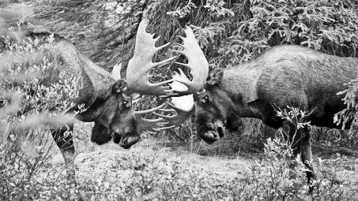
1. Two male moose fought over territory and a female. The moose on the left (A) was bigger, stronger, had more impressive antlers, ran faster, had healthier fur etc, and easily won the fight and the right to mate with the female. The moose on the right (B), lost the battle and moved to another territory where it struggled to find food and got weaker over time.
Moose (A) mated with the female, but she was infertile and they did not have any offspring. Moose (A) eventually died before producing any offspring.
Moose (B), although weak and in poor physical condition, found a mate and produced an offspring.

Which moose has the higher fitness and WHY?

2. Draw the graph after selection for the following scenarios. Label each with the appropriate type of selection and be sure to label your axes!!!
