Name: Bell Ringer – Gymnosperm Life Cycle Date:
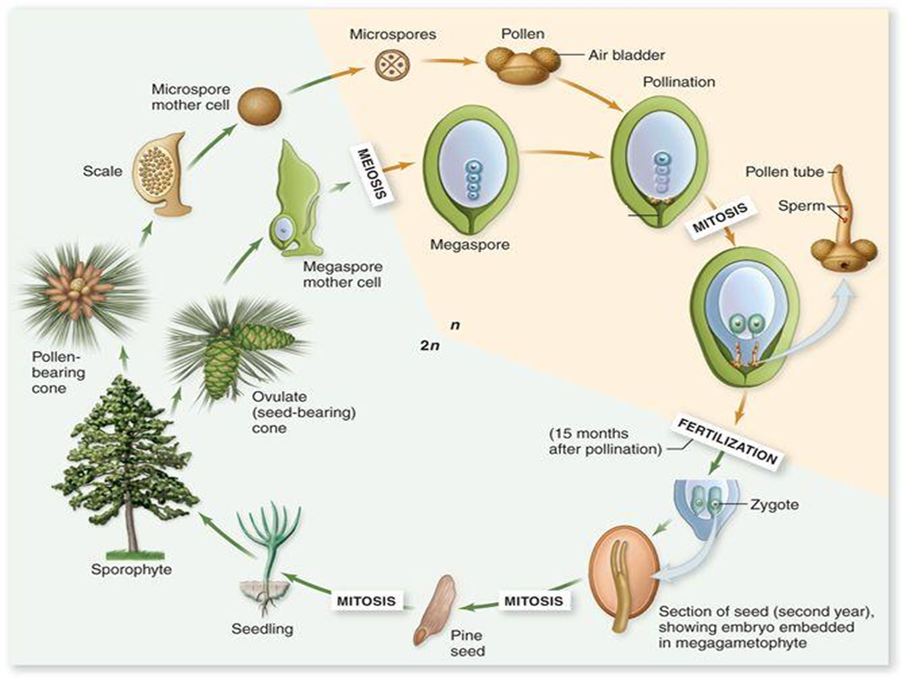
Name: Bell Ringer – Gymnosperm Life Cycle Date:

