Bell Ringer
Question: Does penicillin prevent infection?
Hypothesis: If the medicine prevents infection, then the medicine will prevent the growth of bacteria that cause infection.
Experiment: Carly placed ten same size circles of paper in a Petri dish (something used for growing bacteria). Five circles of paper were soaked in penicillin. The other five had nothing on them. She poured a liquid filled with bacteria into the Petri dish and evenly spread it out. The circles of paper were evenly spaced apart into the Petri dish.
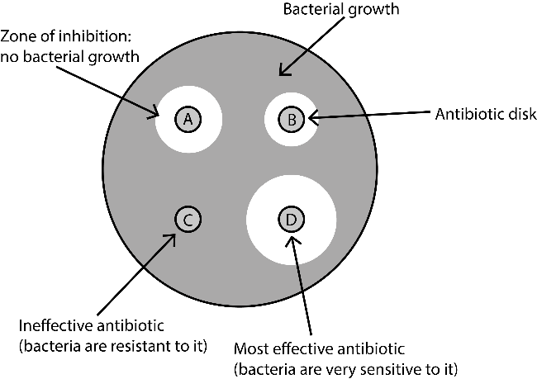
At the end of the experiment, circles with a radius of 2cm formed around the circles of paper soaked in penicillin. There were no bacteria growing inside the 2cm circle. No change had occurred around the other circles of paper which had not been soaked in penicillin. The bacteria were growing well.
- What was the independent variable?

- What was the dependent variable?

- What was the control group?

- What was the experimental group?

- What controls (or constants) are used in this experiment?

Bell Ringer
Question: Does penicillin prevent infection?
Hypothesis: If the medicine prevents infection, then the medicine will prevent the growth of bacteria that cause infection.
Experiment: Carly placed ten same size circles of paper in a Petri dish (something used for growing bacteria). Five circles of paper were soaked in penicillin. The other five had nothing on them. She poured a liquid filled with bacteria into the Petri dish and evenly spread it out. The circles of paper were evenly spaced apart into the Petri dish.
At the end of the experiment, circles with a radius of 2cm formed around the circles of paper soaked in penicillin. There were no bacteria growing inside the 2cm circle. No change had occurred around the other circles of paper which had not been soaked in penicillin. The bacteria were growing well.
- What was the independent variable?

- What was the dependent variable?

- What was the control group?

- What was the experimental group?

- What controls (or constants) are used in this experiment?

