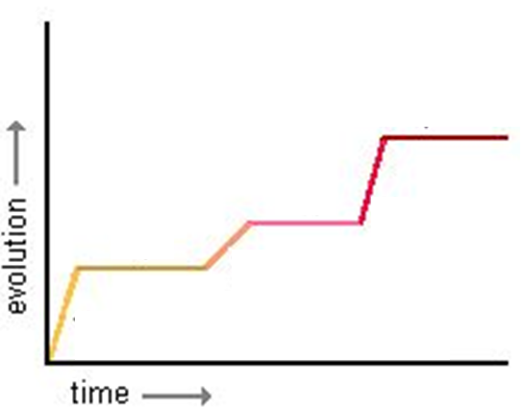
Bell Ringer Name: Date:
1. a) Label the diagram with rapidly changing environment and stable environment

b) Does this diagram represent Gradualism or Punctuated Equilibrium?

2. Which diagram shows a fossil record consistent with Gradualism? Which is consistent with PE?
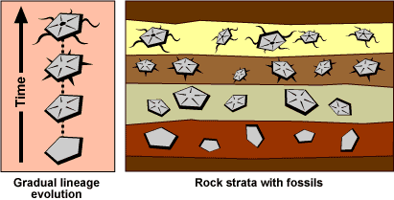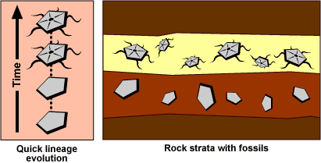
3. Which patterns of speciation are demonstrated by the following diagrams?
