Bell Ringer – Porifera Name: Date:
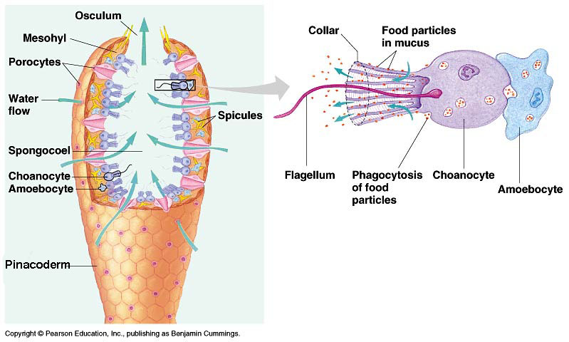
- Label the structures and functions of a typical poriferan. You will need to write very small!

- Why are sponges included in Kingdom Animalia?

Bell Ringer – Porifera Name: Date:
- Label the structures and functions of a typical poriferan. You will need to write very small!

- Why are sponges included in Kingdom Animalia?

