Bell Ringer – Protein Synthesis Name:
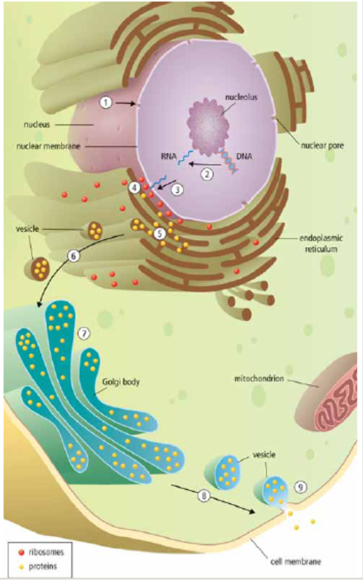
Science 9 Date:
Job #1: Label and colour the ribosomes and proteins (Think: Which is the cell producing to send out of the cell? Which is going to be going inside vesicles, Golgi body, etc?)

Job #2: Based on the scenario below, put the following statements in the correct order to produce a protein:
An organ in your body called your pancreas plays a vital role in chemically digesting your food. When partially digested food that has been ground up in your stomach reaches your small intestine, your small intestine releases a hormone called CCK that travels through your blood to your pancreas, causing it to produce pancreatic amylase (an enzyme to digest sugars), trypsin (an enzyme to digest proteins) and lipase (an enzyme to digest fats). Focusing specifically on the production of pancreatic amylase, what is the chain of events that causes a cell in the pancreas to produce and secrete out this enzyme?

___ The RNA now contains information (the instructions) to produce one protein (pancreatic amylase). This RNA message is small and can leave the nucleus through a nuclear pore.
___ The protein is put into a new vesicle for transport out of the cell. The vesicle is moved along the cytoskeleton until it reaches the cell membrane.
___The nucleus of a cell in the pancreas receives a chemical signal in the form of the hormone CCK which signals it to begin making a specific protein (pancreatic amylase)
___ The information to produce everything in the body is stored in DNA. The DNA information to build this specific protein (pancreatic amylase) is stored in a small section of the DNA called a gene. This gene is copied from the HUGE DNA into a new SMALL molecule called RNA. The DNA is left completely unchanged during this process.
___ The manufactured protein enters the ER and travels through a network of channels until it reaches the end.
___ The RNA message is delivered to the ribosome embedded in the rough endoplasmic reticulum. At the ribosome, a protein building factory, the information stored in the RNA is read like a recipe to produce the protein (pancreatic amylase).
___ A vesicle filled with the protein forms off the end of the ER. The vesicle is 'walked' along the cytoskeleton until it reaches the Golgi body.
___ The vesicle's membrane and the cell's membrane fuse together and release the protein (pancreatic amylase) out of the cell.
___The Golgi completes the protein by folding it and attaching other parts (such as sugars, fats, or other proteins) to it.
___ The completed protein is released from the pancreas and sent to the small intestine to digest your food.

Job #3: Check to see if your order is correct by looking at the back of this paper.

An organ in your body called your pancreas plays a vital role in chemically digesting your food. When partially digested food that has been ground up in your stomach reaches your small intestine, your small intestine releases a hormone called CCK that travels through your blood to your pancreas, causing it to produce pancreatic amylase (an enzyme to digest sugars), trypsin (an enzyme to digest proteins) and lipase (an enzyme to digest fats). Focusing specifically on the production of pancreatic amylase, what is the chain of events that causes a cell in the pancreas to produce and secrete out this enzyme?
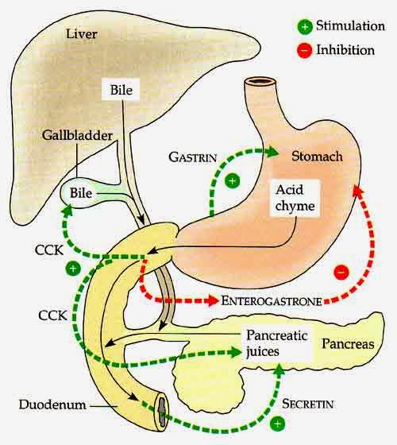
_3_ The RNA now contains information (the instructions) to produce one protein (pancreatic amylase). This RNA message is small and can leave the nucleus through a nuclear pore.
_8_ The protein is blebbed into a new vesicle for transport out of the cell. The vesicle is moved along the cytoskeleton until it reaches the cell membrane.
_1_The nucleus of a cell in the pancreas receives a chemical signal in the form of the hormone CCK which signals it to begin making a specific protein (pancreatic amylase)
_2_ The information to produce everything in the body is stored in DNA. The DNA information to build this specific protein (pancreatic amylase) is stored in a small section of the DNA called a gene. This gene is copied from the HUGE DNA into a new SMALL molecule called RNA in a process called transcription. The DNA is left completely unchanged during this process.
_5_ The manufactured protein enters the ER and travels through a network of channels until it reaches the end.
_4_ The RNA message is delivered to the ribosome embedded in the rough endoplasmic reticulum. At the ribosome, a protein building factory, the information stored in the RNA is read like a recipe to produce the protein (pancreatic amylase) in a process called translation.
_6_ A vesicle filled with the protein forms off the end of the ER in a process called blebbing. The vesicle is 'walked' along the cytoskeleton until it reaches the Golgi body.
_9_ The vesicle's membrane and the cell's membrane fuse together and release the protein (pancreatic amylase) out of the cell in a process called exocytosis.
_7_The Golgi completes the protein by folding it and attaching other parts (such as sugars, fats, or other proteins) to it.
_10_ The completed protein is released from the pancreas and sent to the small intestine to digest your food.

IN CORRECT ORDER:

- The nucleus of a cell in the pancreas receives a chemical signal in the form of the hormone CCK which signals it to begin making a specific protein (pancreatic amylase)
- The information to produce everything in the body is stored in DNA. The DNA information to build this specific protein (pancreatic amylase) is stored in a small section of the DNA called a gene. This gene is copied from the HUGE DNA into a new SMALL molecule called RNA in a process called transcription. The DNA is left completely unchanged during this process.
- The RNA now contains information (the instructions) to produce one protein (pancreatic amylase). This RNA message is small and can leave the nucleus through a nuclear pore.
- The RNA message is delivered to the ribosome embedded in the rough endoplasmic reticulum. At the ribosome, a protein building factory, the information stored in the RNA is read like a recipe to produce the protein (pancreatic amylase) in a process called translation.
- The manufactured protein enters the ER and travels through a network of channels until it reaches the end.
- A vesicle filled with the protein forms off the end of the ER in a process called blebbing. The vesicle is 'walked' along the cytoskeleton until it reaches the Golgi body.
- The Golgi completes the protein by folding it and attaching other parts (such as sugars, fats, or other proteins) to it.
- The protein is blebbed into a new vesicle for transport out of the cell. The vesicle is moved along the cytoskeleton until it reaches the cell membrane.
- The vesicle's membrane and the cell's membrane fuse together and release the protein (pancreatic amylase) out of the cell in a process called exocytosis.
- The completed protein is released from the pancreas and sent to the small intestine to digest your food.

