Name: Bell Ringer Date:

- Put these in order from biggest taxonomic category to smallest.
Species Domain Class Order Kingdom Phylum Family Genus

- What is the name of Bird Z?

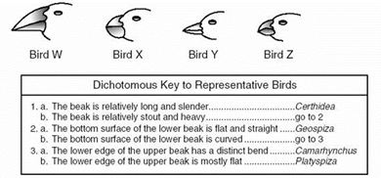

- Identify the Domain and Kingdom each of the following belong to:
 | Organism A | Organism B | Organism C | Organism D
Has nucleus | Yes | Yes | No | Yes
Has chloroplasts | No | Yes | No | No
Has cell wall | No | Yes (made of cellulose) | Yes (made of peptidoglycan) | Yes (made of chitin)
Number of cells | Multicellular | Multicellular | Unicellular | Most multicellular, some unicellular
Mode of nutrition | Heterotrophic | Autotrophic | Autotrophic or Heterotrophic | Heterotrophic

Organism A belongs to Domain ______________ and Kingdom ________________.

Organism B belongs to Domain ______________ and Kingdom ________________.

Organism C belongs to Domain ______________ and Kingdom ________________.

Organism D belongs to Domain ______________ and Kingdom ________________.

- The fact that you need oxygen to survive makes you an obligate anaerobe or an aerobe?

  - In trying to classify a newly discovered organism, the following characteristics were noted: multicellular, specialized tissues and organs, chlorophyll-containing structures and cell walls. Into which kingdom should this organism be placed?
    - Fungi
    - Protista
    - Eubacteria
    - Plant

  - Animalia, Fungi, Protista, and Plantae are the
      - scientific names of different organism
      - names of kingdoms of organisms
      - levels of classification
      - names of scientists

  - Which of the following statements is true of dichotomous keys?
      - They identify organisms by separating them into kingdoms.
      - The identify organism by comparing ancestors.
      - They identify organisms through analyzing scientific names.
      - They identify organisms based on descriptive statements.

