Biological Macromolecules

Date: Student Mostly Made of Macromolecules:
By the end of the lesson you should be able to:
- Recognize the structure of the 4 molecules of life
- State the function and give examples of the 4 biological macromolecules

4 Molecules of Life
- Besides water, a cell is mainly made up of 4 types of molecules
1. ______________________________________________________
2. ______________________________________________________
3. _______________________________________________________
4. _______________________________________________________
These molecules are composed mostly of four elements: C, H, O & N
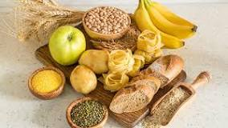
Carbohydrates

- Functions:
- ________________ for cell
- short term energy ______________
- _________________

- There are 3 types:
1. Monosaccharides
2. Disaccharides
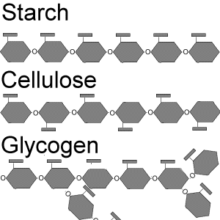
3. Polysaccharides

- ____________________________________ are a single unit of sugar
- If two monosaccharides are combined together, the result is called a ____________________________
- If there are many monosaccharides combined, the resulting molecule is a _______________________ . ___________________________ is an example of a structural carbohydrate at it forms ______________ ________________
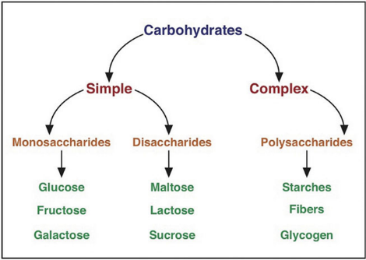
Examples of Carbohydrates

- Monosaccharides: _______________________, fructose, galactose
- Disaccharides: sucrose, ______________________, maltose
- Polysaccharides: starch, chitin, glycogen, _________________

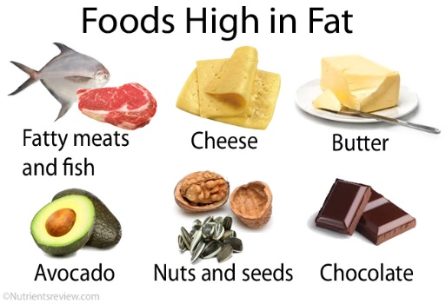
Lipids (Fats)

- Lipids are fatty, waxy, or oily compounds that are insoluble water

- There are 3 main types:
1. ____________________________: long term energy storage
2. __________________________: used to make cell membranes
3. __________________________: hormones

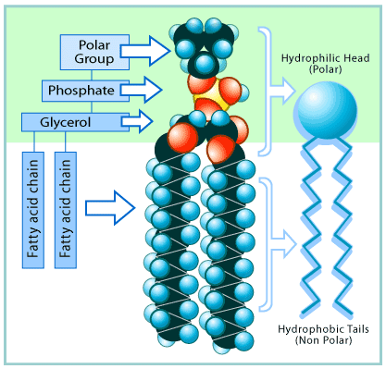
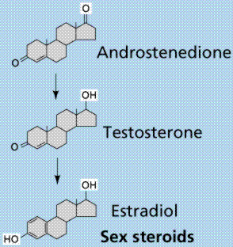
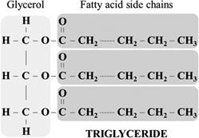

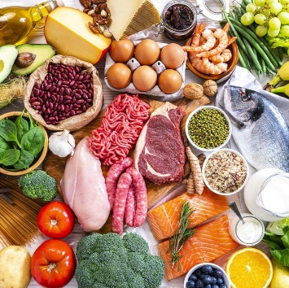
Proteins
- Proteins are _________________________ for muscle, cell structures, enzymes, I immune system (antibodies), etc …
- Proteins are made up of smaller units called _____________________________
- Amino acids are located in the cytoplasm (jelly) of the cell * remember for later! *
- The amino acids link together to form a chain
- These long chains of amino acids _______________________________________
- The difference between proteins is the sequence of the amino acids and how they are folded up
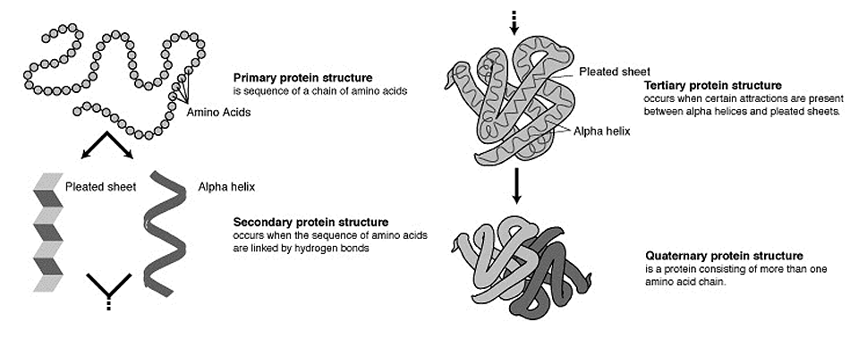

Nucleic Acids
- Nucleic acids contain _______________________________________.

- There are two types of nucleic acids used for heredity: __________________________

- A nucleic acid is made up of small molecules called _____________________ which include a base (ACTG&U), a sugar and phosphate group.

- Nucleotides are found inside the nucleus of a cell in the nucleoplasm * remember for later*

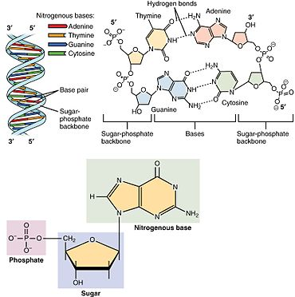
- Deoxyribonucleic Acid (DNA)
Largest molecule on earth!

Contains all the genetic information (a
____________) to build a living organism

Fits into the nucleus and is twisted into a
double stranded helix

- Ribonucleic Acid (RNA): there are 3 main types

1. Messenger RNA (mRNA) a _________
______________________ from the DNA
that exits the nucleus
2. Transfer RNA (tRNA) (Grade 12)

3. Ribosomal RNA (rRNA) (Grade 12 - makes ribosomes)

  - All are ________________________________ and help DNA make proteins

  - Has a U base instead of the T base

__________________________________________________ (ATP)
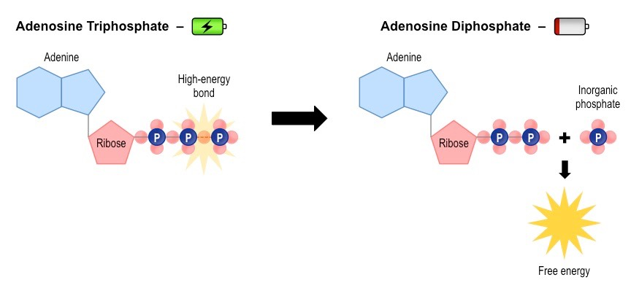
This is the _________________ molecule of life

There are 3 phosphate molecules bonded together

The last two have a lot of energy ____________

Can You …

… recognize the structure of the 4 molecules of life?

… state the function and give examples of the 4 biological macromolecules?

