Biological Macromolecules

Date: Student Mostly Made of Macromolecules:
By the end of the lesson you should be able to:
- Recognize the structure of the 4 molecules of life
- State the function and give examples of the 4 biological macromolecules

4 Molecules of Life
- Besides water, a cell is mainly made up of 4 types of molecules:
1. ______________________________________________________
2. ______________________________________________________
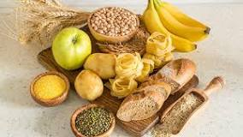
3. _______________________________________________________
4. _______________________________________________________
These molecules are composed mostly of four elements: C, H, O & N.

Carbohydrates

- Carbohydrates are _______ molecules and are your main source of ___________. You eat your carbs in the form of breads, cereals, rice, and pasta.

- The mitochondria in your cells use the sugar for ______________________ to make ________. ATP is the cellular energy that all cells use.
Carbohydrates are composed of the elements carbon (C), hydrogen (H), and oxygen (O).
They typically form 5 or 6 sided carbon rings.

- There are 3 types:
1. Monosaccharides
2. Disaccharides
3. Polysaccharides

- _____________________________ are a single unit of sugar.
- If two monosaccharides are combined together, the result is called a ________________.
- If there are many monosaccharides combined, the resulting molecule is a ___________________ .
Examples of Carbohydrates

- Monosaccharides: _______________________, fructose, galactose
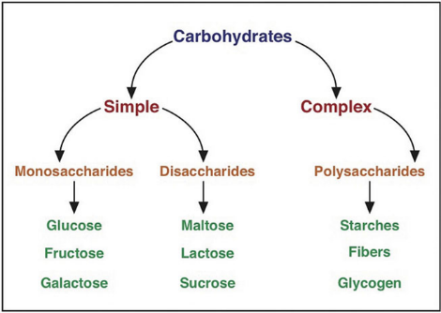
- Disaccharides: sucrose, ______________________, maltose
- Polysaccharides: starch, chitin, glycogen, _________________

Functions of Carbohydrates

- Simple monosaccharide sugars (such as glucose) and disaccharides (such as lactose) are used in cellular respiration to quickly make energy for cell in the form of ATP.
- Polysaccharides are more complex sugars and have two main functions:
- - short term energy ________________
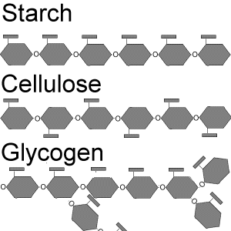
- - _________________

- _______________ and ______________ are examples of short-term energy storage polysaccharides.
- They are made of long branching chains of ____________ molecules which can be stored and saved for use in cellular respiration later.

- _____________________ is an example of a structural carbohydrate at it forms plant _____________.
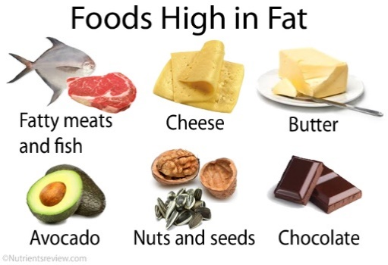
- ______________________ is an example of a structural polysaccharide as it forms ____________ cell walls and _____________________________.
Lipids (Fats)

- Lipids are fatty, waxy, or oily compounds that are insoluble in water. You eat your lipids in the form of butter, oils, cheese, meat fats, avocados, etc.
- Lipids are used for ____________________________________, insulation, ________________, and sending signals through the body.

- Lipids are composed of the elements C, H, and O.

- There are 3 main types:
1. ____________________________: long term energy storage, insulation (blubber) fat!
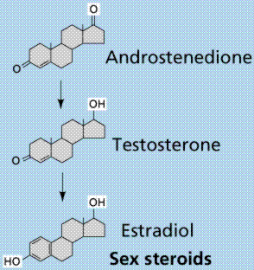
2. __________________________: used to make cell membranes
3. __________________________: hormones (signalling molecules)

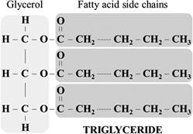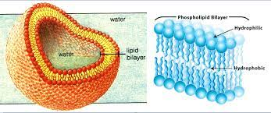

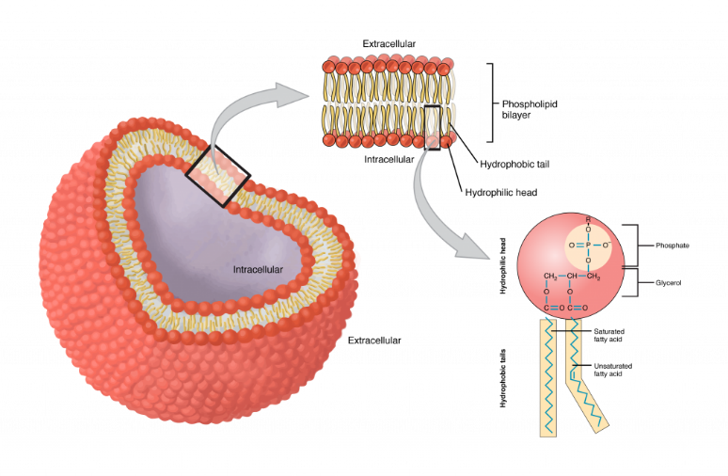
Phospholipids have a glycerol structure attached to two fatty acid tails and the one phosphate head.

One end of the phospholipid is attracted to water

(______________________) and the other end is repelled

by water (__________________________). This causes

phospholipids to automatically form a spherical ____________________ when placed in water.

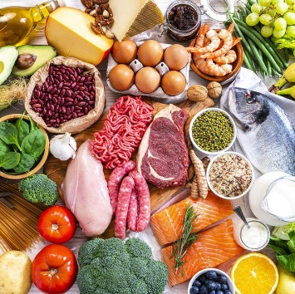
Proteins
- Proteins are _________________________ for muscle, skin, hair, bones, cell structures, enzymes, immune system (antibodies), and are responsible for the majority of functions of cells in the body. You eat your proteins in the form of meats, eggs, nuts, beans, etc.
- Proteins are primarily made up of the elements C, H, O, and nitrogen (N).
- Proteins are made up of smaller units called _____________________________.
- Amino acids are located in the cytoplasm (jelly) of the cell * remember for later! *
- The amino acids link together to form a chain.
- These long chains of amino acids fold up in a very specific way.
- The difference between proteins is the _____________________________ and how they are folded up
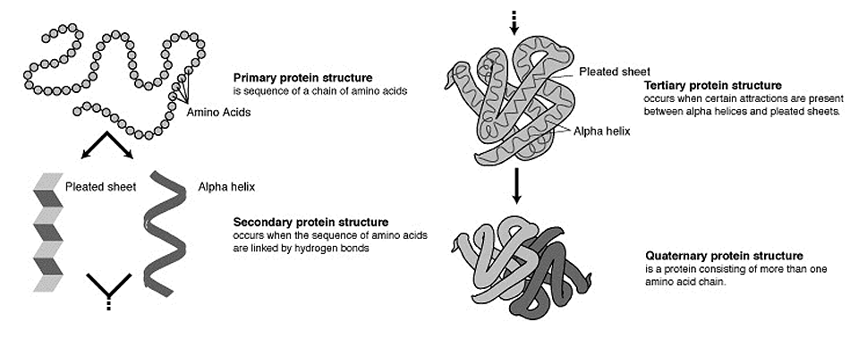
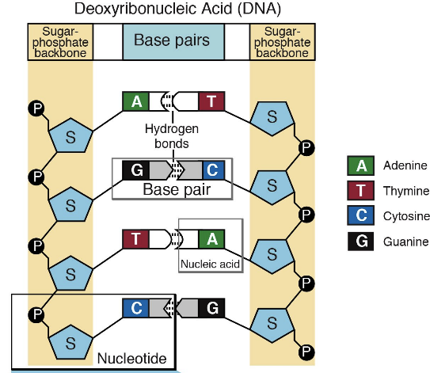
Nucleic Acids
- Nucleic acids contain _______________________________________. Nucleic acids are found in all living things so fruit, vegetables, meats, etc. are good sources of nucleic acids.

- Nucleic acids are made of C, H, O, N, and phosphorus (P).

- There are two types of nucleic acids used for heredity: ____________

- A nucleic acid is made up of small molecules called _____________________ which include a base (ACTG&U), a sugar and phosphate group.

- Nucleotides are found inside the nucleus of a cell in the nucleoplasm.
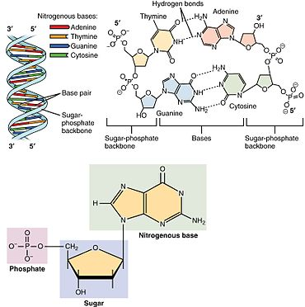
- Deoxyribonucleic Acid (DNA)
Largest molecule on earth!

Contains all the genetic information (a
____________) to build a living organism
DNA is found in the nucleus (*** remember for later ***) and is twisted into a double helix

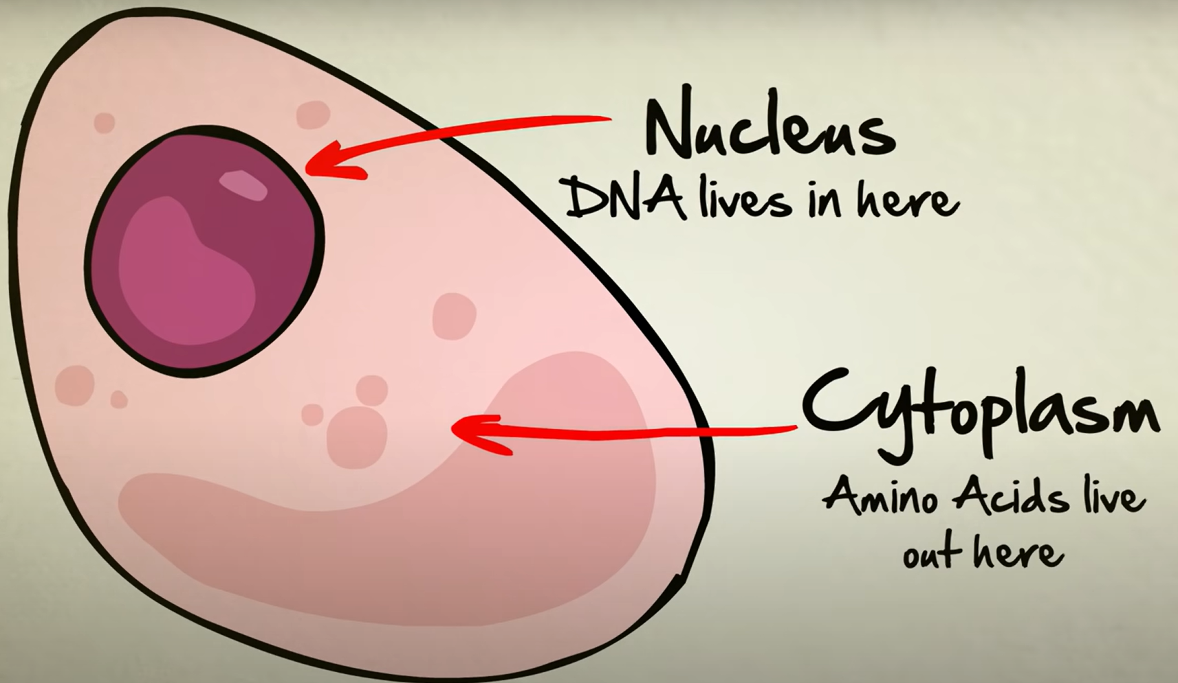

- Ribonucleic Acid (RNA): there are 3 main types

1. Messenger RNA (mRNA) a _______________________________ from the DNA
that exits the nucleus
2. Transfer RNA (tRNA) (Grade 12)

3. Ribosomal RNA (rRNA) (Grade 12 - makes ribosomes)

  - All are ________________________________ and help DNA make proteins

  - Has a U base instead of the T base

__________________________________________________ (ATP)
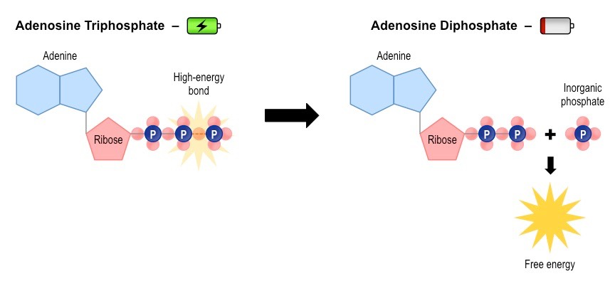
.
This is the _________________ molecule of life which acts like a rechargeable battery that cells can use.

There are 3 phosphate molecules bonded together. The last two have a lot of energy ____________________.

Can You …

… recognize the structure of the 4 molecules of life?

… state the function and give examples of the 4 biological macromolecules?

