Biology 11: Cell Processes
Date: Name:

By the end of the lesson you should be able to:
- Describe protein synthesis
- Compare and contrast the processes of mitosis and meiosis
- Compare and contrast diffusion and osmosis.

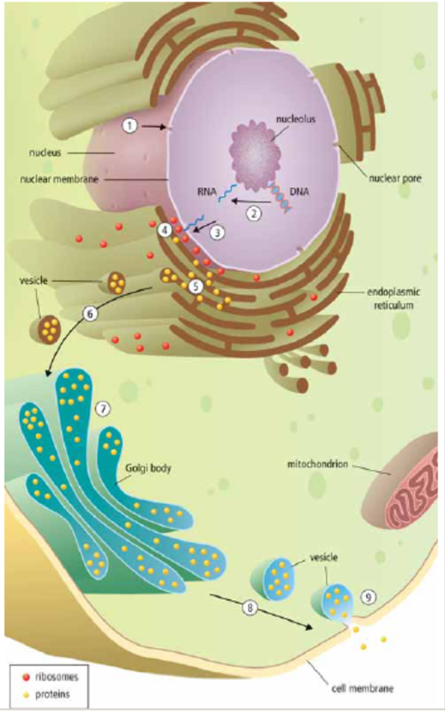
Protein Synthesis
- The nucleus receives a _________________________ _____________________ to make a specific protein
- The DNA message for a specific protein is copied into a small molecule called _______________________
_______________________
- RNA leaves through a ________________________
- The RNA message is delivered to the _____________, where the protein is made
- The manufactured protein enters the __________
- A _______________________ forms off the end of the ER and carries the vesicle to _________________
- Golgi ________________________ the protein for transport
- A vesicle forms off the end of Golgi and _________
___________________________
- The vesicle attaches to cell membrane and is released out of the cell.

Protein Synthesis Analogy

Cell Reproduction
MITOSIS MEIOSIS
- -

- -

- -

- -

Mitosis
- A __________________________________ (contains ______________________________________________ – one from each parent) will divide to form ______________________________________________ cells.

Meiosis
- A 2N diploid cell (contains two copies of each chromosome – one from each parent) will divide to form ____ __________________________________________ cells (half as many of the original number of chromosomes)
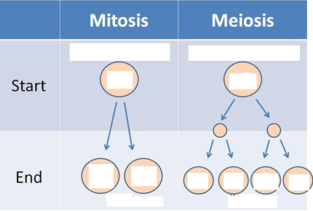

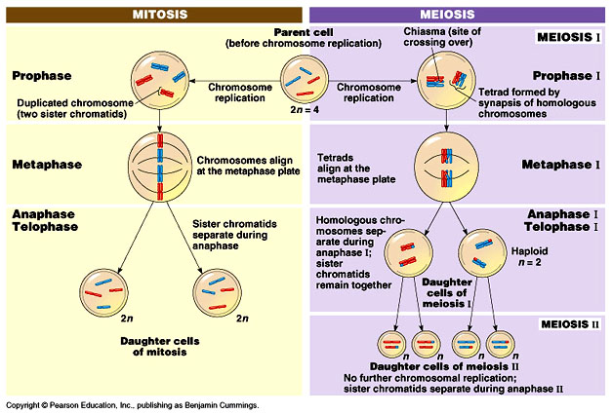

Diffusion and Osmosis
Diffusion
- Movement of _____________________________________________________________________________
Osmosis
- Movement of _____________________ from an area of high concentration to an area of low concentration

Selectively Permeable Membrane
- Cell membranes are selectively permeable – they select what is _____________________________________
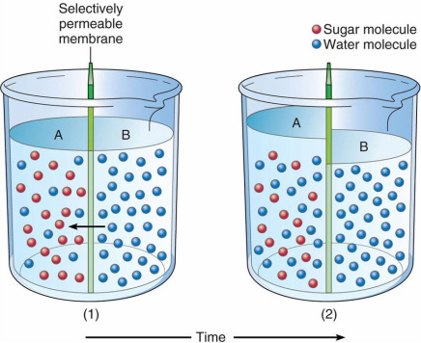
- Water is able to cross membranes while many solutes (_____________________________________________ such as sugar) do not cross freely
- This leads to osmosis, the diffusion of water

Osmosis Details
______________________: _________________________________________________________________
  - The concentration of the solute is equal on both sides of the cell membrane
  - ____________________________ of water into or out of the cell
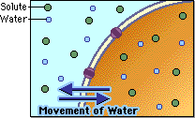

_____________________: higher concentration of water inside the cell
  - The concentration of the solute is higher outside of the cell
  - _______________________________ of the cell; the cell shrinks
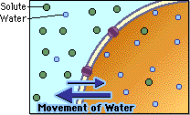

_____________________: lower concentration of water inside the cell
  - The concentration of the solute is higher on the inside of the cell so _____________________ _____________________________________; the cell swells (if too much it can burst! ___________________________!)
