Life Sciences 11: Cell Processes
Date: Name:

By the end of the lesson you should be able to:
- Describe protein synthesis
- Compare and contrast the processes of mitosis and meiosis
- Compare and contrast diffusion and osmosis.

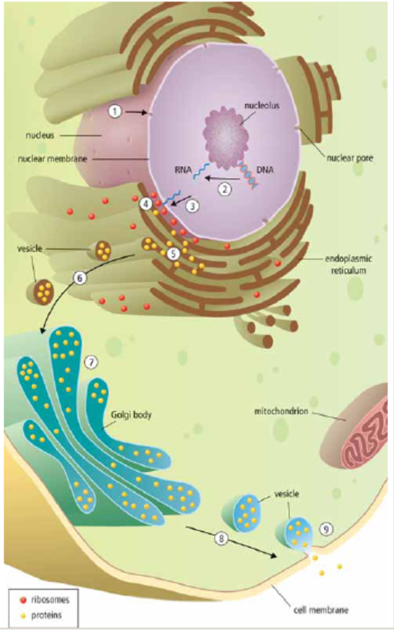
Protein Synthesis
- The nucleus receives a _________________________ _____________________ to make a specific protein
- The DNA message for a specific protein is copied (_______________________) into a small molecule called _______________________
_______________________
- RNA leaves through a ________________________
- The RNA message is delivered to the _____________, where the protein is made (_____________________)
- The manufactured protein enters the __________
- A _______________________ forms off the end of the ER and carries the vesicle to _________________
- Golgi ________________________ the protein for transport
- A vesicle forms off the end of Golgi and _________
___________________________
- The vesicle attaches to cell membrane and is released out of the cell.

Protein Synthesis Analogy – Apple Products

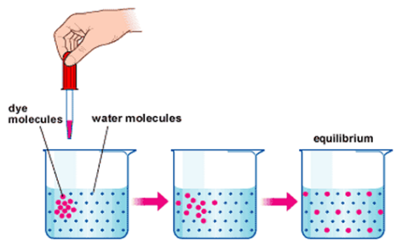
Diffusion and Osmosis
Diffusion
- Movement of _____________________________________________ _________________________________________

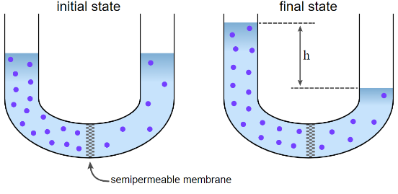
Osmosis
- Movement of _____________________ from an area of high concentration to an area of low concentration

Useful Terms
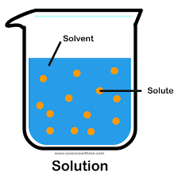
- Solution: mixture of one or more substances evenly distributed in another substance
- Solute: substance dissolved in a solution
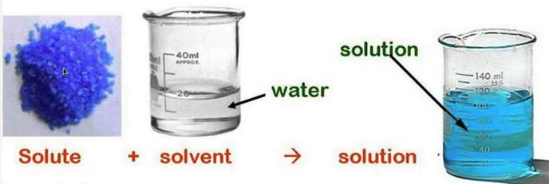
- Solvent: substance in which the solute is dissolved

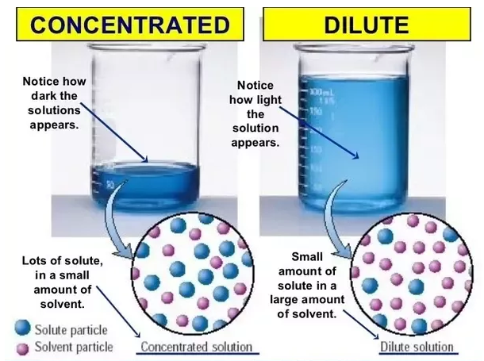

- Concentration: the amount of solute dissolved in the solution

Selectively Permeable Membrane
- Cell membranes are selectively permeable – they select what is _____________________________________
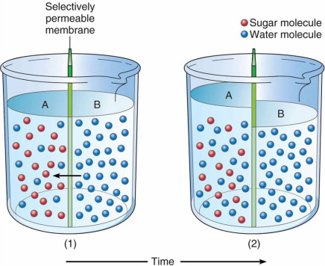
- Water is able to cross membranes while many solutes, such as sugar or salt, do not cross freely
- This leads to osmosis, the diffusion of water

Osmosis Details
- _________________ solution: equal concentration of solute in the solution compared to the cell
  - The concentration of water is equal on both sides of the cell membrane
  - ____________________________ of water into or out of the cell
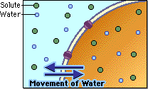

- __________________ solution: higher concentration of solute in the solution compared to the cell
  - The concentration of water inside the cell is greater than outside (solution) of the cell
  - _______________________________ of the cell; the cell shrinks
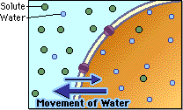

- _________________ solution: lower concentration of solute in the solution compared to the cell
  - the concentration of water outside (solution) the cell is greater than inside the cell
  - so ____________________________________________________________; the cell swells (if too much it can burst! ___________________________!)
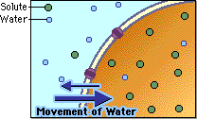
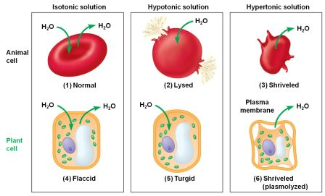

Cell Reproduction
MITOSIS MEIOSIS
- -

- -

- -

- -

Mitosis
- A __________________________________ (contains ______________________________________________ – one from each parent) will divide to form ______________________________________________ cells.

Meiosis
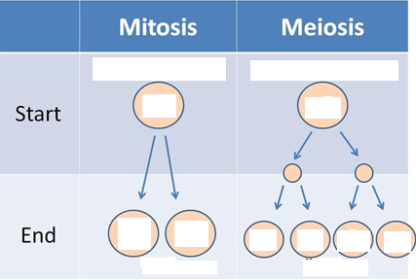
- A 2N diploid cell (contains two copies of each chromosome – one from each parent) will divide to form ____ __________________________________________ cells (half as many of the original number of chromosomes)

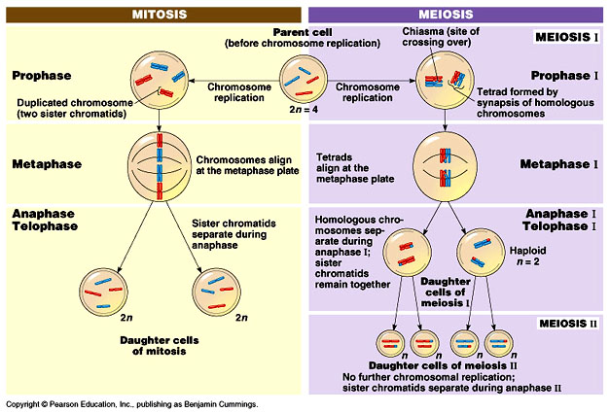

Can you …
… describe protein synthesis?
… compare and contrast diffusion and osmosis?
… compare and contrast the processes of mitosis and meiosis?

