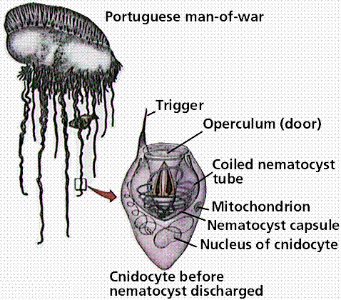**Phylum Cnidaria: The Stingers** Name: Date:

Cnidarians – Overview:

* Cnidarians are soft-bodied, carnivorous animals
* Have true tissues - _______________________
* Defining characteristic is that they have a stinging tentacles around their mouths
* The stinging cell is called a __________________________, which is where the name cnidarian comes from
* They have body symmetry and start to show specialized tissues

Cnidocytes:

* Cnidocytes, or stinging cells, are located on their tentacles and used for defense and to capture prey
* Inside of these cnidocytes, there is a _________________________________________________ ___________________________ that contains a tightly coiled dart!
* When a prey item brushes by the cnidarian, thousands of nematocysts explode into the animal, paralyzing or killing them.
* Think of the ____________________________ as the '_________________________' and the ___________________________ as the '________________________'.

Cnidocyte = ______________________ nematocyst = ____________________

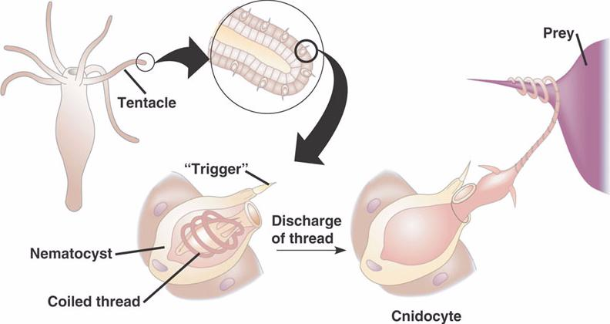

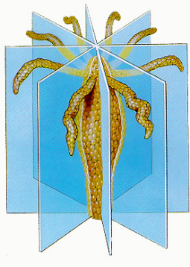

Body Plan:

* ______________________________, __________________________
* Cnidarians have two main body plans, __________________________ and ___________________

**Medusa Polyp**

* Polyps are *usually* _____________
* Cylindrical body with arm like tentacles
* Mouth points upwards
* Typically reproduce asexually
* _________________, bell shaped body
* Mouth at the bottom
* Typically reproduce sexually

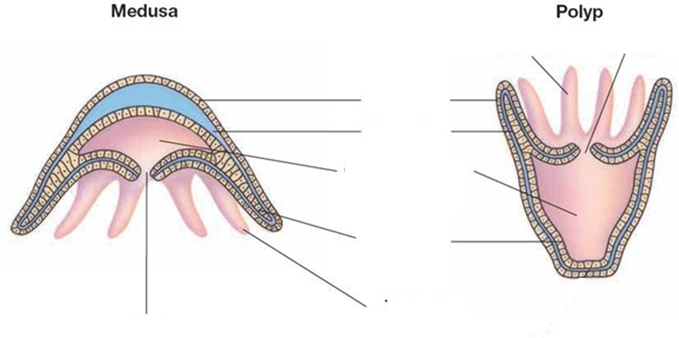

Feeding:

* After paralyzing the prey, cnidarians pull the prey into its mouth and into its ____________________
* Food is digested extracellularly (outside cells) and then ____________________________________ __________________________________________________.
* Any undigested materials leave through this same opening.
* ____________________________________________.

Respiration, Circulation and Excretion:

* Diffusion, diffusion, diffusion!
* _________________________ of nutrients, oxygen and wastes occurs through their body walls

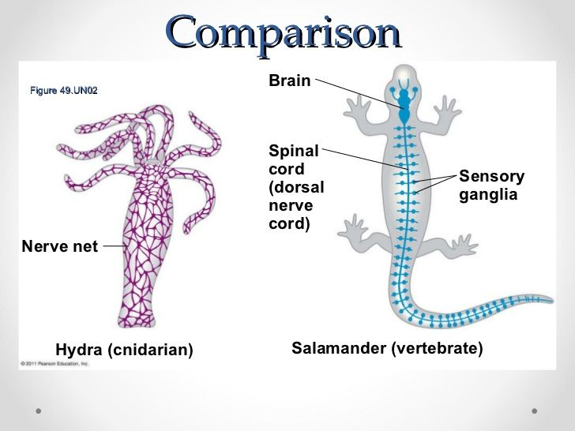Response:

* They have a ____________________________-
* Nerve net is a loosely organized network of nerves that work together to detect stimuli
* Distributed uniformly throughout the body
* _______________________________ are a group of sensory cells specifically to detect the direction of gravity
* _________________________ are eyespots made up of nerve cells that detect light are found rarely in some species

Movement:

* Because there are so many different types of Cnidarians, they have different forms of movement.
* One important component is the **_____________________________________________________**, which is a circular layer of longitudinal muscles that, together with the water in the gastrovascular cavity, enable the cnidarian to move.
* This allows the polyps to get taller and medusas to create a __________________________________.

Reproduction and Life Cycle:

* Show “____________________________________________” with a polyp and medusa stage
* Most cnidarians reproduce sexually and asexually
* Polyps can reproduce _____________________________________________ which may produce a medusa or new genetically identical polyp
* Sexes are different and sexual reproduction occurs as _________________________________ in the water.
* The male and female release their gametes into the water and fertilization occurs creating a genetically different offspring
* After fertilization, a larva develops called a _________________________ which looks different from adult forms

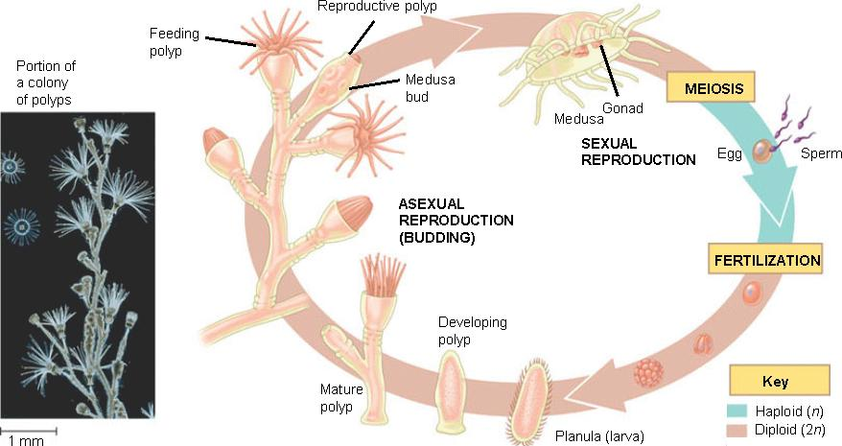

Groups of Cnidarians

* Are all predators
* Found in both fresh and salt water
* Groups of Cnidarians include:
* Hydras and their relatives - Sea anemones
* Jellyfish - Corals

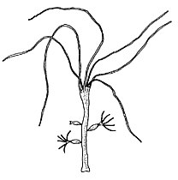

Class ________________________

* ________________________ is dominant
* Medusa is used for ____________

___________________

* Examples: *Hydra sp*and *Obelia sp*.

Class ________________________

* Generally have polyp stage only
* Include: ___________________________________ and sea pens

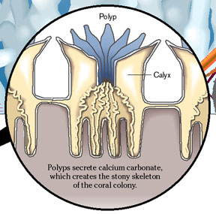

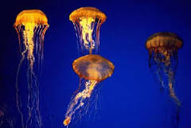

Class ________________________

* _________________________ is dominant
* 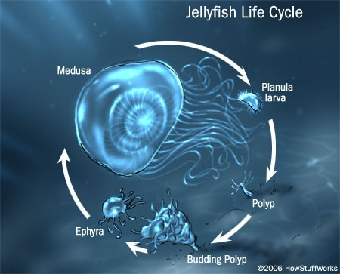Includes the jellies