**Phylum Cnidaria Review**

Name______________ Date__________

1. The feature that all cnidarians share and for which the phylum is named is the: cnidocyte
2. The cnidarian habitat is: marine & fresh water
3. Give three classes of cnidarian and an example of each. Hydrozoa – Hydra, Anthozoa – Anemone, Scyphozoa - Jellies
4. Body plans of cnidarians …
5. Symmetry: radial
6. Tissue layers (how many and names): cdiploblastic – 2 layers. Endoderm – inside layer, ectoderm – outside layer.
7. Third "layer": mesoglea
8. Number of body openings: one
9. The gastrovascular cavity's two functions: digestion and respiration
10. Similarity to porifera body plan: sac plan
11. The sessile, asexual form of cnidarians is the: polyp
12. The mobile, sexual form is the: medusa
13. A life cycle that includes two different body forms is called: alternation of generations
14. Draw and label a diagram that outlines the life cycle of a typical cnidarian.

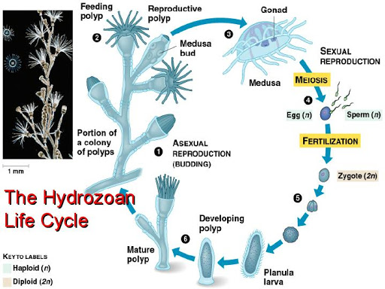

1. Define the term larva. a juvenile form which looks different from the parent
2. The larva of cnidarians is called a: planula larva
3. Similar to poriferans, asexual forms of reproduction are budding and regeneration
4. Define external fertilization. sperm and egg meet outside the body
5. Give a function of muscles in a …
6. polyp catch and eat prey
7. medusa movement – jet propulsion
8. The specialized cells used to capture prey are called cnidocyte and they contain a

"harpoon" like structure called a nematocyst.

1. How do cnidarians obtain oxygen and get rid of carbon dioxide from respiration?
2. Do sponges have a brain? ____no__________ Do cnidarians have a brain? ___no_________
3. Do sponges have nerves? _____no_________ Do cnidarians have nerves? __yes (nerve net)_______
4. Why do cnidarians need nerves? move, sense prey, move muscles, balance (statocysts), detect light (ocelli)
5. Give a realistic situation when you would not want to meet a cnidarian. swimming in the ocean
6. Label the following diagrams of the jellyfish polyp and medusa. 