The Prime Minister's Dinner (AKA How to make a dichotomous key)

Nine Martians landed in the schoolyard this morning and introduced themselves as Eena, Daie, Noag, Mrap, Galk, Tocs, Ezag, Nisps and Tyco. As ambassadors for the planet Mars they have been invited to dine with the Prime Minister. You are the Prime Minister's aide, and the Prime Minister has asked you to make up a dichotomous key so she will know their names without having to ask.

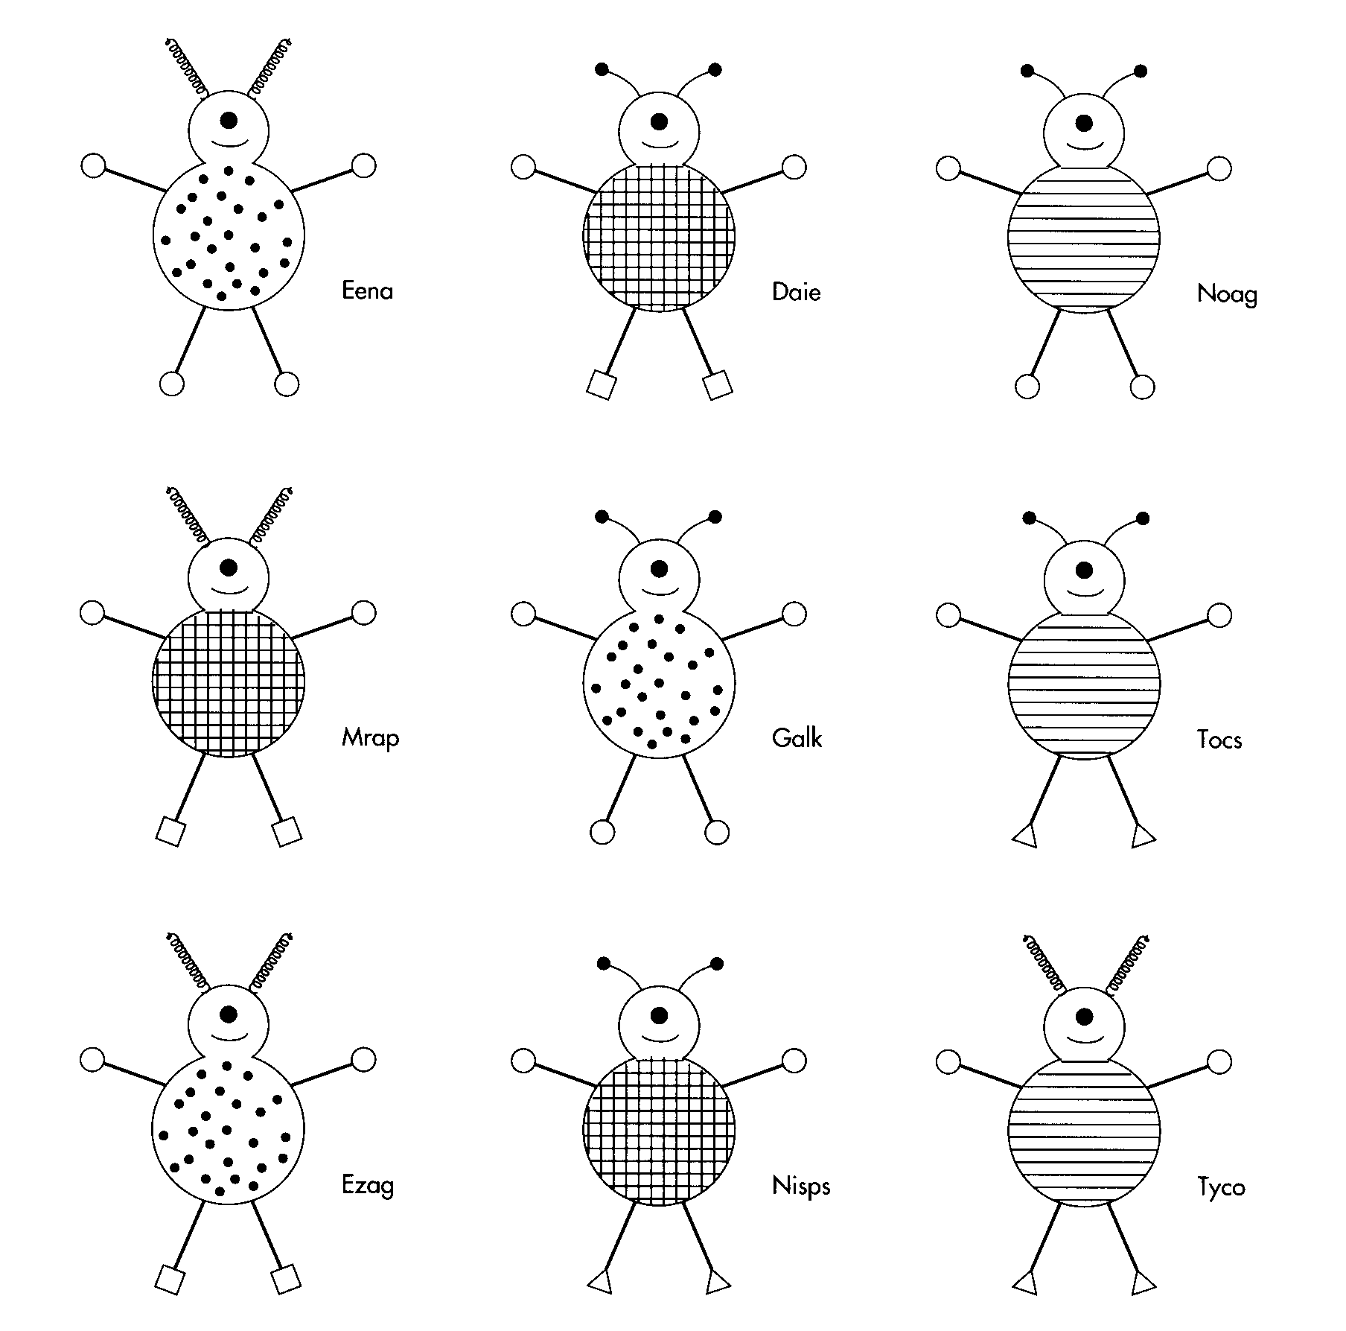Fill in the blank tree below in a manner that will enable the Prime Minister to identify all 9 aliens. Try to minimize the number of branches you use.

Does it have bent antennae?

No Yes

Does it have Does it have

_________ _________

No Yes No Yes









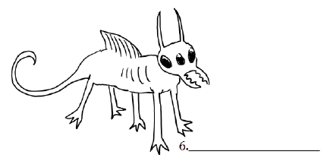

Planning your Dichotomous Key

Use this template to create your dichotomous key based on the six creatures you just named. **You may add extra boxes if you need, or you may remove boxes to fit your key.** Label each box with a question number. These will be used in the last step. 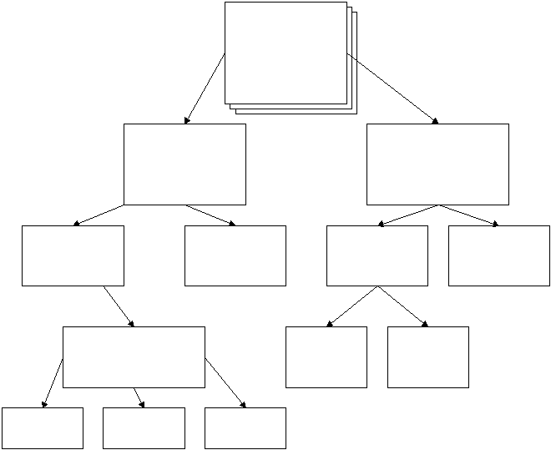

Your Dichotomous Key

Your dichotomous key should now become a **series of questions** which will eventually lead to identifying each organism. Follow the examples we have done so far in class. When you are finished, trade your key with a partner and have them try to correctly identify your organisms using your key and vice versa. Good luck!