Phylum Echinodermata: The Spiny Skins
Deuterostomes
We now move to the other great branch of animal
evolution; the ___________________________
This branch is dominated by the vertebrates which we will study next
The other phylum of deuterostomes seems a strange evolutionary mate for the vertebrates
They are the ____________________________________

Characteristics: "______________________________"

1. ____________________________________

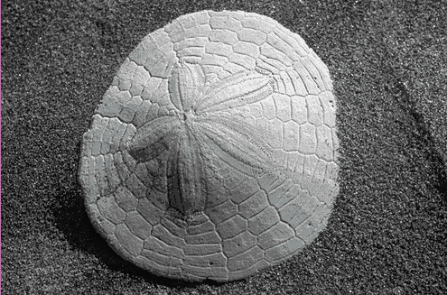
2. _____________________________________________ of calcarious plates

3. Show ________________________________________

_________________________ (as seen in the sand dollar).
4. Reproduction mostly sexual but good powers of regeneration.
5. Unique system called _____________________________________________________” system, used for

_____________________________________________________________

6. Externally shows as ________________________________________________________________
7. Contains 5 classes:
- Class ____________________________
- Class _____________________________
- Class _____________________________
- Class _____________________________
- Class _____________________________

General External Anatomy
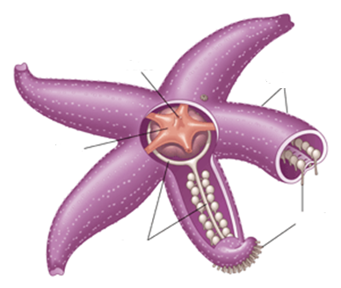

General Internal Anatomy
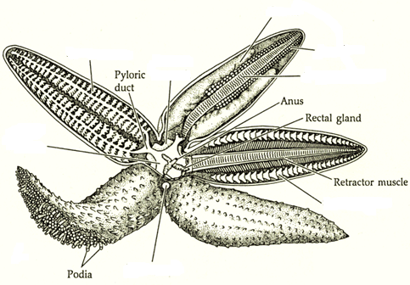

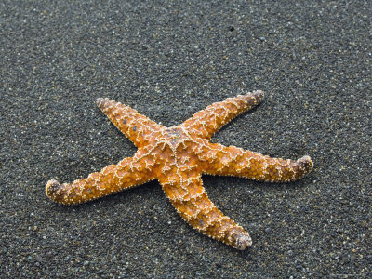
Class __________________________: _____________________________
- Greek asteroeides, ______________________________
- Flattened body with ______________________________
- Mostly ________________________________
- Good powers of _________________________

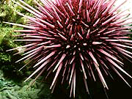
Class_______________________: __________________________

- Greek ekhinos, ________________ (figuratively), sea urchin, hedgehog
  - Oval shaped body covered in ____________________________________ (calcium carbonate) material that make up the spines
- _________________________
- Mostly ____________________________
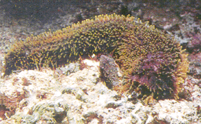
Class ________________________: __________________________
- Greek, holothurum, a sedentary marine animal, possibly from Greek holos, whole; or (thureos, oblong shield (from thura, door))
- _______________________________
- Arms absent
- _______________________________
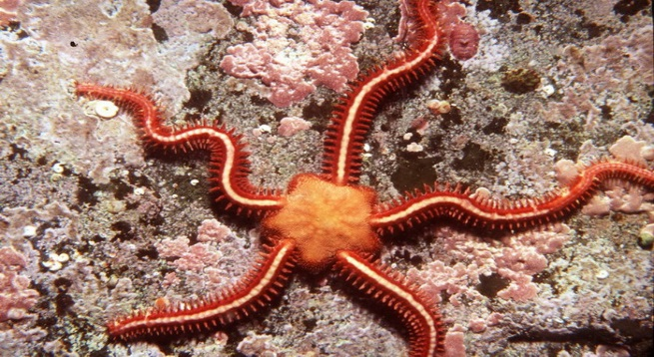
Class ________________________ : _________________________
- Greek ophis, snake + Greek oura, tail
- Penta-radial symmetry with ______________________________
- Mostly detritivores or filter feeders

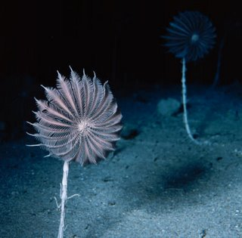
Class _______________________: ______________________________
- Greek krinon, _________________
- _________________________
- Mostly filter feeders

