Phylum Echinodermata: The Spiny Skins
Deuterostomes
- We now move to the other great branch of animal evolution; the ___________________________
- This branch is dominated by the vertebrates which we will study next
- The other phylum of deuterostomes seems a strange evolutionary mate for the vertebrates
- They are the __________________________________

Characteristics: "______________________________"

1. ____________________________________

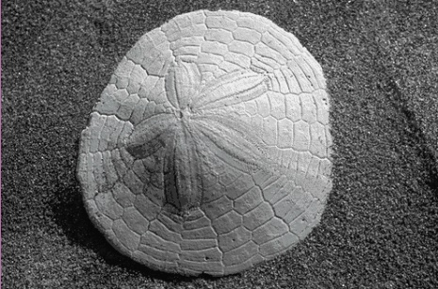
2. _____________________________________________ of calcarious plates

3. Show ________________________________________

_________________________ (as seen in the sand dollar).
4. Reproduction mostly sexual but good powers of regeneration.
5. Unique system called _____________________________________________________” system, used for

_____________________________________________________________

6. Externally shows as ________________________________________________________________
7. Contains 3 classes:
- Class ____________________________
- Class _____________________________
- Class _____________________________

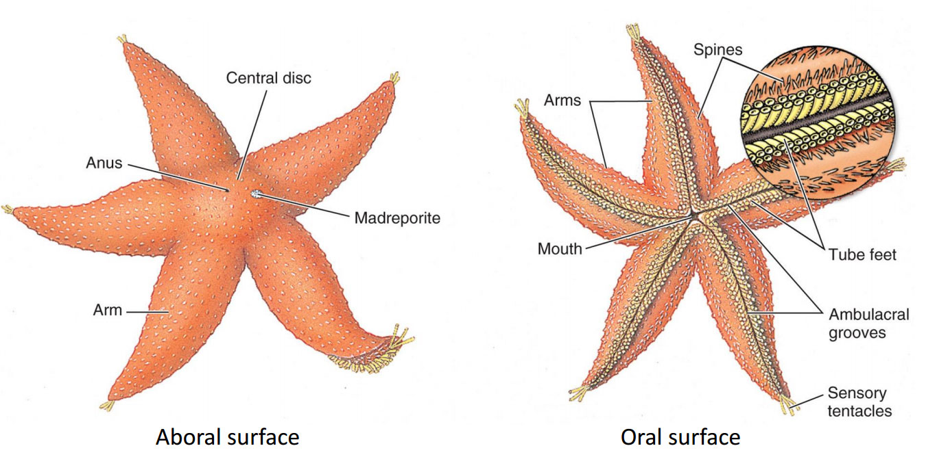
General External Anatomy

General Internal Anatomy
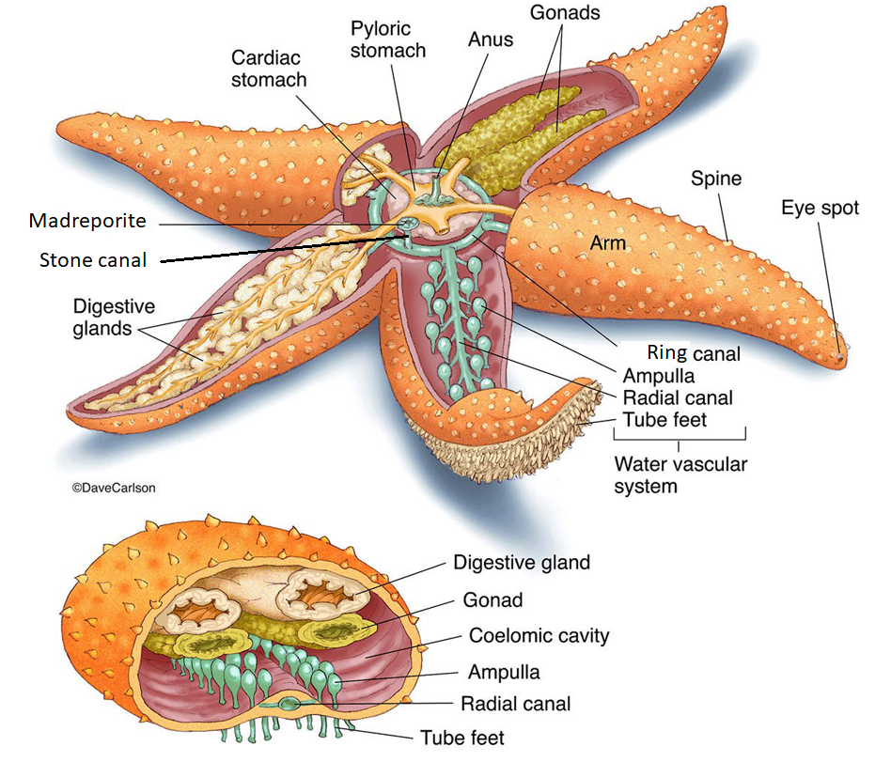

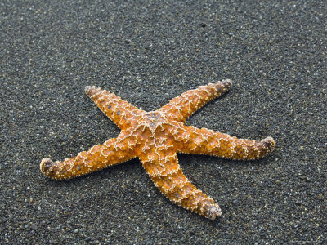
Class __________________________: _____________________________
- Greek asteroeides, ______________________________
- Flattened body with ______________________________
- Mostly ________________________________
- Good powers of _________________________

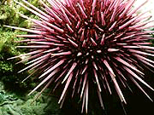
Class_______________________: __________________________

- Greek ekhinos, ________________ - sea urchin, hedgehog
  - Oval shaped body covered in ____________________________________ (calcium carbonate) material that make up the spines
- _________________________
- Mostly ____________________________
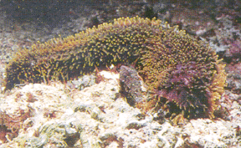
Class ________________________: __________________________
- Greek, holothurum, a sedentary marine animal, possibly from Greek holos, whole; or (thureos, oblong shield)
- _______________________________
- Arms absent
- _______________________________

Can You …
… describe the advancements echinoderms have over arthropods?
… describe the defining characteristics of echinoderms?
… describe the 3 classes and example organisms of echinoderms?
… draw and describe the body plan and systems of a sea star?

