Phylum Echinodermata
Name:
Read pages 734 - 738 Date:
- Define "echino-derm"

- What is an endoskeleton? What are they made of in an echinoderm?

- What are the 5 defining characteristics of echinoderms?
- ____________________________ b)___________________________
c) _____________________________ d) ___________________________
e) _____________________________
- Why are echinoderms and vertebrates (animals with back bones) considered to be closely related?

- What is the water vascular system and what does it do?

- Label the diagram of the water vascular system.
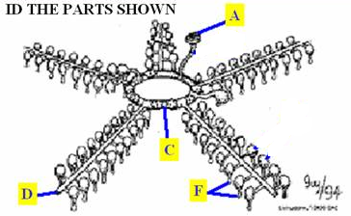

- What does a madreporite do and where does it lead to?

- What is a tube foot and what are two things an echinoderm can do with its hundreds of tube feet?

- Describe the process by which each member of this phylum obtains food.
Sea Stars

Sea Urchins

Sea Cucumbers

- Describe how an echinoderm carries out respiration and circulation.

- How do echinoderms excrete wastes?

- What can the nervous system of an echinoderm detect?

- What is the main reproductive strategy of echinoderms?

- Echinoderm Diversity
Trait | Class Echinoidea | Class Ophiuroidea | Class Holothuroidea | Class Asteroidea | Class Crinoidea
Examples | Sea urchins  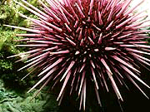  Sand dollars | Brittle stars  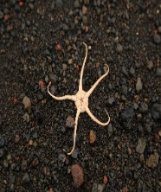  Basket stars | 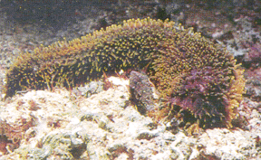  Sea cucumbers | 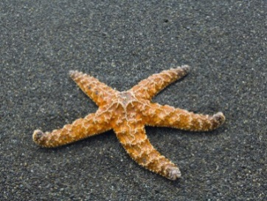  Sea stars | Sea lilies  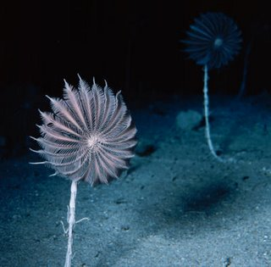  Feather stars
Description:
Feeding Habits:
Interesting Facts:
- Describe how one type of echinoderm is detrimental to the Great Barrier Reef in Australia.

- Describe two roles of echinoderms in their ecosystem.

