Life Sciences 11 Sea Star Dissection Name:
Purpose: to investigate the internal and external structures of a sea star (an Echinoderm)

Materials:
Preserved sea star
Dissecting pan
Dissecting kit

Method:
Part 1: Dorsal Surface
- Obtain a preserved sea star and rinse off any preservative with water.
- Place the sea star in the dissecting pan with its dorsal or aboral (top) surface upward.
- Observe the sea star and determine its symmetry.
- Locate the central disc in the center of the sea star. Locate the small, round hard plate called the madreporite on top of the central disc. Water enters through this into the water vascular system.
- Feel the upper surface of the sea star for spines. These spines protect the sea star and are part of their internal skeleton.
- Look at the tip of each arm and find the eyespot.

Part 2: Ventral Surface:
- Turn the sea star over to its ventral or oral surface (underside).
- Locate the mouth in the center of the central disc. Find the ring of oral spines surrounding the mouth.
- Find the groove that extends down the underside of each arm. This is called the ambulacral groove.
- Feel the numerous, soft tube feet inside each groove. These are part of the water vascular system & aid in movement and feeding.

Part 3: Internal anatomy:
- With the sea star’s dorsal surface facing up, cut off the tip of a ray. Cut along lines A, B, and C and then remove this flap of skin.
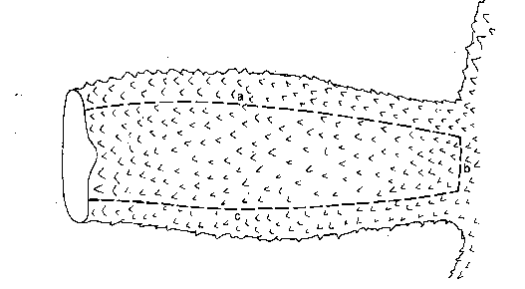

A

B

C

- Inside each arm, locate two long digestive glands called the pyloric caeca. These make enzymes to digest food in the stomach.
- Cut a circular flap of skin from the central disc. (You will have to also cut around the madreporite in order to remove this flap.) Observe the stomach under the central disc.
- Remove the pyloric caeca from the dissected ray. Find the gonads (testes or ovaries) underneath. These may be small if the sea star is NOT in breeding season. Remove these to see the rest of the water vascular system.
- Cut off the tip of a ray to observe the parts of the tube feet. Find the zipper-like ridge that extends the length of the ray. The tube feet are attached to these.
- Locate the bulb-like top of a tube foot called the ampulla. This sac works like the top of an eyedropper to create suction. The bottom of the tube foot is a sucker.
- Embedded in the soft body wall are skeletal plates called ossicles.
- Running down the center of each arm is a lateral or radial canal to which tube feet are attached.
- In the central disc the five lateral canals connect to a circular canal called the ring canal.
- A short, canal called the stone canal leads from the ring canal to the madreporite where water enters.
Analysis:
- What type of symmetry did your sea star have?
- How many arms or rays does your sea star have?
- Label the central disc, arms, spines, eyespot and madreporite on the diagram below.

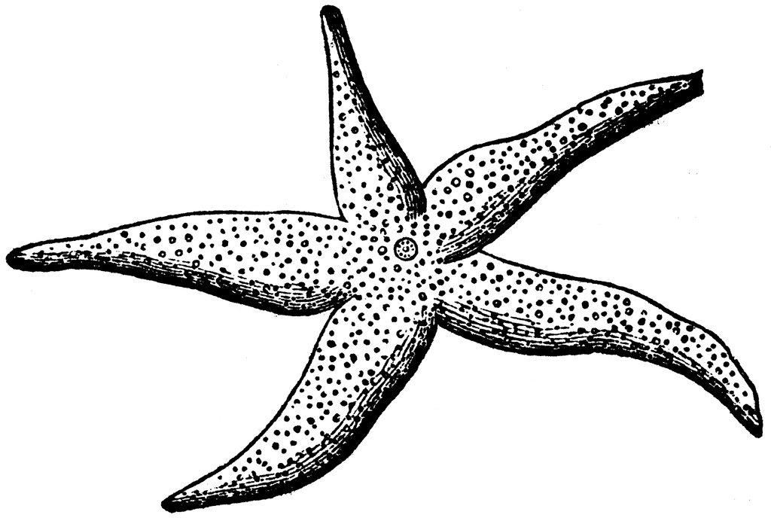

- What is the upper surface of the starfish called?

- What is the lower surface of the starfish called?

- Label the oral spines, mouth, ambulacral groove and tube feet on the diagram below
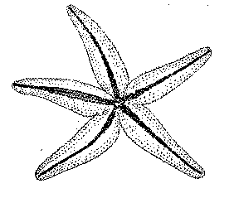

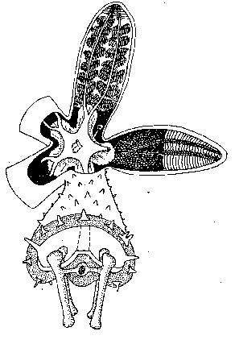
- Label pyloric caeca, stomach, central disc, gonads, ampulla and ossicles in the diagram below:

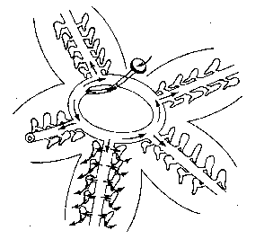
- Label the lateral canal, ring canal, stone canal and madreporite in the diagram below:

- Colour an arrow on the diagram above tracing the path that water takes when it enters and moves through the sea star.

- On which surface are these parts of a sea star visible:
a. Mouth -
b. Madreporite -
c. Suckers -
d. Oral spines -
e. Eyespots -
d. Ambulcaral groove –

- What part of the tube foot creates suction to open clams whenever the sea star feeds?

- Why do the gonads sometimes appear larger?

- What type of skeleton, endoskeleton or exoskeleton, does the sea star have?

- What bony plates make up its skeleton?

- What is the function of the pyloric caeca?

- Where is the stomach of a sea star located? What can the sea star do with its stomach when feeding on clams & oysters?

