Sea Star Lab Analysis

Analysis
1. Q: What type of symmetry did your seastar have?
A: Pentaradial symmetry
2. Q: How many arms or rays does your seastar have?
A: Five
3. Q: Label the central disc, arms, spines, eyespot, and madreporite.
A:
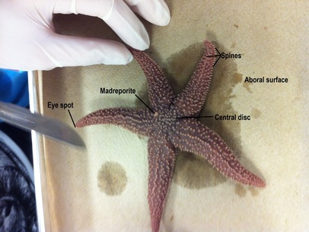
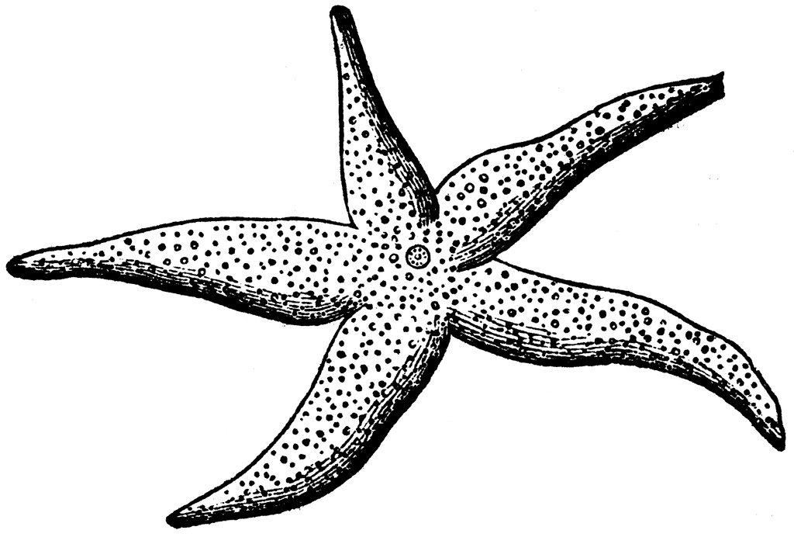
4. Q: What is the upper surface of the starfish called?
A: Aboral surface
5. Q: What is the lower surface of the starfish called?
A: Oral surface
6. Q: Label the oral spines, mouth, ambulacral groove, and tube feet.
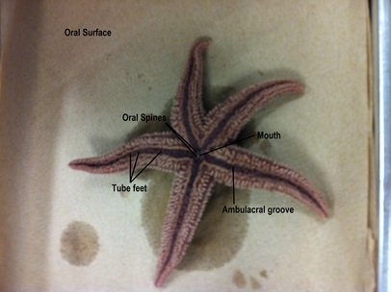
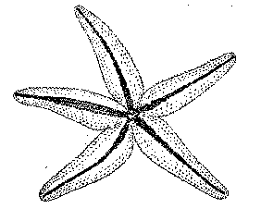

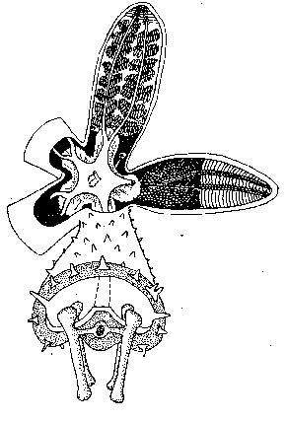
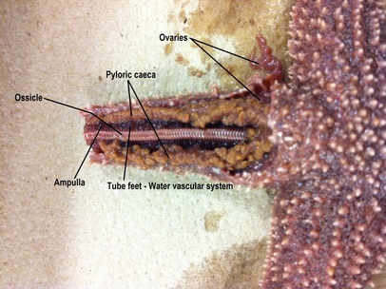
7. Q: Lable pyloric caeca, stomach, central disc, gonads, ampulla, and ossicles.

8. Q: Label the lateral canal, ring canal, stone canal, and madreporite.
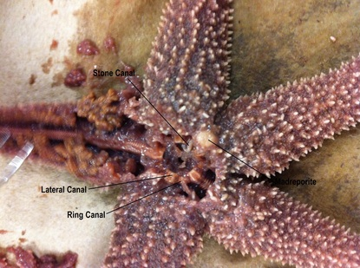
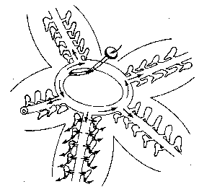

9. Q: Trace the path that water takes when it enters and moves through the seastar.
A: Water enters the seastars body through the madreporite. It travels through the stone canal into the ring canal. It then enters the five radial canals, which take the oxygen to various places around the body. It also goes in and out of the tube feet for gripping onto rocks, as well as for hunting. Deoxygenated and un-needed water are sent back to the ring canal, up the stone canal and out of the madreporite.
10. Q: On which surface are these parts of a seastar visible:
A: Mouth - Oral surface of central disc
Madreporite - Aboral surface of central disc
Suckers - Oral surface of rays
Oral spines - Oral surface of central disc, surrounding mouth
Eyespots - On the tip of each ray
Ambulcaral groove - Oral surface of rays
11. Q: What part of the tube foot creates suction to open clams whenever the seastar feeds?
A: The ampulla
12. Q: Why do the gonads sometimes appear larger?
A: If the seastar was going through its reproductive phase at the time of death, then the gonads would be enlarged.
13. Q: What type of skeleton, endoskeleton or exoskeleton, does the seastar have?
A: Seastars have a basic endoskeleton comprised of ossicle plates which surround the muscles.
14. Q: What bony plates make up its skeleton?
A: Ossicles
15. Q: What is the function of the pyloric caeca?
A: It produces enzymes to aid in the digestive processes of both stomachs
16. Q: Where is the stomach of a seastar located? What can the seastar do with its stomach when feeding on clams and oysters?
A: Both the pyloric and cardiac stomachs are located in the central disc of the sea star. To feed, the seastar wraps itself around the clam and opens the shell. It then inverts its cardiac stomach into the shell of the clam, releasing its digestive enzymes. This process turns the insides of the clam to liquid, which the starfish then brings back into its body and into the pyloric stomach to be distributed throughout the body.

