Endosymbiotic Theory – Where Did Eukaryotic Cells Come From?
Date: Name:

1. What does the endosymbiotic theory explain?  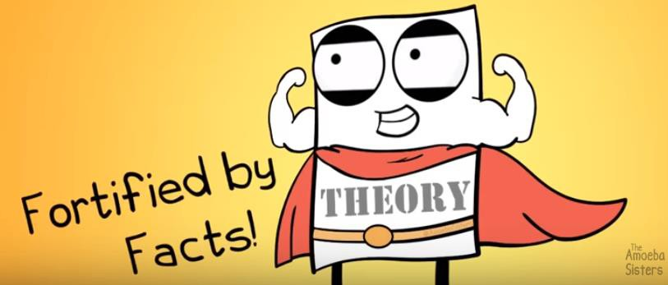 | 4. How did mitochondria and chloroplasts develop?
2. THREE examples of bacteria billions of years ago.  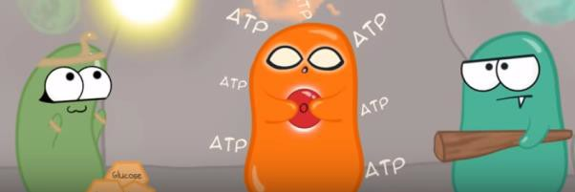 | 5. What is evidence for #4 above?
3. Explain the premise behind the Endosymbiotic Theory – How did different eukaryotic cells evolve? | 6. What is a modern-day example of endosymbiosis?  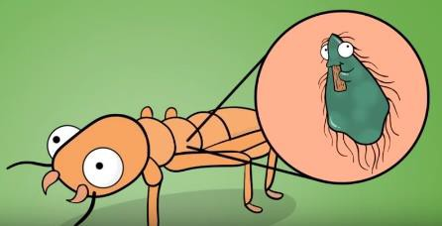

Summary of Evidence for Endosymbiotic Theory

Diagram Explanation

