Unit 2: Evolution – Evidence of Evolution Date: _____________
By the end of the lesson you should be able to:
- State 4 types of evidence AND explain why they are good pieces of evidence
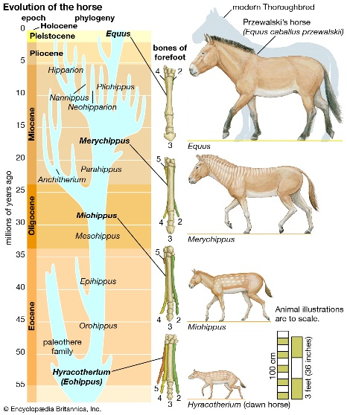
Evidence of Evolution
Four approaches to studying evolution are:
1.
2.
3.
4.

1. Fossil Evidence
- Fossils are _________________________________________________ .
- Fossils allow us to ________________________ and follow evolution through history.
- Fossils are ________________________ and the closest we have to a time machine
- Allow us to compare _________________________________________________ in fossil to species alive today.

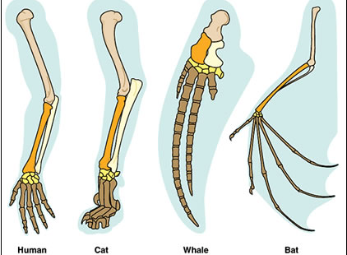
2. Comparative Anatomy
- Comparing homologous structures of species alive today.
- Can be any homologous organs, not just bones.
Homologous Structures
- Many organisms have _______________________________
_________________________________________
- Therefore they must have had a ____________________
- Similar ____________________________________

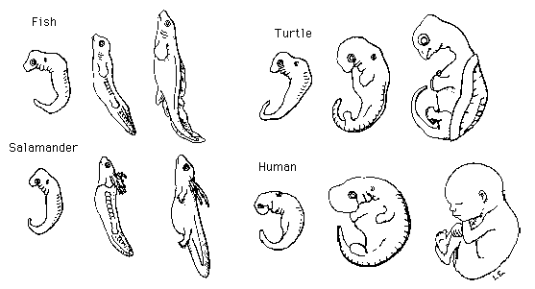
3. Comparative Embryology
- A growing embryo ____________________
____________________________________
____________________________________
- the basic structures of a common ancestor

4. Molecular Evidence
- This method examines the ___________________ or its product, a protein. (remember the protein synthesis story??!)
- This new method is lab intensive but provides some of the most convincing evidence for evolutionary relationships.
1. DNA Comparisons
- The _______________________________________________________________, and genes from one organism can be transferred in a lab from organisms to another and still function
- Members of the same species have ___________________________________________________
- Interbreeding species distribute any mutations that occur quickly through the gene pool.
- Isolated species collect their own ____________________________ which become subject to different environmental pressures, leading to the creation of a new species.
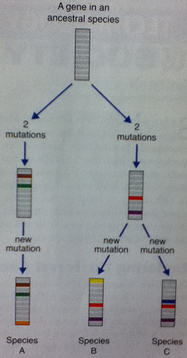
- This new species will have ________________________________________________ to the previous
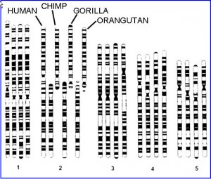
2. Molecular Clocks
- Inheritable mutations occur in any population at the same rate. The longer the
two populations are isolated, the ______________________________.

- Differences in DNA sequences act as a “________________________________” to approximate how long the gene pools have been separated.
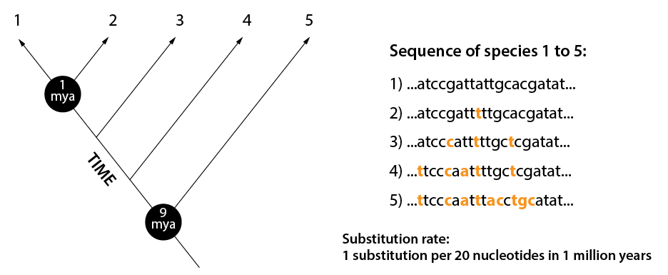
Summary
- By putting data from all methods together, we can determine the evolutionary history of a group of organisms.
- This is also used to determine the correct classification of living organisms.
- We will be doing classification next!

