Evolution of Populations Name: Date:

- How might natural selection on genetic traits lead to evolution?

- What is directional selection?

- In stabilizing selection, how does the fitness of individuals at the center of the curve differ from the individuals at either end?

- How does disruptive selection result in two distinct phenotypes?

- What occurs during genetic drift?

- Explain what happens in gene flow.

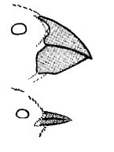
- You examine these two beaks: One is narrow and needlelike. The other looks like a pair of pliers. What type of natural selection could have produced birds with these two extreme types of beaks? Explain your answer.

