Name: _____________________ Date: ________________
Evolution Reminders
- What does it mean to say that an animal is the “most fit”?

The organism that passes on the most genes to the next generation.

- What are the 3 possible types of selection? Draw the graphs!

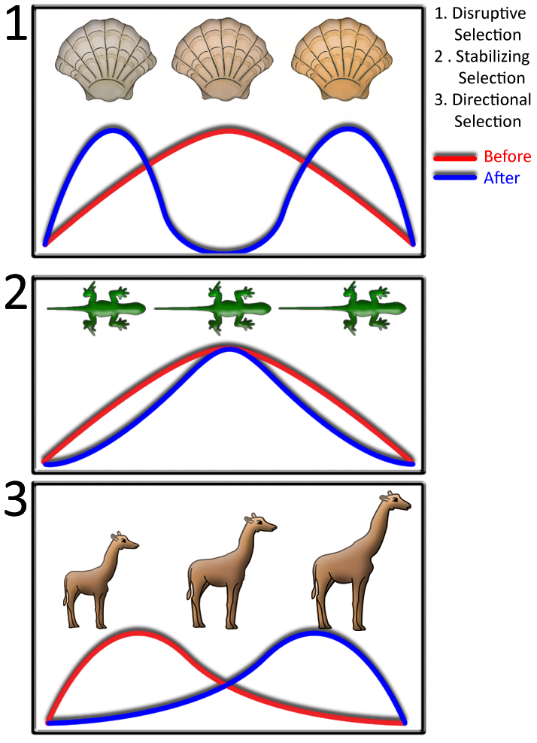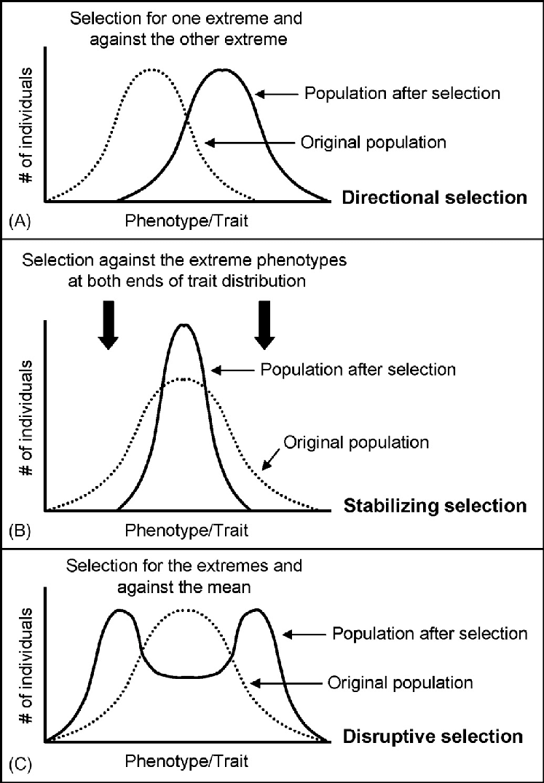

- Define “species” and "population"

Species – similar organisms which can breed to make fertile, viable offspring.

Population – Group of individuals of the same species in the same location.

- Define “gene pool”

All the available genes available in a given population

- Compare and contrast gradualism and punctuated equilibrium. Draw an example of each.
Gradualism - Darwin Punctuated Equilibrium – Eldredge and Gould
Slow and steady change over time Long periods of no change, short periods or rapid change
Intermediate fossils No (or fewer) intermediate fossils

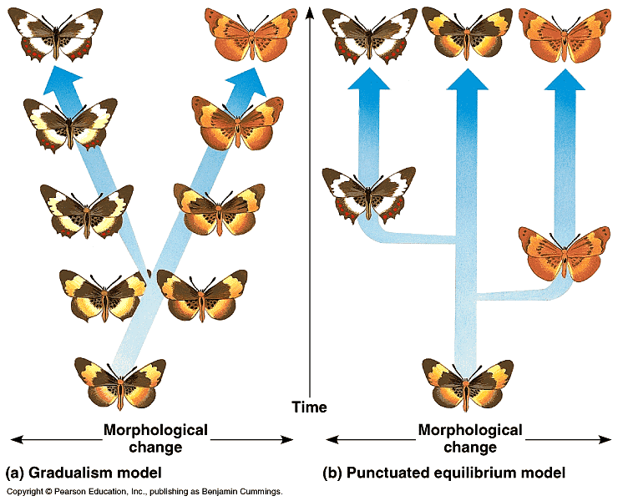

- Who are these people and what did they do: Jean Baptiste Lamarck, Charles Darwin, Eldredge and Gould, Alfred Russell Wallace?

Jean Baptiste Lamarck – Inheritance of Acquired Characteristics. First to propose a mechanism for evolution.

Charles Darwin – Natural selection as a mechanism for evolution Gradualism

Eldredge and Gould – Punctuated equilibrium

Alfred Russell Wallace – made similar observations to Darwin, presented his ideas with Darwin, not credited as his boat sank and his evidence was lost.

- Describe the 5 ways to change a gene pool

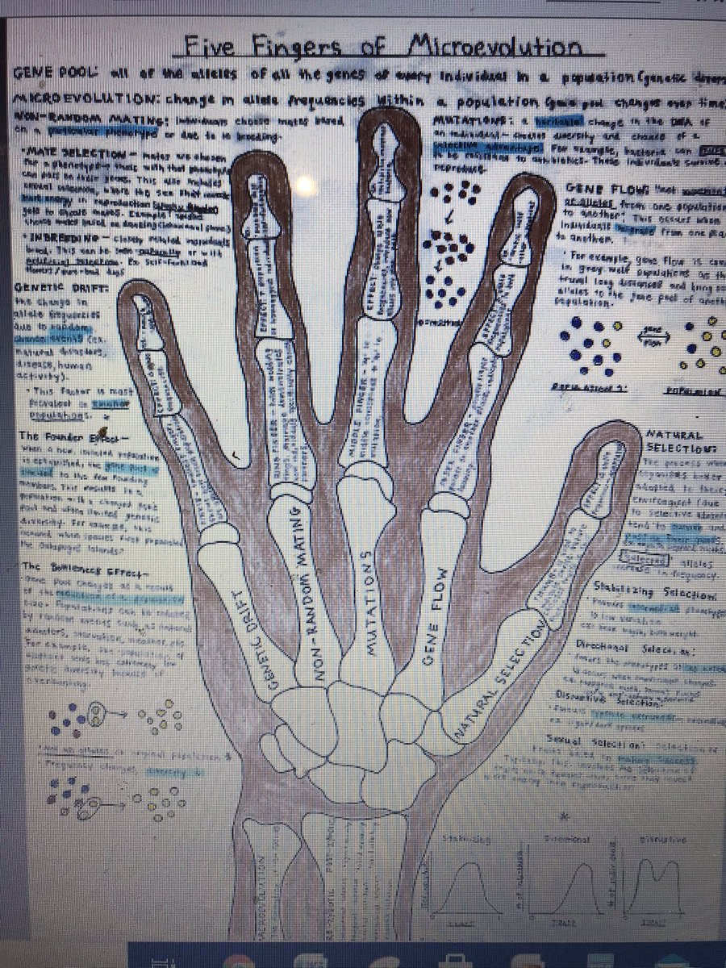

- Define “speciation”

Macroevolution or 'big' evolution – process of making new species over time. In isolated populations, small microevolutionary changes add up over time until the isolated groups of organisms are so different that they can no longer interbreed.

- Compare and contrast micro and macro evolution

Micro – small changes within a population 5 Fingers of Evolution

Macro – big changes from one species to another Speciation

- Why are these examples used in evolution: Peppered Moth, Galapagos Finches, Giraffes’ necks? Describe each of these examples

Peppered Moth – example of directional selection based on industrial melanism. Clear case of natural selection occurring in Darwin's time period.

Galapagos Finches – example of speciation due to natural selection occurring on different islands with different selection pressures. Example of divergent evolution as all the different species of finch originated from one mainland species.

Giraffe necks – Lamarck Use/Disuse or Inheritance of Acquired Characteristics. Giraffes would use their necks and stretch them within their lifetime and pass this trait on. Not supported by future DNA evidence.
Darwin Natural selection. There is variation among giraffes. Giraffes that have longer necks would have a survival advantage and would have a better chance to reproduce and pass on their genes to the next generation. Supported by future DNA evidence.

- Describe the idea of “Inheritance of Acquired Characteristics”. Who came up with it, what is the mechanism behind it, and what are some flaws?

Lamarck Theory: Inheritance of Acquired Characteristics. Mechanism: Use/Disuse. Giraffes would use their necks and stretch them within their lifetime and pass this trait on. Flaw: Doesn't account for genetics. If a rat acquired the characteristic of no tail in its lifetime, the trait of no tail would not be passed onto the next generation. Not supported by future DNA evidence.

- What does DNA have to do with evolution?

- DNA is unique to each organism
- If DNA changes, the organism changes
- Evolution is the change of populations of organisms over time
- THEREFORE the DNA must be changing over time if the organisms are changing!

- The accumulation (build-up) of characteristics that improve a species’ ability to survive and reproduce is called adaptation! What is the mechanism for adaptation?

The accumulation of new characteristics occur due to the 5 fingers of evolution mutations and gene flow for example introduce new traits. Natural selection acts on those traits. Advantages traits build up over time while disadvantage traits are weeded out. Natural selection is the mechanism for adaptation.

- Compare and contrast convergent and divergent evolution.
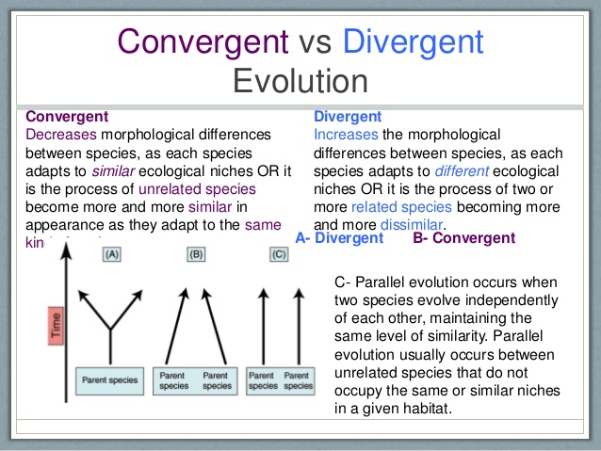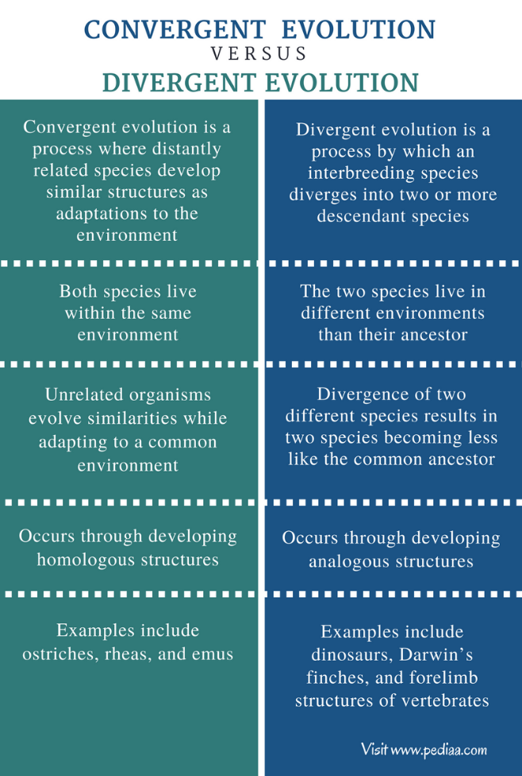
Bill of a duck and platypus
Shape of a dolphin, shark, ichthyosaurus and puffin

- Describe 4 types of evidence which support the theory of evolution.
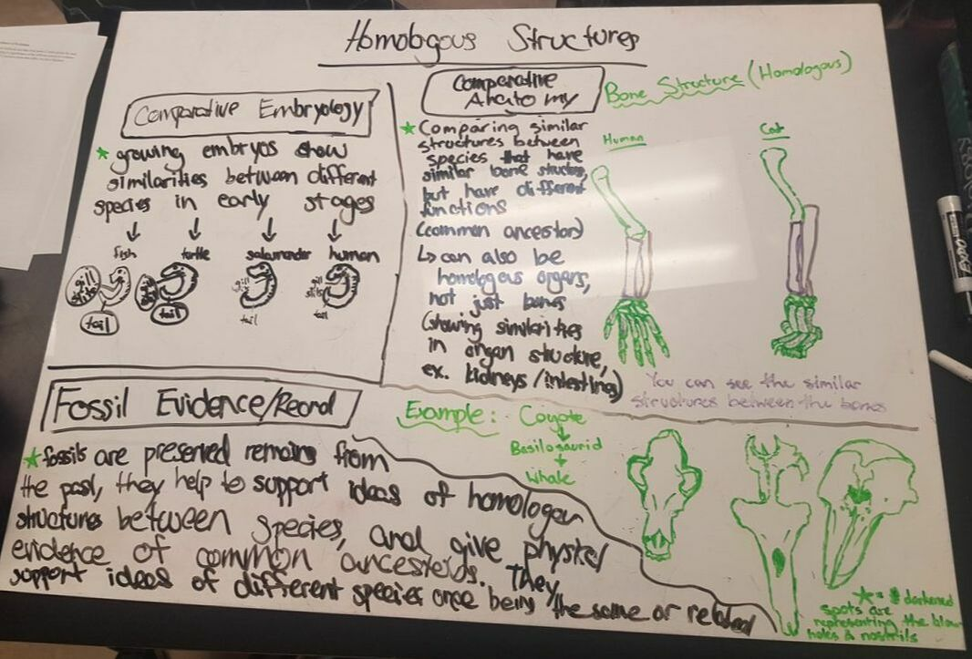
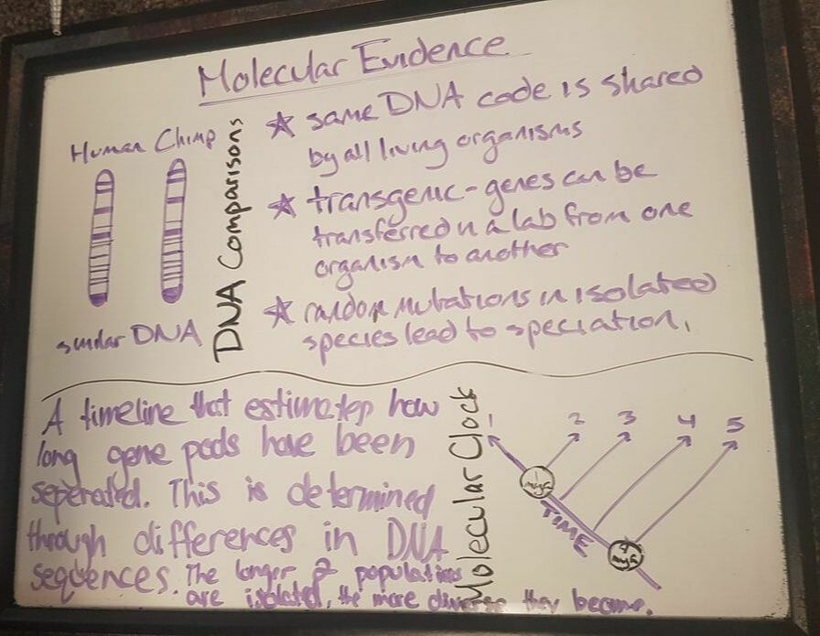
Image Credit to Amelie H.

