Biology 11 Frog Lab Name:
Purpose: to observe the external and internal structures of a frog (Amphibian)

Materials:
Dissecting kit
Frog specimen
Dissecting tray

Procedure:
- Put on safety goggles, gloves, and a lab apron.

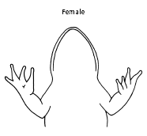
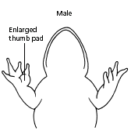
- Place a frog on a dissection tray. To determine the frog’s sex, look at the hand digits, or fingers, on its forelegs. A male frog usually has thick pads on its "thumbs," which is one external difference between the sexes, as shown in the diagram below. Male frogs are also usually smaller than female frogs. Observe several frogs to see the difference between males and females.

- Use the diagram below to locate and identify the external features of the head. Find the mouth, external nares, tympani, eyes, and nictitating membranes.
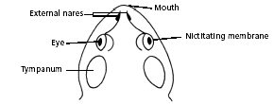

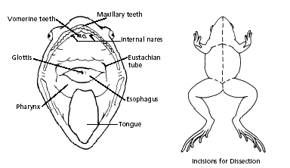
- Turn the frog on its back and pin down the legs. Cut the hinges of the mouth and open it wide. Use the diagram below to locate and identify the structures inside the mouth. Use a probe to help find each part: the vomerine teeth, the maxillary teeth, the internal nares, the tongue, the openings to the Eustachian tubes, the esophagus, the pharynx, and the slit-like glottis.

- Look for the opening to the frog’s cloaca, located between the hind legs. Use forceps to lift the skin and use scissors to cut along the center of the body from the cloaca to the lip. Turn back the skin, cut toward the side at each leg, and pin the skin flat. The diagram above shows how to make these cuts

- Lift and cut through the muscles and breast bone to open up the body cavity. If your frog is a female, the abdominal cavity may be filled with dark-colored eggs. If so, remove the eggs on one side so you can see the organs underlying them.

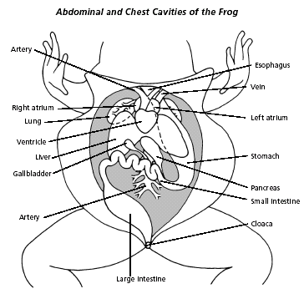
- Use the diagram below to locate and identify the organs of the digestive system: esophagus, stomach, small intestine, large intestine, cloaca, liver, gallbladder, and pancreas.

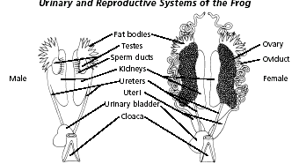

- Again refer to the diagram above to identify the parts of the circulatory and respiratory systems that are in the chest cavity. Find the left atrium, right atrium, and ventricle of the heart. Find an artery attached to the heart and another artery near the backbone. Find a vein near one of the shoulders. Find the two lungs.

- Use a probe and scissors to lift and remove the intestines and liver. Use the diagram above to identify the parts of the urinary and reproductive systems. Remove the peritoneal membrane, which is connective tissue that lies on top of the red kidneys. Observe the yellow fat bodies that are attached to the kidneys. Find the ureters; the urinary bladder; the testes and sperm ducts in the male; and the ovaries, oviducts, and uteri in the female.

- Remove the kidneys and look for threadlike spinal nerves that extend from the spinal cord. Dissect a thigh, and trace one nerve into a leg muscle. Note the size and texture of the leg muscles.

- Dispose of your materials according to the directions from your teacher.

Analysis:
- What is the function of the nictitating membrane?
- A frog does not chew its food. What do the positions of its teeth suggest about how the frog uses them?
- Trace the path of food through the digestive tract.
- Trace the path of blood through the circulatory system, starting at the right atrium.
- Trace the path of air through the respiratory system.
- Trace the paths of sperm in a male and eggs in a female.
- Trace the path of urine in both sexes.
- Which parts of the frog’s nervous system can be observed in its abdominal cavity and hind leg?
- Suppose in a living frog the spinal nerves extending to the leg muscles were cut. What ability would the frog lose? Why?
- The abdominal cavity of a frog at the end of hibernation season would contain very small fat bodies or none at all. What is the function of the fat bodies?
- Structures in an animal’s body that help it survive in the environment are called adaptations. How do the frog’s powerful hind legs help it survive in water and on land?
- During one mating, the female lays between 2,000 & 3,000 eggs in water and the male sheds millions of sperm over them. How do these large numbers relate to the frog’s ability to survive in water?

