Microbiology: Gram Staining

What is Gram Staining? Name: Date:
- Basic classification of bacteria that is based on the ___________________________.
- There are 2 main groups: Gram positive and Gram negative.
- Gram staining is a staining technique that provides an easy differentiation of bacteria into one of two groups.
- The staining technique, developed in the late 1700’s by Christian Gram classifies microorganisms into two groups based on the structure of their cell walls.
How is this possible?
- The component of the cell wall which makes Gram staining possible is _______________________.
Gram Positive Cell Walls Gram Negative Cell Walls
- Have a thin cell wall with a -Have a thick cell wall with a
______________________________ ___________________________________

Cell Walls
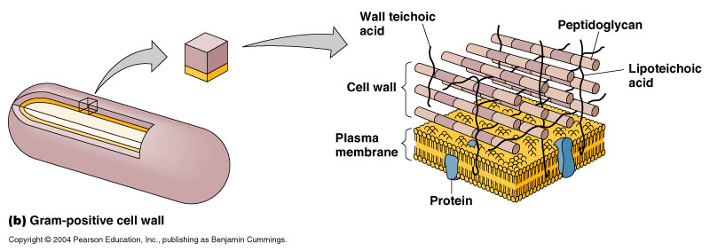
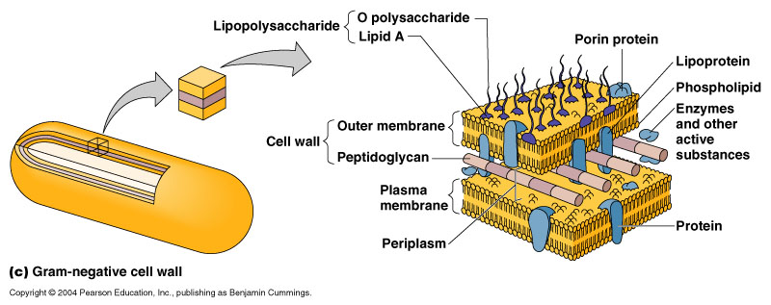
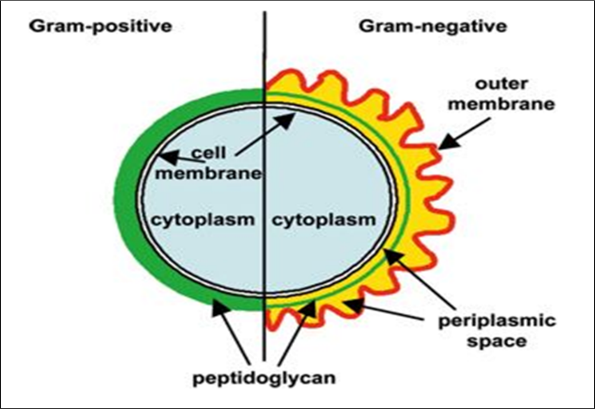
Why do we Gram Stain?
- To differentiate between different types of bacteria based on their cell wall structure.
- ___________________________________
NOTE:
Other ways to identify bacteria
- What they eat Waste Products
- _____________ Colony Formation (colour, shape etc...)
- _____________
Process
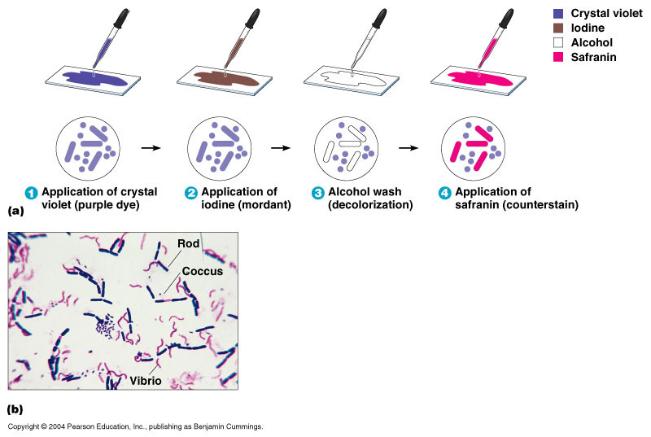
The process includes the use of:
a primary stain (crystal violet) (30sec)
a mordant (helper) iodine solution, (60sec)
a decolorizer (95% ethanol),
a counterstain (safranin). (30sec)

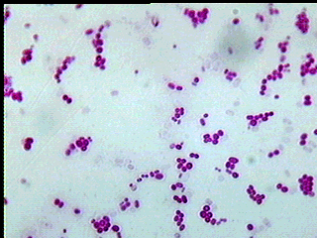

Upon Completion

- Gram Positive cells appear ________________________

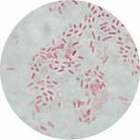

- Gram Negative cells appear _____________________

